Into the Ocean
by Missy Jane

Nerina watched Kegan enter the room like he owned it, confidence in every step as his masculine swagger carried him towards her. She steeled her spine and pushed her shoulders back, raising her chin as she assessed him from head to toe. He was in that damn gray t-shirt again. She rolled her eyes and tried to keep the annoyance from her face. But really, tonight of all nights? She understood his attachment to the worn gray shirt, the white letters so faded only his closest friends knew they spelled Galveston. She'd never deny him the reminder of what he'd had, except it was holding him back so securely from what could be.

His strong, long legs were encased in well-worn blue jeans and he had on black military-style boots. He created a tough image, standing six-four in said boots with his broad shouldered build. Most men stepped out of the way when they saw him coming, some women too. But Nerina never had. She'd taken one look at him when they were teenagers and fallen helplessly in awe. Once her heart became irrevocably his, she was at loose ends, unable to move forward even as he continued to look back. But two years had passed in heartbeats and she was tired of sitting in limbo. Tonight she would lay it all out for him and deal with the consequences. She would either lose a great friend or gain a lover. Both prospects terrified her.

He reached her side and flashed his knee-melting grin. Thank god she was already sitting down. Playing nonchalant with him was always a challenge but she was feeling very vulnerable tonight.

"Hey, beautiful. What's got such a serious look on your face?"

His deep voice sent a shiver up her spine and she rubbed her hands up and down her bare arms. The sleeveless silk blouse had seemed like such a good idea this afternoon when the thermostat read eighty. However, in true south-Texas fashion the temperature had dropped with little notice and was now a cool sixty-eight outside. She'd been sitting by the door waiting for him, but now that he was here the rest of the room was too full to move.

She looked around with a shrug.

"I have a lot on my mind, Kegan. I wanted to talk to you but the party started early and you're a little late."

It was the only admonishment she'd give him. Not that it mattered. His world ran on Kegan time, as all of his friends knew by now.

His confident grin melted into serious regret and he stepped closer. She hated when his heat warmed her skin, giving her a hint of what she was missing every night in her lonely bed.

He placed his large palms over her smaller hands and moved them up and down in unison. Now she shivered for a different reason as her body instantly warmed.

"I'm sorry I'm late, honey. I had to find the perfect gift to give the perfect gal. It was a hell of a lot harder than I'd expected."

She rolled her eyes again but smiled to ease his mind. She was upset but didn't think it would matter much to him anyway. No use getting worked up.

"No problem."

Anger flashed across his face so briefly she might have imagined it. He tightened his grip on her arms and gently pulled her from the bar stool she'd been perched on the past hour. She allowed it, more curious than concerned as he pulled her against him and turned her toward the back of the house. It was crowded with her friends and co-workers, who parted like the Red Sea as Kegan navigated his way through them. She smiled and spoke briefly to who she could as they passed, but no one seemed to find it odd that he had her in his grasp as they headed for her bedroom.

His muscular chest pressed against her back and she wanted to melt into his arms. Being strong was a lot harder than she'd thought it would be. How could she say goodbye to him? She would be ripping half of her heart from her chest, but it had been waiting in vain for too long.

They finally reached her room and went inside. She walked to her dresser and looked down at the picture of them at the lake from three months ago. That was the weekend she'd decided to end this farce. He'd seemed so happy until someone had mentioned Angela. Then the rest of the time he'd been distant.

The lock clicked into place behind her and she spun on her heel to face him. He was leaning against the door with his arms crossed over his chest. She ran her gaze across his biceps, wishing that strength still surrounded her. He was always quick to hug her, but then just as quick to let her go. She didn't want to go.

"All right, now that we're alone, tell me what you wanted to talk to me about."

This was it. The time had finally come and real fear snaked up her spine. Could she really do this? Could she really give him her ultimatum and face the consequences of his choice? Tears burned the back of her throat as she realized she had to. It was now or never and she may as well get it over with. She took a deep breath and let it out slowly, opening her mouth to speak, but then he raised a hand to stop her.

"Wait. With the look you have on your face, I think maybe I need to go first."

She closed her mouth and frowned at him, but he just uncrossed his arms and ran his hands through his thick, black hair.

"Kegan—”

“Nerina, honey, let me talk. I always let you do all the talking while I just smile and nod. I know I’ve been an ass for months and you’ve put up with it. Now I need to talk.”

She refused to let hope fill her. Damn near anything could fly out of his mouth with that introduction. With a huff of annoyance she walked over to her bed and sat down. Her feet were killing her. She kicked off her heels without a thought and looked up to find him grinning at her.

"What?"

"You have such dainty feet. I've always thought they look so feminine."

Her face heated at the odd compliment and she crossed her ankles as if that could hide the objects of his inspection. His grin widened as he if he knew what she was doing and she frowned again.

"So, what do you have to say?" she asked.

His grin faded and he closed the distance to the bed. She fought the urge to squirm when he sat down on the floor. He pulled her feet onto his lap and ran his hands up and down her calves.

"I've missed you, Nerina."

"I haven't been away."

"Not physically, but ever since we left Lake Conroe there's been distance between us. I don't like it, honey. I know its my fault but I don't know how to fix it. Tell me what I need to do."

It was hard to think with his hands on her legs. Even with the thin stocking separating their skin, she felt a jolt from his touch. Her modest skirt fell below her knees even while she was sitting, but his hands didn't stop at the hem. He ran his fingers up to her knees, tickling the backs ever so slightly until she wanted to scream.

"K-Kegan, stop that."

"Stop what?"

Any other time she would've laughed at the innocent expression on his face, but not tonight.

"Stop...touching me."

She pulled her feet away and stood, pacing across the room to ease her agitation.

“I like touching you.”

She huffed out a breath and continued to pace. “Sure you do.”

“What the hell is that supposed to mean?”

She stopped walking and turned to face him, setting her hands on her hips.

“Why do you think there’s been distance, Kegan?”

He frowned in thought, and twisted around to lean against the bed and face her.

“Luke said I’m being an ass and Mark agreed. When I asked them to elaborate they clammed up. Are you going to enlighten me or is everyone just going to continue watching me be an ass and then get pissy with me for it later?”

He was getting angry. She could hear it in his voice. This conversation wasn’t going exactly as planned and now he was on the defensive. She considered dropping it and saying something lighthearted to ease his mind, but she just couldn’t do it anymore.

“I’ve been offered a really good job in Austin.”

His head snapped up from where he’d been studying his boots, and shock radiated from him. He shook his head, then jumped to his feet and closed the distance between them. “Are you going to take it?”

“I don’t know yet.”

“Don’t.”

“Kegan—”

He grasped her face in both hands and kissed her suddenly. She placed her hands on his but made no attempt to stop him, just held on for dear life as shock filled her. It wasn’t a chaste or quick kiss. He took his time, nibbling on her lips until she opened for him, then he plunged his tongue in deep. She moaned and leaned her body into his, reveling in the sensation of him against her.

“I don’t want you to go,” he panted between kisses.

He made an erotic trail from her lips down to her throat. She let her head fall back to give him full access, and he wrapped an arm around her to keep her steady.

“Say you’ll stay with me,” he whispered.

“Say you want me to,” she whispered back.

He stopped kissing her and looked into her eyes. “Can’t you tell?”

She sighed, and pulled away from him. He seemed reluctant to let her go but she persisted.

“Will her ghost always be between us? Will you be able to dedicate yourself to me without her getting in the way?”

His expression closed down and he took a step back, widening the gap between them in more ways than one. “What are you talking about?”

“Kegan, you know what I’m talking about. Things are always good with us until someone mentions Angela. Then you shut down and I feel like I’m talking to a brick wall. I know you miss her, and I don’t blame you for that, but it’s been two years.”
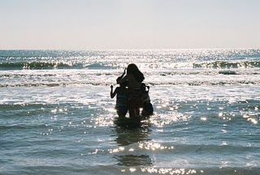
He turned away and paced the length of her bedroom. She watched his strong back and silently cursed fate.

“Sometimes I wonder if you look at me and wish I was her. I wonder if you wish I’d been the one in the water instead.”

He immediately spun around and came to her, grabbing her arms and pulling her against his chest. “That’s not true. I’ve never…never, felt that way about you. What Angela did, she did to herself. It had nothing to do with you.”

Tears burned the back of her throat. Guilt ached like a knife in her chest and she almost couldn’t get the next words out.

“Sh-she told me.”

He frowned and loosened his grip slightly. “Told you what?”

“She told me she wanted to die. She said she had been thinking about killing herself and I tried to talk her out of it.”

“Did you know she was going out on the boat that night?”

“No. We’d been up all night, drinking wine and talking about stuff. I passed out and when I woke she was gone.”

He continued to look into her eyes a heartbeat longer, then pulled her fully into his arms.

“Oh, honey, it’s not your fault anymore than it’s mine. We were closest to her and couldn’t stop her from leaving us. It was her choice.”

Nerina sobbed against his chest, releasing the guilt and pain she’d been holding the past two years. He rubbed her back and let her cry, holding her up when her knees weakened. After what felt like an eternity, there was a sharp knock on the door.

“Shit, I guess they finally noticed we’ve been missing,” he said.

She sighed and moved out of his arms, turning away to wipe her face with her hands. Kegan opened the door and had a quiet conversation with Mark, then closed and locked the door again.

“Hey, birthday girl, the party is winding down. Mark and Luke are herding out the stragglers. They’ll lock up behind them here in a few minutes.” She nodded but kept her back to him. “You haven’t opened your presents.”

A sigh escaped as she realized what a terrible hostess she had been. The first part of the night had been spent sitting by the door waiting for Kegan to arrive. The second part had been spent holed up in her room with him. She would have many apologies to make tomorrow.

“I’ll do it later,” she mumbled.

“Not mine you won’t. Come on.”

He took her by the arm and dragged her out of her room. True to their word, Mark and Luke had gotten everyone out the door and locked up. A few beer bottles and empty plates strewn around the house proved a party had taken place but it was over now. She was officially twenty-five.

Kegan led her to a table shoved in one corner of the living room where colorful bags and packages were displayed. Her birthday gifts. There were about a dozen in various shapes and sizes, and he took the smallest one from the pile.

“I wasn’t kidding when I said I’d had a hard time getting your gift. I wanted something unique and beautiful, like you. That was damn near impossible. So, I settled for something important instead.”

He handed her a flat, rectangular purple box. She untied the bow holding it closed and opened it warily. It was the type that typically held expensive jewelry but there was only paper inside. “What’s this?”

“Read it.”

She took the paper out and realized it was a computer print out of an itinerary.

“I don’t understand.”

“He took the box and paper from her hand and set them on the table, then pulled her into his arms again.

“We’re going on a trip.”

“Where?”

His slight hesitation made her wary. “Galveston.”

She sighed and tried to pull away but he tightened his grip.

“No, wait. Listen to me, Nerina.”

“I don’t want to go there ever again.”

“Me either, but that’s why we should.”

She stopped struggling but kept her face averted, stubbornly refusing to face him. “I don’t want to.”

He huffed out a breath and pressed his mouth to her cheek. “We’re going to say goodbye, honey. I’m going to rip this shirt into little pieces and toss it into the gulf. Then we’ll say goodbye to her once and for all, and start fresh.”

She finally faced him, almost afraid to hope. “We?”

“Yeah, you and I. I’m not letting you go without a fight, honey, and if Angela’s ghost is what’s getting between us then it’s time to do something about it.”

Hope was slow to come as she considered the past few months of trying to hold on to it. But this was the first time he’d mentioned saying goodbye to Angela, and he was even willing to get rid of the gray shirt. That had to count for something.

“Okay,” she finally said.

“Okay?”

“Yeah. Let’s do it. When are we going?”

He smiled and kissed her lightly. “You’re off tomorrow, right?”

*****
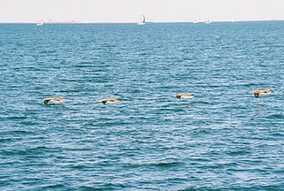
Kegan watched the waves lap against the seawall and inhaled a deep breath of salty air. He’d missed this the past few months, but the pain of returning wasn’t nearly as acute as he had feared. Nerina’s hand in his gave him strength and reminded him that he had too much in his future to keep living in the past. He had loved Angela but she had needed something he couldn’t give. What that was, none of their circle of friends had been able to find out, and now she was gone.

He’d made Nerina wait on him for way too long. The knowledge that he’d come close to losing her terrified him. Austin wasn’t that far away, but she would’ve started a whole new life there. She would’ve met another man that wasn’t being held back by a ghost. The fact that losing her was so much more painful than this goodbye only solidified his decision. It was time to start fresh.

They left the seawall and walked the beach all afternoon, then returned to the hotel for dinner. Nerina had been quiet most of the day and it worried him, but he knew she would open up when she was ready. As they took the elevator up to their room she finally voiced her thoughts.

“You only reserved one room.”

He smiled to himself. “Yes.”

“So…we’re both sleeping in one bed?”

“Yes.”

Agitation radiated from her in waves and he nearly laughed. This was what they both wanted and he knew it. They had waited long enough. They reached their floor and she remained silent as they entered the room. He picked up the remote and turned the TV on while she set down her purse and removed her jewelry.

“Oh, I love that song.”

Her admission brought his attention to the channel he had stopped on, where the video for Into the Ocean by Blue October was playing.

“Yeah?” he asked. “It’s kind of depressing isn’t it?”

She shrugged and kicked off her sandals. “It’s like a sad love song, I guess.”

He listened more closely to the words and set the remote on the nightstand.

“Sounds like it’s about surrendering your heart,” he said.

She shrugged again and watched him warily as he approached.

“Are you willing to do that, Nerina?”

“Surrender my heart to you?” He nodded. “I already have.”

Pleasant surprise filled him at her easy admission and grew into shock as she pulled her shirt over her head. He remained frozen in place as she unzipped her shorts and let them fall to her feet, then stepped from the puddle to stand inches away.

“Are you willing, Kegan?”

For a moment he thought she meant to get naked, but luckily he realized his mistake before answering. He pulled his shirt off and wrapped his arms around her waist, looking into her curious gaze.

“I’m more than willing, honey, I’m eager. I know I can trust you to hold my heart and care for it like I need. Just as I’m willing and able to do the same for you.”

Her amusement melted away and moisture filled her gaze. He kissed her before she could say anything else. It was a few minutes before he could think clearly again. The sweet taste of her mouth drowned him in sensation and he was reluctant to stop. Once he did, he lifted her into his arms and took her to the bed. He placed her in the center and hovered over her on hands and knees, just watching her wait for his touch.

“You are so perfect,” he whispered.

She smiled and ran her hands over his chest. “So are you.”

He grinned and looked at her black lace bra and panties. “I love you in black lace, honey, but I think I’ll love you even more out of it.”

She laughed breathlessly and unhooked the front clasp of her bra. He held his breath as her amazing breasts were slowly revealed to his starving eyes. He'd had fantasies about those breasts.

“Perfect,” he whispered.

As soon as her bra was out of his way, he bent his head and ran his tongue across one of her light brown nipples. She gasped and plunged her hands into his hair, holding him in place.

“Kegan…”

He had a thorough tasting of first one, then the other, before licking a path down her stomach. He nibbled on her navel, making her laugh and push on his head, before traveling further south. Her panties stopped his progress but he didn’t mind the interruption. He left the bed long enough to strip off the rest of his clothes and get a condom from his bag.

“Kegan?”

“Just a minute, honey, I don’t want to forget this.”

She smiled as he dropped the foil packet beside her and rejoined her on the bed.

“Now…where was I?”

She laughed again as he ran a fingertip beneath the top of her panties. He pulled them down slowly to reveal the prize beneath. His heart nearly stopped when he saw she was shaved bare.

“Damn. I’m going to die of pleasure just from looking at you.”

She shivered as he ran his fingers between her legs. He urged her thighs apart and took a moment to just stare.

“What are you doing?” she asked.

“Just looking at paradise, honey.” She laughed and rolled onto her side to face him. “Hey.”

“Hey nothing. Do you know how long I’ve waited for you to touch me? Let’s get this show on the road, cowboy. You can explore later.”

He barked out a laugh as she pushed on his shoulders until he lay flat on his back. Then she straddled him and picked up the condom.

“Honey, wait—”

“I don’t think so.”

She ripped open the package and made short work of covering his erection.

“But you’re not ready.”

“Are you kidding?”

“I mean…”

She laughed and moved up to rub herself against him. Moisture glistened on his covered cock, telling him she was definitely ready.

“I know what you mean, but trust me…I’m ready.”

His body was telling him to shut up and let her do as she would, but his heart was still unsure. He grasped her hips to slow her ministrations as she continued to thrust against him.

“Nerina…”

“Kegan, if you stop me, I swear I’ll…punch you in the mouth.”

He laughed and his hold loosened. She grasped his cock in one small fist, abruptly ending his amusement. He moaned as she began to stroke him. “All right, honey. Go for it.”

Her face brightened with his permission and he promised himself he would do whatever it took to always get that smile from her. Then she placed his erection at her entrance and slowly sank down. All coherent thought flew from his head as sensation took over. Tight, warm pleasure filled his mind and he groaned in surrender.

She set her hands on his shoulders and moved against him slowly. He let her set the pace as their bodies became acquainted. Her soft skin warmed his hands and he filled them with her breasts. She moaned as he teased her nipples before wrapping his arms around her and pulling against his chest.

“I can’t…move…like this,” she panted.

He thrust his hips upward to show he could continue their movement and held her head for his kiss. She let him control their pleasure for a little while, but soon took over again. She kissed him one last time before sitting up to increase their tempo. He let her ride his cock and watched pleasure wash over her face. She was glorious, with a light sheen of sweat beading on her tanned skin. Her dark brown hair fell in waves to her waist, brushing his thighs when she threw her head back.

He grasped her hips and increased the tempo yet again, urging her to climax. Her fingertips dug into his chest and she closed her eyes. He knew she was close. He slipped a hand between them and found her hardened clitoris, rubbing it with his thumb. She cried out as an intense orgasm washed over her, clenching her feminine muscles. He gasped when the grip on his cock tightened and in the next heartbeat joined her in ecstasy.

He held her against his chest and listened to her breathing slow to normal. This was what had been missing in his life. He’d needed to hold her, to love her and know that she loved him. She hadn’t said it but it had been in her gaze, in her voice and in every touch they had shared for months. He would be forever grateful that he’d realized it before it was too late.

She stirred against him and he tightened his hold. He didn’t want to relinquish her warmth just yet.

“We should shower,” she mumbled.

He chuckled. “Yeah, probably.”

“Do I have to get up or will you carry me?”

“I’ll carry you, honey, but I want to tell you something first.”

“What?”

“Thank you.”

She lifted her head and looked into his eyes. “For the sex?”

He chuckled again and shook his head. “The sex was amazing, but that’s not what I’m thanking you for.”

“Then what?”


“Not giving up on me. You know, the more I think about that song we were listening to earlier, the more I realize just how lost I was. I kind of felt like that, you know? Like I just wanted to float away because no matter how hard I swam I couldn’t make it to shore. But even on my darkest days you were always the beacon that brought me back.”

She sniffed and placed a kiss on his chin. “I’m glad I could. You’re welcome.”

He smiled. “I love you, Nerina.”

Surprise lit her gaze before a small smile brightened her face.

“I love you too, Kegan.”

“I know, honey, and I’ll be forever grateful that you do.”
He kissed her thoroughly before carrying her to the shower.

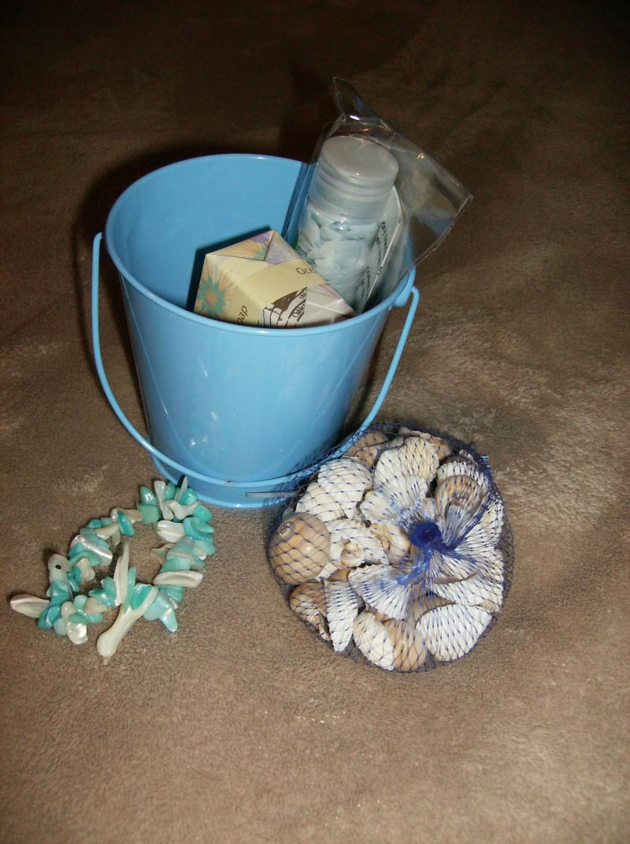
**********

Ms. Missy Jane is a native Texan, mother of four and wife of fifteen years. Her most recent release is an erotic short story available through Ellora's cave, titled Educating Macey.

*Make reading a guilty pleasure...*
www.msmissyjane.com

