 | Steps and Ways of drawing faces
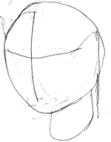 | Using the geometrical figure technique, here is a model of the head. This is simply to give loose cordinates. This here doesn't have to be anything complicated, or accurate. With practice, you'll be able to do this in your head, and visualize these lines on the paper. Then, you can skip the step.
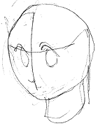 | draw in a very loose and quick sketch of eyes and nose. this doesn't have to be detailed at all. As a matter of fact, I strongly advise you AGAINST drawing detailed works at this stage. This is simply to give you an idea of where the eyes and the nose will be. Here, I drew a generic slanted-down eyes, but it can be anything. It's a positioning techniques, so I can change the eyes to a slanted-up eyes later, when I draw in the details, if I want to.
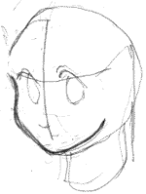 | here I gave the edge of the face a definition. the curves of the faces follow the eyes-nose-mouth positioning. This is an important point. You can do vice versa, meaning drawing the curves first, then drawing the eyes-nose-mouth following the curves. Which comes first differs with artists, but always make the other follow the other.
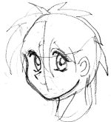 | now I started drawing the details of the eyes, as well as giving the nose and the mouth a stronger definition. I have also made quick rough sketch of the hair. Again, this is a loose rendering, and doesn't have to be accurate or detailed. It's suggesting where and how the hair might be. Also the loose sketch of the ears are added.
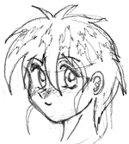 | Now the rest of the details are drawn in to make this picture a sucessful rough sketch. At this stage, clean up the unwanted lines, such as the sphere and its suggestive lines.

