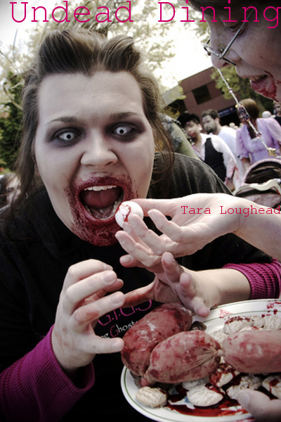

Undead Dining
by Tara Loughead

Smashwords Edition

Copyright 2010 Tara Loughead

"Welcome to the Crimson Okra restaurant, gentlemen. You are here for our renowned special, I believe?"
"Yes, yes we are," answered the diner seated directly opposite the the black-tie clad Head Waiter. Behind this first guest, seen through splendid glass doors, the sun was rapidly setting.
"Here are your menus then gentlemen." He passed the well-dressed quartet their fancily embossed lists from a bundle under his arm. "Can I interest you in drinks?"
"Sure, bring us a couple of bottles of sparking shiraz to start with."
"Certainly, sir," he replied, motioning to a waitress, who nodded and headed for the bar. "Now, while you wait, I'd like to draw your attention to the conditions." He opened a menu, and indicated a block of text at the bottom. "In particular, guests are reponsible for their own drycleaning. Bloodstains included."
"Bloodstains?" The second diner. "Oh." Recognition dawned.
"Yes, sir. Your party's booking indicated that this was your first time dining with us?"
"Right." The third man, looking slightly nervous.
"If you look inside the pocket at the rear of your menu, you will find a waiver and souvenir pen. Please fill it out while I continue." He paused to check they understood. "Gourmands of your sophistication no doubt are familiar with the Japanese fugu? Precise preparation by expert chef, otherwise potentially fatal consequences?"
"Sure, I had that in Osaka," said the fourth, handing over his waiver.
"Well then, the same applies for the special. I can reassure you that our head chef is world class, and will prepare it for you personally."
"Zombie cooking expert then, is he?"
"Indeed, sir. Although at the Crimson Okra we prefer the term 'Reanimated'." He cleared his throat. "Now, as you are aware, eating such a delicacy improperly cooked will result in, shall we say, a terminal condition--however, unlike fugu there is an additional complication." He now had their undivided attention. "Experiments after the end of the Reanimate Virus Wars showed that a small percentage of the population have a genetic condition. Any ingestion _at all_ of reanimated brains will have unfortunate consequences."
The first guest gulped. "Ah...and in the event of this undesirable outcome?"
The head waiter turned, gesturing with his left hand in the direction of the raised platform along the side wall. They saw a muscular young woman clad in sleeveless shirt and butcher-style apron, standing attentively, hands clasped behind her back. With a slight, knowing smile, she tilted her head backwards, indicating the brackets mounted on the wall directly above.
Therein, the last rays of the setting sun glinted off the shining head of a very large and very sharp steel axe.

The End

Cover photography by Zenobia Joy
http://www.flickr.com/photos/zenobia_joy/4008563841/
http://creativecommons.org/licenses/by/2.0/deed.en_GB

JEKKARA PRESS

You can find out more about the Adventures of Bulays and Ghaavn at the Jekkara Press wordpress website:
http://jekkarapress.wordpress.com
or the blogger website:
http://jekkarapress.blogspot.com

You can find all of the Adventures of Bulays and Ghaavn as well as The Gender Switch Adventures at :
http://www.smashwords.com/profile/view/jekkarapress

Whethere you prefer html, text, epub, mobi, kindle, pdf or rtf formats, Smashwords has them all.

Coming Soon

The Adventures of Bulays and Ghaavn
13 Skathi-Tooth: The Karshi Imperative Part 2 - Tara Loughead

The Gender Switch Adventures
A Witch Shall Be Born Once More [Conyn the Barbarian] – Roberta E. Howard
Shadow Kingdoms Fallen [Kell] – Roberta E. Howard
Sargasso of Lost Starships Rehidden – Poula Anderson

