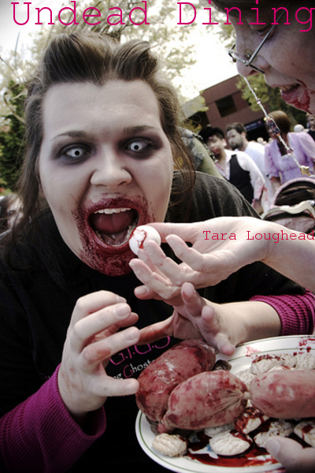

Undead Dining
by Tara Loughead

Smashwords Edition

Copyright 2010 Tara Loughead

"Welcome to the Crimson Okra restaurant, gentlemen. You are here for our renowned special, I believe?"
"Yes, yes we are," answered the diner seated directly opposite the the black-tie clad Head Waiter. Behind this first guest, seen through splendid glass doors, the sun was rapidly setting.
"Here are your menus then gentlemen." He passed the well-dressed quartet their fancily embossed lists from a bundle under his arm. "Can I interest you in drinks?"
"Sure, bring us a couple of bottles of sparking shiraz to start with."
"Certainly, sir," he replied, motioning to a waitress, who nodded and headed for the bar. "Now, while you wait, I'd like to draw your attention to the conditions." He opened a menu, and indicated a block of text at the bottom. "In particular, guests are reponsible for their own drycleaning. Bloodstains included."
"Bloodstains?" The second diner. "Oh." Recognition dawned.
"Yes, sir. Your party's booking indicated that this was your first time dining with us?"
"Right." The third man, looking slightly nervous.
"If you look inside the pocket at the rear of your menu, you will find a waiver and souvenir pen. Please fill it out while I continue." He paused to check they understood. "Gourmands of your sophistication no doubt are familiar with the Japanese fugu? Precise preparation by expert chef, otherwise potentially fatal consequences?"
"Sure, I had that in Osaka," said the fourth, handing over his waiver.
"Well then, the same applies for the special. I can reassure you that our head chef is world class, and will prepare it for you personally."
"Zombie cooking expert then, is he?"
"Indeed, sir. Although at the Crimson Okra we prefer the term 'Reanimated'." He cleared his throat. "Now, as you are aware, eating such a delicacy improperly cooked will result in, shall we say, a terminal condition--however, unlike fugu there is an additional complication." He now had their undivided attention. "Experiments after the end of the Reanimate Virus Wars showed that a small percentage of the population have a genetic condition. Any ingestion _at all_ of reanimated brains will have unfortunate consequences."
The first guest gulped. "Ah...and in the event of this undesirable outcome?"
The head waiter turned, gesturing with his left hand in the direction of the raised platform along the side wall. They saw a muscular young woman clad in sleeveless shirt and butcher-style apron, standing attentively, hands clasped behind her back. With a slight, knowing smile, she tilted her head backwards, indicating the brackets mounted on the wall directly above.
Therein, the last rays of the setting sun glinted off the shining head of a very large and very sharp steel axe.

The End

Cover photography by Zenobia Joy
http://www.flickr.com/photos/zenobia_joy/4008563841/
http://creativecommons.org/licenses/by/2.0/deed.en_GB

Email : taraloughead@gmail.com

Jekkara Press

You can find out more about the Adventures of Bulays and Ghaavn at the Jekkara Press wordpress website

http://jekkarapress.wordpress.com

And you can find this book and other Tara Loughead books in html, text, epub, mobi, kindle, pdf and rtf formats at Smashwords :-

https://www.smashwords.com/profile/view/jekkarapress

Also by Jekkara press

The Adventures of Bulays and Ghaavn currently include:

01 Blood Demons of Titan - Tara Loughead

The warriors Bulays and Ghaavn hunt demons and their master through the dim and dusty streets of Barnes, on Titan. Can they stop him before he completes a devastating ritual?

02 Death Queen of Neptune - Tara Loughead

Bulays and Ghaavn are called in to investigate why a frontier base on Neptune has gone silent. Ice monsters and an ancient, beautiful evil await.

03 She Devils of Europa - Tara Loughead

One of the richest women in the Solar System asks Bulays and Ghaavn for help in stopping a series of thefts. There is a mystery to solve at the most expensive resort in existence, The Europa. Larceny, magic and dancing await, in an all expenses paid evening.

04 Shadow Emperor of Phobos: The Martian Moon War Part 1 - Tara Loughead

Bulays and Ghaavn try and stop a underworld shooting war. First they must get past a Martian Shadowcat, employ surprising combat techniques, and try and reason with Ghaavn's criminal mentor.

The Gender Switch Adventures

The Devil In Iron, Respawned [Conyn the Barbarian] - Roberta E Howard

Any resemblance to Robert E. Howard's Conan is completely intentional. A resurrected demon menaces Conyn on an island fortress, along with other monsters.

The Pool of the Black One, Reswum [Conyn the Barbarian] - Roberta E Howard

Any resemblance to Robert E. Howard's Conan is completely intentional. Conyn, a pirate, puts herself in charge and investigates a strange island with mystic waters.

Jewels of Gwahlur, Reboxed [Conyn the Barbarian] - Roberta E. Howard

Any resemblance to Robert E. Howard's Conan is completely intentional. Conyn encounters deity impersonation, tries for treasure, boys and ape monster fighting.

Stand Alone

Undead Dining - Tara Loughead

A very short horror story about a very different restaurant.

Coming Soon

The Adventures of Bulays and Ghaavn

05 Desert Empress of Deimos: The Martian Moon War Part 2 - Tara Loughead

The Gender Switch Adventures

Red Nails Polished (Gender Switch - Conyn the Barbarian) - Roberta E. Howard
Beyond the Black River, Recrossed (Gender Switch - Conyn the Barbarian) by Roberta E. Howard
Queen of the Black Coast, Recrowned (Gender Switch - Conyn the Barbarian) - Roberta E. Howard

Queen of the Martian Catacombs, Recrowned (Gender Switch - Erica Joan Stark) - Lee Brackett
Black Male Amazon of Mars (Gender Switch - Erica Joan Stark) - Lee Brackett

Song In A Minor Key, Retuned (Gender Switch - Norawest Smith) - Cathan L. Moore

The Tree of Life, Revisited (Gender Switch - Norawest Smith) - Cathan L. Moore

The Valor of Cappea Verra, Recapped (Gender Switch - Cappea Verra) by Poula Anderson

If you prefer:

Also at Scribd :
https://www.scribd.com/jekkarapress

or Wattpad :
https://www.wattpad.com/user/jekkarapress

