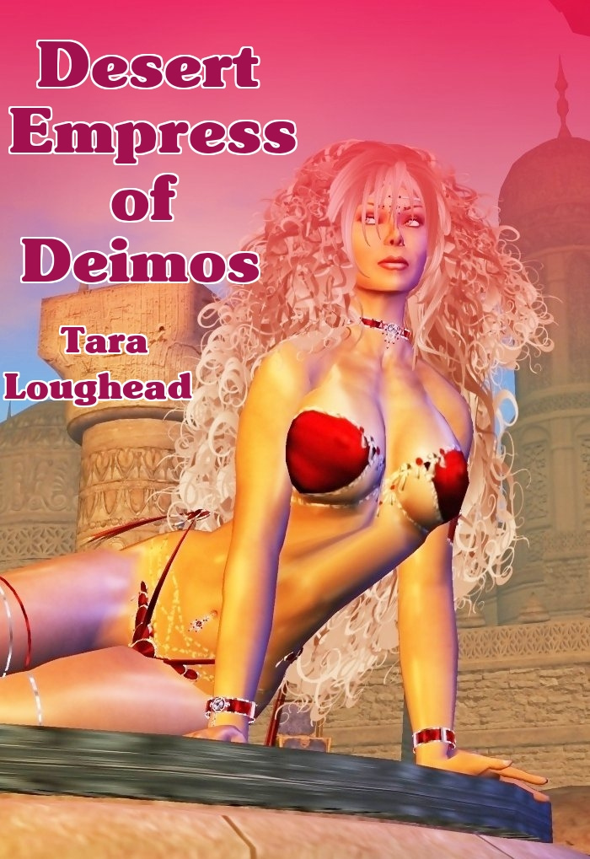

Desert Empress of Deimos

Tara Loughead

Smashwords Edition

Copyright 2010 Tara Loughead

For Leigh Brackett

The Martian Moon War, Part Two

"Diving into that space wreck has cost us quite a lot of time, Bulays."
"Tell me about it. That projectile vomiting matron who couldn't handle the zero-G wasn't much fun, either."
"Yes, it appears you have a talent for attracting the nasty green stuff," grinned Ghaavn. He turned his attention to his headset communicator. "How long until we reach Deimos, Captain?"
"About 20 minutes until you'll be in shuttle range, Ghaavn. So get your gear together and get down there," answered Buck. "Lady G asked me to tell you that she has cleared things with Dahminike. You shouldn't have any amateur lion taming to do on this trip." She chuckled, then cut the communication.
***
Looking back at their newly landed shuttle, Bulays remarked: "Definitely more civilised, parking near the front door."
Ghaavn nodded in reply. "Said front door is still heavily guarded, though. So take it easy." Two heavily armed and red battle-armour clad women stepped out from a well-fortified gate to meet them. "We're expected," said Ghaavn, showing his Ministry credentials. The pair stepped apart, and let them through.
Through the gate they were met by a woman in orange-hued leather, just a shade darker than the flaming mane of hair she possessed. "I am Pira, Dahminike's battle commander."
"We're here to try and make your job less interesting, Pira. Can we see her?"
"Yes. She will be available shortly, and asked me to meet you."
"We appreciate your time, Commander. We possibly don't have very long, however. As far as I am aware, Dargolm and Dahminike command similar forces. Is that actually the case?"
"Pretty much. I'd prefer not to get any of my girls or boys killed, though. Unless it is by me when they deserved it."
Bulays laughed. "Lady, I think I like your style. After this is over, drinks are on me."
Pira appraised the tall blonde black body-armoured Amazon of Earth, looking her up and down. "Sounds good to me. Right this way then. She'll be finished now, I reckon."
***
The chamber Bulays and Ghaavn entered at Pira's direction was a warm, earthy colour. The woman seated on the throne at the far end, was golden-skinned. Her wavy white-blond tresses reached all the way to her hips. She wore the briefest of red-satin bikini panties, with red metal bracelets, collar and thigh rings. Adorning her breasts were little more than two large nipple shields of similar satiny material. "Come, Ghaavn," she called, beckoning the two warriors forward. They complied. "I know you find all this old fashioned, but it is ancient tradition." She held out her hands to either side of her body, palms upward. Indeed, her attendants wore even less. Bare-breasted, the women to either side of her had gauzy skirts, and around their brown-skinned ankles tiny golden bells could be seen. The occasional faint chime of such could be heard as they shifted position. The pole arm-bearing male guards in each corner of the chamber had uniforms that covered almost as little. Leather harness straps, and sandals. The steely expressions on their hard, red faces matched the dull scarlet metal of the armoured codpiece that was their only other accoutrement.
"It's been a long time, Dahminike. So I'll cut to the heart of the matter. As I suspect that may be what this involves. Where is Rhogan?"
"The boy is here, Ghaavn. Yet it is not what you may think." Her eyes gleamed with the dangerous light of the ruler that knows she commands. "Pira is bringing him now."
"He's hardly a boy any more, Dahminike. He is not much younger than I am."
Suddenly the woman laughed, very clear and ringing. "You've definitely grown up, Ghaavn, from the boy I used to so delight in teasing as a teen."
Bulays raised an eyebrow at this. "You managed to stay out of this golden creature's clutches then? Well done."
"I did want to live, after all." Her partner replied, smiling. At that, the doors opened again and Pira returned. She brought a man and a woman, dressed in a similar manner to the commander herself. However, the man's bodysuit was green and gold, and the woman's purple and indigo. She carried an energy staff. He had a needle gun on his hip. Both shared similar auburn hair, although for someone of his age, his was going a very early white down the middle.
The man separated from the two women, running up to Ghaavn, and grabbing him in a bear hug, then kissing him happily on the lips. "Ghaavn!" He cried. Then his enthusiasm dimmed. "Wait...did my father send you?"
"You should know better than that, Rhogan. I was never Dargolm's errand boy. That is why I left." Ghaavn's rejoinder left the younger man thinking briefly. Bulays thought she could almost see the effort that this took him, clearly not the brightest bulb.
"Ok...." He paused. "Right you are, then." He waved to the younger woman that had entered with him, and she moved to him. "There's someone I want to you meet.". He put his arm around the lithe woman now standing beside him, a devilish red glint in her brown eyes. "This is Rema."
"Hello." She said, with a golden-skinned red-lipped smirk.
The true reason for the conflict was now obvious to both Bulays and Ghaavn, as they eyeballed Dahminike's daughter.
"Let's fill 'er in then love." Bulays said, indicating Pira. "Ghaavn knows the whole story, I don't."
"What do you mean?" Growled the Commander.
"I mean your boss might be getting some of your lot killed for no reason," Bulays replied. As Ghaavn started to speak, Dahminike began to rise, an angry look on her face.
"Sit down!" Ghaavn commanded. The force of his tone and the cold gray look in his eyes ensured that she did. "Unlike times past, I am definitely big enough to spank you, now. Except I wouldn't, because you'd enjoy it too much. I'd get Bulays to do it. I knew you could be a spiteful spoiled little hellcat, but even you should have grown out of that by now, having a business empire to run. This is about what Dargolm did in the past, isn't it? You decided to have your daughter return the favour, with his son."
"Yes," she flashed back. "The stupid girl wouldn't see it through, though. She actually really likes that thickhead." Now Rhogan started to get mad. He grabbed Rema's arm. "What's she talkin' about?"
"It's true, Rhogan. Mother dearest asked me to break yah heart. I couldn't do it, because I find your damn green and gold arse so sexy it makes me want to hump something even right now. That's why I stayed. I love yah, you dumbo." With that, she grabbed him and gave him a big, tongue-enfolding kiss.
"What neither of you young lovers have realised is that during your time together here she has been censoring communications. You've probably spent too much time in bed to notice. Your father has been trying to contact you, but Rema's mother has manoeuvred this situation into looking like she has been holding you here. Which of course she could, if her daughter was still on her side, and not yours. She's had to approach it a bit more delicately than that."
"I thought he was just ignoring me, like in the past."
"She's right about one thing, Ghaavn. He's not too bright." Bulays put in.
Ghaavn went and took his old friend by the shoulders. "She's using you to make your father look weak. With your rank now in his organisation, if it looks like you've gone missing, he has to act. Especially with another organisation involved. He's been trying to stall, but has run out of time."
He went on. "Your father has never married, man or woman. Which is somewhat odd, given the power and influence that can come from these arrangements between crime families. He's never told you why, has he?"
"No, he won't. I've asked." Rhogan said.
"I was just old enough at the time to have an idea something was going on, but no-one knew what. I pieced some of together later, with the help of the Ministry's databases. Had no reason to go to this effort, until recently. When you were a kid, Dargolm and Dahminike had been seeing each other for a while."
"WHAT?!" Interjected an astonished Pira. Dahminike sat there stony-faced, arms folded across her breasts, legs crossed.
"They'd been talking about a way to bring it out in the open. With a big romantic evening planned to discuss it further, among other things."
"Little miss gilt and scarlet there 'd been looking forward to being wined, dined and mined, to put it politely," added Bulays helpfully.
"Yes," said Ghaavn. "Only he never showed. She couldn't reach him, and stormed off in a vicious rage, after waiting many hours. Not a patient woman your mother, Rema, as you are probably aware. Not hearing from him the next day didn't help, either. So she cut him dead."
"A vindictiveness I don't share, thank the Purple Priestess," said Rema into the ear she was nibbling on, arms around Rhogan's neck.
"What she didn't know," said Ghaavn, "was that there had been an accident. They had to literally cross worlds to see each other, and it was harder in those days. Dargolm was fine, but he stayed to help with the injured, having some combat medical training and no problems in space. His ship did lose communications, too.
When he did manage to make it to Deimos, she refused to talk to him. This is when the bad luck hit, making things much worse. Dargolm picked a bar to drown his sorrows in Mercurian whiskey. The problem was, it was down the street from a club. When he staggered out, he saw Dahminike basically being dragged out of a club, drunk, draped between a man and a woman."
"Yep. Not only did your mum display the emotional maturity of a thirteen-year-old, she got caught goin' to a game of tag-team 'ide the truncheon." Bulays again embellished.
"What's worse was that the man was a Patrolman. A cop. Dargolm cared enough not to want her disgraced by her family with this, so he didn't say anything. He just went home, and grew colder."
A sob escaped Dahminike's lips. Her face in her hands, long hair flowing around. As she did, a voice rang out over a wall speaker. "Red alert. We've got incoming." Ghaavn went to her side, shook her. "Pull yourself together. You're in charge. Make up for it. Keep these people alive."
To her credit, she did, snapping orders to her guards.
Bulays turned to Pira, and took her arm. "We can help."
Ghaavn joined his partner. "If you have long range defenses, have someone take Bulays there. I'll be more use on a ground team."
"Yep. Never did get to bullseye enough two metre long Moon rats back home. Even those shootin' back."
"Right," said Pira. "Rhogan, take Bulays to a minaret, then come back here. You cannot get hurt, above all else, now. Rema, take Ghaavn with you. Get him a staff. I'm taking my flame squad out."
***
"I got one!" shouted the quad-gunner.
"Great, kid. Don't get cocky." Bulays shot back as she spun to face him. "It isn't over." It was for the planetary assault flier in question though, just as the barely-not-a-farmboy defender had exclaimed. Trailing smoke, it headed for the ground.
"We've got incoming at two o'clock!" blared the voice from the speakers in the gun battery emplacement, proving Bulays right as well. A considerably larger, black craft approached, and they turned back to their task.
"HOLD YOUR FIRE!" Commanded the voice from the speaker. It was Dahminike. "That's Dargolm's Raven! Let them land. Find Pira and have her escort their party in. Feel free to burn down anyone hostile where they stand."
"Looks like you've got those covered, kid." She rose, giving him a quick peck on the cheek. "Good job. I'll go and see if I can help the so-called grownups stay out of trouble."
***
Bulays ran into a sweaty and tired Ghaavn near the entrance. He was helping Rema get the remnants of the crimson sand out of her hair. She reciprocated after directing the rest of the squad to deal with the battered and bloody prisoners they had brought in. "She's good with that staff, Bulays. We should invite her and her fiancé to train, sometime."
"Keeping secrets is a trait you do share with yer mum then?" Bulays smiled.
Rema grinned, pulling off her leather half-helmet, and shaking her hair free. Her eyes widened, and she pointed.
Pira had returned. With her and her surrounded by her orange-suited flame squad were three others. Two men, and a woman, all currently unarmed, with hands in the air. One of the men was the blue-skinned Margalt. The second was a freedom force squad leader that Bulays and Ghaavn definitely recognised. The third was the Shadow Emperor of Phobos.
"This'll be good," Bulays smirked, as all eyes turned to watch the escorted get marched in. The partners and Rema couldn't wait to follow.
***
Dargolm stood in front of Dahminike, in her throne room, surrounded by armed guards, the atmosphere electric. He wore even less than she did, slender shorts concealing little.
"Stand down," ordered the Desert Empress of Deimos of her warriors. They did, and Dargolm raised his hands to shoulder height, palms outward to indicate his peaceful intentions. Then, like lightning, he grabbed Dahminike, and kissed her hard. The guards tensed, but she reciprocated with equal fervour, hands exploring his muscular blue back. Suddenly she pushed him off and landed a very solid left cross to his jaw, followed by a nice right jab to his stomach. She couldn't kick him to any effect, as her feet were bare. Otherwise she would have.
Dargolm rubbed his jaw. "Ow."
"Why didn't you do that all those years ago?"
"Come and be your punching bag?"
"No, you big blue-skinned idiot freak." She stamped her foot, eyes flashing. She tore off her brief costume and leaped naked into his arms, yelling. "Everybody out! Thirty seconds ago! Drinks are on us. Go!" She gestured frantically to her attendants, but could no longer speak, mouth occupied.
Rapid evacuation followed, her personal guard taking up position outside the door.
***
"He did have pants on this time," Bulays observed, arms around the shoulders of both Ghaavn and Pira, as they settled in for the first round. Rhogan was lounging across Rema's lap, head under her breast, happily being fed olives.
"Probably for about five or six seconds," replied Ghaavn mirthfully, eyes twinkling.
His blonde partner drained her glass and stood, pulling Pira to her feet. "Come on hot stuff. We've got a certain farmboy gunner to corrupt." The answering smile crinkled the corners of Pira's eyes nicely. As Bulays was dragging her off, arm around her waist, Pira reached back to snag a bottle. Ghaavn passed her another. As they exited, Ghaavn called over to the corner, where Margalt and the squad leader were sitting quietly, nursing a beverage. "Margalt, room for two over here now." The blue man and soldier moved to join them. "Now, Rema, if you are going to get married and drain some of that mobster cash out as presents, better do it soon. Your mother's got the makings of a monster bride."
The table cracked up at that.
***
Dahminike put her arm across Dargolm's chest, as they lay on a sumptuous floor rug, sheened by sweat. "How should I have your traitorous underlings executed then, my blue lover?"
"I had something far, far worse in mind for them." He gave a lustful, evil grin.
"Oh?" She enquired, running a scarlet-nailed hand down his flank, and snaking it across to his groin, fondling.
"Yes. I was going to give them to you, to be flunkies for your wedding planner. That is a much more slow and painful expiration."
Dahminike laughed throatily, as thanks to her ministrations she moved to mount her new fiance yet again.
***
"You know how they say you can't teach an old dog new tricks?" Bulays said, pausing. "In Pira's case that's certainly right." She rubbed her aching thighs. "She got me. I think the farmboy might sleep for two days straight. D&D still haven't come out yet either. If Rhogan takes after dad, no wonder Rema likes him."
Ghaavn laughed, as he piloted the shuttle to rendezvous with the Northhound.

The End

Artwork by Kim Dench

http://www.flickr.com/photos/kim_dench/2613528859/in/set-72157605831078436/
http://creativecommons.org/licenses/by-nc/2.0/deed.en

Jekkara Press

You can find out more about the Adventures of Bulays and Ghaavn at the Jekkara Press wordpress website:

http://jekkarapress.wordpress.com

And you can find this book and other Tara Loughead books in html, text, epub, mobi, kindle, pdf and rtf formats at Smashwords :-

https://www.smashwords.com/profile/view/jekkarapress

Also by Jekkara press

The Adventures of Bulays and Ghaavn currently include:

01 Blood Demons of Titan - Tara Loughead
The warriors Bulays and Ghaavn hunt demons and their master through the dim and dusty streets of Barnes, on Titan. Can they stop him before he completes a devastating ritual?
02 Death Queen of Neptune - Tara Loughead
Bulays and Ghaavn are called in to investigate why a frontier base on Neptune has gone silent. Ice monsters and an ancient, beautiful evil await.
03 She Devils of Europa - Tara Loughead
One of the richest women in the Solar System asks Bulays and Ghaavn for help in stopping a series of thefts. There is a mystery to solve at the most
expensive resort in existence, The Europa. Larceny, magic and dancing await, in an all expenses paid evening.
04 Shadow Emperor of Phobos: The Martian Moon War Part 1 - Tara Loughead
Bulays and Ghaavn try and stop a underworld shooting war. First they must get past a Martian Shadowcat, employ surprising combat techniques, and try and reason with Ghaavn's criminal mentor.
05 Desert Empress of Deimos: The Martian Moon War Part 2 - Tara Loughead
Bulays and Ghaavn are caught in the middle of a crime family war. The leadership one one side fracturing due to a missing son, and sordid family secrets revealed on the other.

The Gender Switch Adventures

The Devil In Iron, Respawned [Conyn the Barbarian] - Roberta E Howard
Any resemblance to Robert E. Howard's Conan is completely intentional. A resurrected demon menaces Conyn on an island fortress, along with other monsters.
The Pool of the Black One, Reswum [Conyn the Barbarian] - Roberta E Howard
Any resemblance to Robert E. Howard's Conan is completely intentional. Conyn, a pirate, puts herself in charge and investigates a strange island with mystic waters.
Jewels of Gwahlur, Reboxed [Conyn the Barbarian] - Roberta E. Howard
Any resemblance to Robert E. Howard's Conan is completely intentional. Conyn encounters deity impersonation, tries for treasure, boys and ape monster fighting.
Queen of the Black Coast, Recrowned [Conyn the Barbarian] - Roberta E. Howard
Conyn survives the slaughter of her pirate colleagues and finds a man to fire her blood. Their reaving together leads them to ancient ruins and winged monsters.

Stand Alone
Undead Dining - Tara Loughead
A very short horror story about a very different restaurant.

Coming Soon

The Adventures of Bulays and Ghaavn

06 Heart Breakers of Hyperion – Tara Loughead

The Gender Switch Adventures

Red Nails Polished (Conyn the Barbarian) - Roberta E. Howard
Beyond the Black River, Recrossed (Conyn the Barbarian) by Roberta E. Howard

Queen of the Martian Catacombs, Recrowned (Erica Joan Stark) - Lee Brackett
Black Male Amazon of Mars (Erica Joan Stark) - Lee Brackett
Song In A Minor Key, Retuned (Norawest Smith) - Cathan L. Moore
The Tree of Life, Revisited (Norawest Smith) - Cathan L. Moore
The Valor of Cappea Verra, Recapped (Cappea Verra) - Poula Anderson

If you prefer, you can find Jekkara Press books at:

Feedbooks:
http://www.feedbooks.com/user/97010/profile

Also at Scribd :
https://www.scribd.com/jekkarapress

or Wattpad :
https://www.wattpad.com/user/jekkarapress

