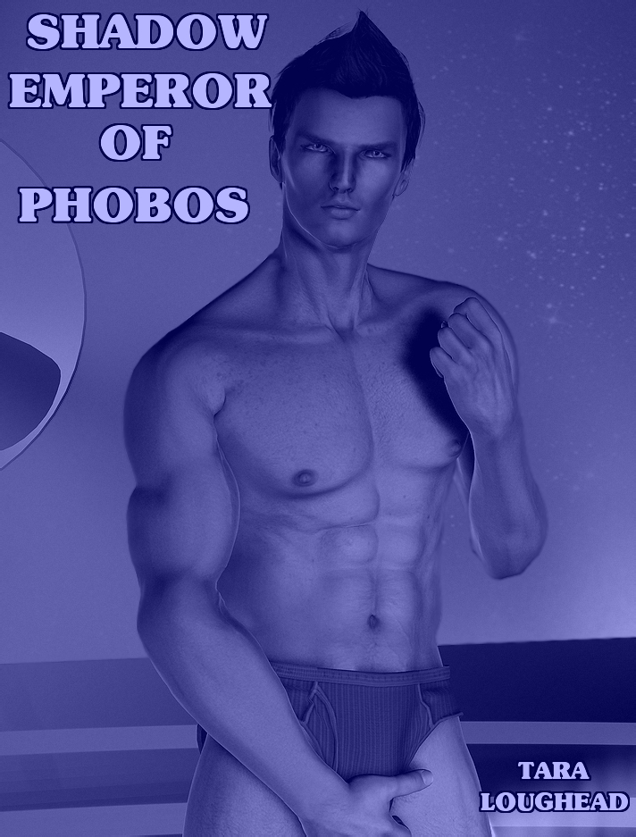

Shadow Emperor of Phobos

Tara Loughead

Smashwords Edition

Copyright 2010 Tara Loughead

For Dave Cockrum

The Martian Moon War, Part One

Bulays slung the rifle over her shoulder as she exited the shuttle. "We have to slog through rocky desert, even though we're invited?" Asked the tall blonde woman in desert gear and boots.
"Yes, part of the little games he likes to play," replied Ghaavn, her shorter partner. "Test of worthiness, and all that."
"Right, let's get on with it then." She said.
The shorter, darker man looked out over the hazardous sandy terrain. "Today's sport will involve a Martian shadowcat."
"Pretty rare beastie, isn't it?"
"Yes, but some still live on Phobos. The Thaumoforming has actually been beneficial for them."
"Pretty sure by the sounds of it he isn't really into zoology or ecology."
"No, he mostly just likes what they can do to people. We need to find a spot to set up, and draw it out."
"That's the part I'm worried about, love."
"You know you are much better with a long gun, Bulays. So that leaves the bait role to me."
Ghaavn carefully led the pair out into the crumbling and reddish sandy terrain.
***
"That outcrop there looks like a good spot." Ghaavn pointed in the direction of a rocky column, about ten metres high. Wiping sweat from his forehead, he observed that the top of the formation was relatively flat, with a small rise to the side they were viewing from.
"Looks climbable," she agreed. "So I'm off."
Ghaavn sat briefly with his back to a large rock, to rest for a minute until Bulays was in place. He took a long swallow of water from his canteen, then put it on the ground with the rest of his gear. Digging into his pack, he pulled out a small, black rectangular electronic device.
Receiving the signal from Bulays that she was ready, Ghaavn activated the machine, and stood. He drew his bolt thrower from its holster with his right hand, and the combat knife at his waist, with his left.
An eerie, crying screaming howl came from the small piece of audio equipment. It rose and fell, the mournful bestial noise echoing among the rocks.
Ghaavn crouched; combat ready, keeping his back to the dusty crimson rocks behind him.
He didn't have to wait long. A large shadow leaped over his head, landing on the ground in front of him. It landed snarling. Something like a tiger, but a little larger, and with pointier ears. No orange, though. The patterns striping this animal were a shadowy blue black, with hints of crimson and brown. The dark stripes across its eyes made it look like it was wearing a mask. Tail twitching, it looked at Ghaavn, growled, then sprang.
Ghaavn fired. His bolt hit the creature in the chest, and passed straight on through the beast, clattering off the rocks as he jumped to is right and rolled.
Bulays had been ready. As soon as Ghaavn fired, she took her shot. The big feline screamed in pain as a crackling energy field enveloped him. It wobbled mid-leap, and collapsed to the ground, landing heavily. It moaned briefly, and fell unconscious.
The energy field around the twitching creature subsiding, Ghaavn approached warily, hand weapon raised. He aimed, and shot the beast.
The large dart from his bolt-thrower lodged in the shadowcat's flank. Bulays had quickly scrambled down from her perch, and joined the relieved man. "Worked as advertised, then."
"Yes," Ghaavn smiled wearily. "The Sandman rifle is the only tool for this job. Used to be popular in hunts out from Syrtis, even of the most dangerous game. In this case, the phase needle round scrambles the shadowcat's ability. Very painful, but won't do any lasting damage. I gave it a good dose of tranquiliser, so we shouldn't have to worry about it for a while."
Bulays unslung her pack, and reached inside, pulling out a decent sized sealed plastic rectangular container, about thirty centimetres in length. She opened it, and put it on the ground next to the big cat, the smell of raw meat wafting into the air. "I brought kitty a snack. That should help him wake up and feel better."
Ghaavn chuckled. "Such a big softy, Princess. If your are through with the zoo keeping, then let's go."
***
"They're kidding, right?" Bulays held the Sandman at the ready and looked at the six shadowy bodysuit wearing women approaching them in an armed manner.
"Doesn't look like it," he sighed. "Even though we are practically at his front door. Those six are from his personal freedom force by the insignia. "Seems like there's a second test. However, I have an idea." A quick series of hand signals told Bulays what Ghaavn had in mind. She grinned ferally, and stood her ground.
Ghaavn moved briefly to Bulays' right, then advanced toward the sextet, bolt-thrower in his right hand. "Only six of you?" He called. "Hardly seems fair. In fact, I do believe I've been insulted."
"We can beat that out of you, pretty boy!" Retorted the squad leader, a muscular brunette.
Ghaavn's left hand moved to his left hip, and ripped. The fastener of his pants opened, and they fell away. He was naked from the waist down, now, sporting a nicely erect penis. The squad's eyes widened in surprise, and they each hesitated for a second. They started to move towards Ghaavn, violence in their eyes.
A second was all Bulays needed to fire, and five of the women went down cursing, ensnared in a large, sticky web. The squad leader had separated from them as she had catcalled, so she was still free.
"Come on then," gestured the bottomless Ghaavn, the head of his rather attractive genitalia bobbing. "If you're woman enough."
She yelled at him, and charged.
One point nine seconds later Ghaavn had shown she definitely wasn't.
Bulays stood over her captives, idly kicking the boot of one of them. The stream of Phobosian invective coming from the pile of female on the ground was impressive. "Want me to shoot them, to shut them up?"
"No. I think I saw a nest of Martian fire ants nearby. They should really stop swearing and start trying to get themselves out of there. If they don't make it, they might have wished you did, though." Ghaavn pointed at the ground where the non-webbed woman lay. "Do bring miss overmatched-and-out-cold with you, however."
Bulays complied, hefting the well-built squad leader over her shoulder, handing the Sandman to her partner. "The Nailer. Always a classic." Ghaavn grinned at her in reply.
***
Ghaavn looked up at the security camera at the entrance gate. "We brought in your rubbish. You can let us in now." The gate opened, and two blue-hued people appeared. Both far less martial and far less clothed than those they disposed of outside. They bowed, the blue woman's naked breasts swaying as their translucent skirts flowed around them. "I am Kaht. Be welcome," she said. The topless man spoke and indicated. "My name is Margalt. He is this way. Please come with us."
"That's a bit more like it then." Bulays smiled cheekily. "I'd offer my arm, but it's holding this junk on my shoulder."
A passage and antechamber lead to a pair of tall, black doors. Two more women in similar battle dress to the unconscious woman on Bulays shoulder stood guard, with guns. Their blue escorts nodded at the scowling guards who moved to intercept. They stepped back into position, and the doors opened.
A well-appointed chamber was revealed. At the far end a man reclined on a couch, Roman style. His skin was of the same smoky blue hue as their escorts. He appeared to be wearing nothing more than body paint and shadows, if you did not count the horns on his head. He waved them toward him regally. To his left stood a motionless slender woman, similarly nude and painted but holding an extremely sharp and Japanese looking sword.
"I'll leave the garbage here then." Bulays dumped the squad leader on the floor next to the door. The man waved them closer with a regal gesture. Bulays and Ghaavn strode across the thick blue carpet.
"It's been a long time, Ghaavn. It appears to have treated you well," said the naked blue man.
"I can't say it's a pleasure, Dargolm."
"More like Dork Horn, given his behaviour." Bulays growled.
"Muzzle your Earthling offcast offsider, Ghaavn. So the grownups can talk."
"Grownups wear clothes. Looks like if I retire I can open the Scumbags Clothing Emporium. Necromancers, sociopathic deities and moon rat drug lords all welcome." Bulays shot back sarcastically.
Dargolm's eyes narrowed. He held up a hand, palm outwards.
"Let's hear him out, Bulays," said Ghaavn. "You, of course, deserved that." He spoke, pointing his finger at the drug lord in question. "Now what's going on? Why the threats of a shooting war? You used to be content with your smoothly running little narcotics empire here, so why force us to get involved?"
Angrily, he replied. "She has Rhogan."
"She? You mean Dahminike?"
"Of course that is who I mean."
"He's not actually a wide-eyed innocent. What do you mean by 'has him'?"
"In her clutches. I can't talk to him."
"Can't, or he doesn't want to?"
Bulays cut in. "Not wanting to talk to you mate? Imagine that!" She rolled her eyes.
"She may have a point, Dargolm," Ghaavn said. "While he was always reckless and prone to doing dumb things when we were friends as children, you didn't make it easy on him. Imagine how you'd feel if someone like me had been promoted or better regarded than you, when you were younger?"
"I know, I know. My failing as a parent are well known. Which is why I asked you here. I thought you might be able to talk to him for me."
"So you shot down shipping to get our attention quickly? There are better ways."
"Not faster ones. Criminals don't exactly get put through on the hotline to Gerald. You were also away at the time, Ghaavn."
"Making us walk through the desert, feed your cat and dispose of your thugs is a a wee time waster?" Bulays pointed out.
Dargolm looked pained. "I do have to keep up appearances. I can't just have Council agents swanning in. It looks weak." He paused. "Besides, I knew Ghaavn could handle it. I did train him, after all."
"This better be what you really mean, Dargolm. If we have to come back, the footage of what Bulays does to you will be widely distributed."
The young blue swordswoman shifted a foot forward, extending her sword in the direction of the muscular blonde threat.
Dargolm held out his arm. "Be still, Kanichi. As I said to Bulays, the grownups are talking." The young woman showed no emotion at the order and reverted to her former stance. "I can give you twenty-four hours, Ghaavn. Maybe a little more. After that, my lieutenants will want blood. Either on Deimos, or maybe mine."
"I presume you can provide us some transport to help?"
"Yes." He motioned to his attendants at the door. "Kaht and Margalt will fly you back."
***
"Buck, we need to get to Deimos quickly."
The Captain of the Northhound answered his comms call. "Lady G thought you probably might. The Northhound is at your disposal today."
"Thank you Captain. We'll rendezvous shortly."
"Can we trust this old dodgy mentor or yours, Ghaavn?"
"Not really." He replied. "There is something he isn't telling us."
The End

Artwork by Nikki Jua

http://www.flickr.com/photos/nikkiejua/4340659612/in/faves-jekkarapress/

http://creativecommons.org/licenses/by-nc/2.0/deed.en

Bulays and Ghaavn will return in "Desert Empress of Deimos: The Martian Moon War Part 2"

About Jekkara Press

You can find out more about the Adventures of Bulays and Ghaavn at the Jekkara Press website

http://jekkarapress.wordpress.com

And you can find this book and other Tara Loughead books in html, text, epub, mobi, kindle, pdf and rtf formats at Smashwords :-

https://www.smashwords.com/profile/view/jekkarapress

Also by Jekkara press

The Adventures of Bulays and Ghaavn currently include:

01 Blood Demons of Titan - Tara Loughead
The warriors Bulays and Ghaavn hunt demons and their master through the dim and dusty streets of Barnes, on Titan. Can they stop him before he completes a devastating ritual?
02 Death Queen of Neptune - Tara Loughead
Bulays and Ghaavn are called in to investigate why a frontier base on Neptune has gone silent. Ice monsters and an ancient, beautiful evil await.
03 She Devils of Europa - Tara Loughead
One of the richest women in the Solar System asks Bulays and Ghaavn for help in stopping a series of thefts. There is a mystery to solve at the most expensive resort in existence, The Europa. Larceny, magic and dancing await, in an all expenses paid evening.
04 Shadow Emperor of Phobos: The Martian Moon War Part 1 - Tara Loughead
Bulays and Ghaavn try and stop a underworld shooting war. First they must get past a Martian Shadowcat, employ surprising combat techniques, and try and reason with Ghaavn's criminal mentor.

The Gender Switch Adventures

The Devil In Iron, Respawned [Conyn the Barbarian] - Roberta E Howard
Any resemblance to Robert E. Howard's Conan is completely intentional. A resurrected demon menaces Conyn on an island fortress, along with other monsters.
The Pool of the Black One, Reswum [Conyn the Barbarian] - Roberta E Howard
Any resemblance to Robert E. Howard's Conan is completely intentional. Conyn, a pirate, puts herself in charge and investigates a strange island with mystic waters.

Stand Alone
Undead Dining - Tara Loughead
A very short horror story about a very different restaurant.

Coming Soon
The Adventures of Bulays and Ghaavn
05 Desert Empress of Deimos: The Martian Moon War Part 2 - Tara Loughead

The Gender Switch Adventures
Red Nails Polished (Gender Switch - Conyn the Barbarian) - Roberta E. Howard
Beyond the Black River, Recrossed (Gender Switch - Conyn the Barbarian) by Roberta E. Howard
Jewels of Gwahlur, Reboxed (Gender Switch - Conyn the Barbarian) - Roberta E. Howard
Queen of the Black Coast, Recrowned (Gender Switch - Conyn the Barbarian) - Roberta E. Howard

Queen of the Martian Catacombs, Recrowned (Gender Switch - Erica Joan Stark)
Black Male Amazon of Mars (Gender Switch - Erica Joan Stark) - Lee Brackett

Song In A Minor Key, Retuned (Gender Switch - Norawest Smith) - Cathan L. Moore
The Tree of Life, Revisited (Gender Switch - Norawest Smith) - Cathan L. Moore

The Valor of Cappea Verra, Recapped (Gender Switch - Cappea Verra) by Poula Anderson

