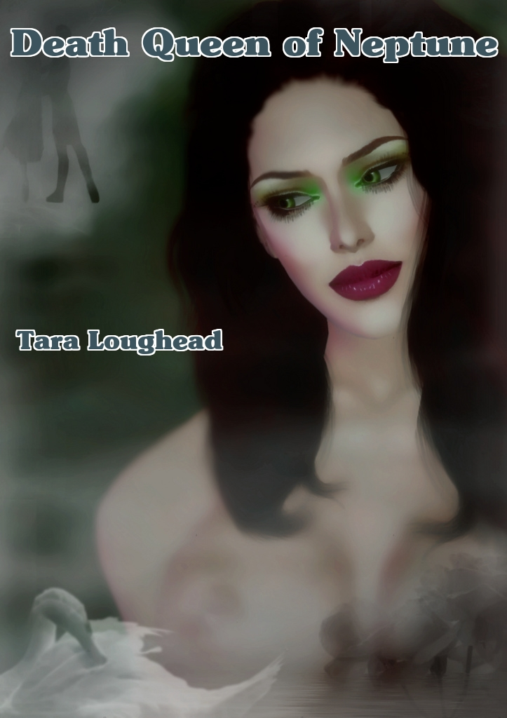

Death Queen of Neptune

Tara Loughead

Smashwords Edition

Copyright 2010

For Jim Shooter, Curt Swan, Chris Claremont and John Byrne

"I prefer the dirty jobs to the frosty ones."

"You mean the frosty ones that don't involve pubs, don't you?" Ghaavn asked.

Bulays chuckled as Ghaavn piloted the shuttle to a landing on Neptune. Clad in parkas and white body armour modified for the snowy conditions, the two disembarked.

"The base is about 500 metres to the east." Ghaavn pointed, pulling on dark glasses. "Keep an eye out."

The pair picked their way through the frozen rocky terrain, soon arriving at the door of a drab, gray bunker-type building about 50 metres long and wide. It was dark and silent with no sounds or signs of life.

Then they heard the roar.

"I think we should get inside before the welcoming committee finds us."

Ghaavn agreed, pulling out his electronics kit, starting in on the lock.

Another roar. Louder. Then an answering bestial scream from the opposite directed.

"Starting to feel surrounded, here, love."

"Almost...ah, got it!" Ghaavn stowed his tools back in his belt pack. Pulling out a pistol from a hip-holster, he toed the door open carefully. "Clear." He signalled Bulays to enter, breath steaming.

Knives in either hand, the tall, muscular shorthaired blonde woman did so. "No-one here but dead 'uns." She knelt down to take a closer look. Grouped closely together on the floor were the corpses of four women, clad in snowsuits. "Not been dead for long, it seems. Although the cold makes it a bit harder to guess.

Ghaavn joined him, reading the insignia on the breast of each body. A black-clad body. "Neville." A woman in Imperial military garb. "Dominic." A gray, leather-clad body was also missing most of its right leg. "Kimball."

"And this one has one of those new experimental AI implants, so must be Ian."

"So that's all four of them, according to Lady G," replied Ghaavn.

Bulays stood, massaging her lower leg, injured on their last mission. "Don't know about you, but I'm starting to feel more like a coroner than a Council agent."

"Well, darlings. Good of you to come. I have plenty of life for both of you." The speaker on the wall crackled into life as part of the wall irised open. The pair spun around, startled, weapons in hand. "Do please join me."

The pair shared a bemused look, and Bulays exited first.

Stepping through, they saw what appeared to be a long, furnished dining hall with a very high ceiling. Seated at the end of the room, in a large, fur-covered chair was a tall, dark haired woman. She wore white leather pants, high-heeled boots, a fur-trimmed cape, and very little else. A necklace with a huge emerald orb nestled between her full breasts. Definitely no signs of feeling the cold, it seemed. She waved them towards her, imperiously. "Very nice. You are the strapping pair, indeed." More impatiently, this time, the gesture. "Come, come." The iris closed behind them.

"Should I perforate her?"

Ghaavn held up his hand to his partner, indicating that she should hold that thought. "Who are you?" He called.

"Why, I'm the Queen of Neptune, of course." Green eyes gleaming in the cold air.

"Looks more like you're the 'ead cannibal in the refrigerator. Bit short on subjects, aren't you, 'your majesty'" Bulays scoffed. "Not to mention clothes."

"Emar of the Htapele doesn't suffer from your human frailties, big blonde and beautiful. You'd like a closer look, wouldn't you?" She smirked. "Although it appears my retinue has increased again, doesn't it? Besides, cannibalism is so declasse. I might have killed them, but I certainly wouldn't leave them to be eaten."

Bulays' left hand twitched, flipping the knife therein. Ghaavn touched his partner's right arm lightly, stilling her. "What are you doing here?"

"Waiting for you, gorgeous."

"With a little mass murder to keep you from being bored?"

Emar's eyes narrowed. "I rule here. Female interlopers with pretensions are dealt with."

"My thoughts, exactly," Bulays retorted.

A great tearing crashed sound came from the direction they had entered the room, cutting the tense discussion short. "Now this makes things interesting." Emar stood, cloak settling around her impressive form. "We'll have to finish our little friendly chat later. Now you'll need my help."

"Not likely," Bulays shot back. The tearing noise became crashing and bashing. With roaring. A solid, smashing thud came against the wall where the iris had opened.

"Child, a splendidly strong pulchritudinous fiery delight you may be, but I believe an extremely hungry family of Apmaw is beyond even your muscular talents."

"I think she's right, Princess. We should get out of here. No point staying, now." Bulays turned to Emar. "I'm listening."

"There's an access hatch to a tunnel that leads out in the opposite direction, but I'll need some time to open it." At that moment, an extremely large and furry taloned white arm smashed through the wall.

Bulays and Ghaavn rushed to grab one of the utilitarian steel tables, hurling it at the wall. "Get to it then, Queenie. We'll do what we can." They followed it up with another, and retreated. A large, shaggy head with a ravenous fanged maw was following the arm through the ever-increasing hole in the wall. They retreated to behind where Emar had been sitting, the only cover left.

"Only got one grenade we can use in here, Ghaavn. Hope she hurries up."

"Bulays. That table. I need a staff."

"Right. On it." She flipped the last table in the room over and wrenched one of the lengthwise tubular supports out, tossing it to her partner.

"Now go cover Emar." Who was crouched in the corner, working an electrical gadget in the wall.

Bulays did do, as Ghaavn advanced to the middle of the room, holding his makeshift quarterstaff. At which point, an Apmaw broke through. All two-and-a-half-metre tall smelly, hairy, yellow eyed monster parts of it. It bellowed. Ghaavn spun the staff, extending, and whirled, smiting the beast in the side of the head. It screamed, clawing at him, as he dodged to retreat, keeping himself between the fanged and furred beast and the other.

The Apmaw leaped, but Ghaavn was ready. Striking swiftly, he used the staff to trip the beast in mid-air. It fell heavily to his right, growling in fury. Dropping one problem, another presented as a second Apmaw barged its way through the wall, shedding furniture. Ghaavn poised, seeing the first start creature start to rise again.

"Ghaavn! Bulays yelled. She's found the hatch." Emar had indeed opened it, and was removing it quickly. She motioned Bulays through. "I have to keep it open. You go." She did, and stood on the other side of the hatch, a metal globe in her hand.

Ghaavn took the offensive, and ran for the second creature, staff extended. He jabbed it forward forcefully, striking the creature in the throat. Its big shaggy paws clutched its neck, as it gurgled and sank to its knees. Ghaavn had taken a calculated risk, and it hadn't completely come off. The other Apmaw was up, and behind him. In a surprise move, it leaped towards Emar, threatening to cut off their escape.

In a move of pure, athletic grace Ghaavn drop-stepped and pivoted. Ran two steps towards the Apmaw now behind him, staff raised, then used it to vault over the top of the beast, landing between it and the hatch. Now staffless, he drew his pistol and fired, taking the beast directly in the eye. It fell towards him, though, lashing out in pain and directly at Emar.

Ghaavn jumped to intercept, pushing Emar through the access opening. Not fast enough to save himself, though. The great rending swipe caught him across the chest, throwing him through to air to right in front of the shaft. Bulays snaked through, grabbing his partner and hauling him in as the injured beast screamed. "Let it go," he ordered Emar, and tossed in the grenade as the opening sealed shut.

"Run!" He picked up his partner, and staggered into a trot after the receding cape and boots.

The boom and concussion of the sonic grenade going off dropped Bulays to her knees, as she cradled the unconscious Ghaavn. Because of his injuries, she had to carry him in her arms as opposed to more advantageous methods.

Emar had stopped when the grenade went off, covering her ears, and shaking her head, turning around. Bulays his partner down gently on the ground and leapt at Emar, knife flashing as she grabbed her by the throat. "What's going on here? You don't look very worried for someone that might 'ave been eaten by ice beasts or blown up just now?"

"So there is a brain in there to go along with that luscious brawn? How delightful." She continued, taking Bulays' hand and removing it from her throat. "The truth is, I find the pair of you thrilling. What's the human term? Oh, weak at the knees. Throbbing. One of those."

"You killed a whole frontier base as setup?"

"Oh no, I killed them for the reasons I told you. However, two lightning birds with one meteor and all that." She put her other hand on Bulays hip, staring into her eyes.

"You can save 'im, can't you, you psycho?"

"Oh yes. Your own efforts may be able to, though. How much are you willing to risk?"

"What do you want?"

"I do believe you are wearing too many clothes."

Bulays rolled her eyes but immediately started to strip, it being obvious what Emar had in mind. Losing her parka, armour, and torso apparel, she bent to take off her boots.

"Enough," said Emar, regarding the now topless warrior. Unlike Emar, she most definitely felt the cold. "Fair's fair. Now come here." As Bulays stood in front of Emar, the latter smiled, then grabbed the Earth woman's arse, and pulled her into a clinch, breast to breast. Bulays was taller, but their figures definitely matched. Emar's full, green lips turned up at the corners as she swiftly pulled the Earth woman's head down into a deep, passionate kiss. The startled buxom warrior was drawn in briefly, but recovered, pushing back, and breaking the lip lock.

"Are we done?" Bulays shivered, bending reaching for her clothes.

"One more, you voluptuous beast. You agree to let me go."

"Done."

Emar moved to where Ghaavn lay, his chest a bloody ruin. She lifted him to a sitting position as Bulays watched, warily. Emar's hand went to Ghaavn's forehead, as the emerald between her breasts began to glow. A pale greenish energy flowed over both of theirs bodies, wounds beginning to heal. He stirred, and Emar turned his head towards her, stealing a kiss as she stroked his thigh. Bulays moved to intercede, and took hold of her partner, getting between the pair.

The viridian lit beauty, stood, sighed. Then she grinned, and waved at Bulays. "Say hello to Gerald for me, won't you?" Emar blew the Earth woman a kiss as she did a slow, verdant fadeout, then disappeared.

Ghaavn's long-lashed eyes fluttered open. "What happened?"

"Story for another time, love. We need to get back to the shuttle in case any other 'airy' homewreckers come callin'." She finished dressing, then led her slightly unsteady partner out of the tunnel into the frigid Neptune air.

***

"Captain Buck, we're coming up to the ship."

"Roger, Bulays. Where's Ghaavn?"

"Sleeping, Captain. He's been hurt. Can you patch me through on the thaumsible to G?"

On connection, Bulays recounted an abbreviated version tale. Lady Gerald had the decency to look contrite. "Very sorry about that, my dear, but it had to be done. I owe you an explanation. History for another day."

Bulays glared. "Break out the top-shelf then, this will cost you dinner."

G inclined her head in acquiescence, and cut the connection.

The End

Artwork by Denise Rowlands

http://www.flickr.com/photos/denise_rowlands/3123073627/in/set-72157611560707406/

http://creativecommons.org/licenses/by-nc/2.0/deed.en_GB

Bulays and Ghaavn will return in "She Devils of Europa".

