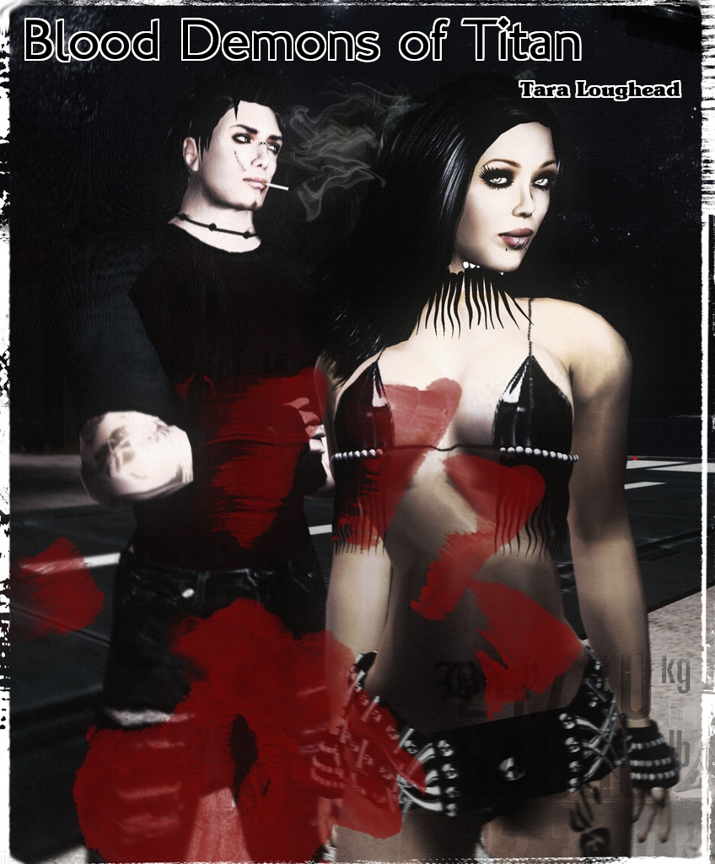

Blood Demons of Titan

By Tara Loughead

Smashwords Edition

Copyright 2010 Tara Loughead

For Peter O'Donnell.

Even the best quality carbon steel blade will stink after gutting seven demons.

Something like a combination of sulphur, dog vomit and sewage, thought Ghaavn disgustedly as he wiped Bulays' blade off in the dusty Titan dirt, gorge rising. Stilling this unappreciated reflex, he stood over the vile, rapidly deteriorating hellish corpse lying in the dust at his feet. He turned to his partner, giving her a grossed out look. Retrieving his own spent bolt from the disintegrating hellish remains was currently way too nasty to contemplate.

Stepping carefully away from the diminishing pile of fiend, he watched the light-skinned, short-haired blonde to his left rise from her crouched combat position. Straightening up in one lithe moment, Bulays then bounced on her toes a couple of times, stretching her well-developed leg muscles.

"Princess, if you work those thighs out any more I think Deena might be in danger of her life," Ghaavn grinned.

The effect of the responsive and suggestive smirk on her face was ruined by the state of her sable body armour. Being a tall, strong and insolently curved black-clad amazon of Titan looks good. Being covered in pustulent green demon juices, not so much.

"So where is your educated 'friend' then, love?" she asked, holdering her hand out for her weapon and looking down at the somewhat shorter, similarly clad man.

Ghaavn passed her the smelly knife, holding the hilt so as to avoid anything disturbing still on the blade. Unlike his partner, the dark-skinned, midnight-haired man had managed to retain a rather more stylish martial appearance. He also smelled rather nicer, if you didn't count a healthy sheen of sweat. There was nary a hair out of place in his ponytail, somehow still curled around its cylindrical wooden fastener. His body armour was also devoid of both ichor and diabolically inflicted damage. Neither did it have the two knives sheathed over the left breast that his partner displayed. Unlike Bulays, Ghaavn did have a holster on his right hip. The resting place for the wicked looking bolt-throwing device in his right hand.

"Apparently there has been another sighting of the Ghost Girl Of Ganymede. So Schteve is off playing spook hunter. A good thing, too. Anti-diabolist combat missions wouldn't be good for his health. Better to leave the more corporeal monsters to us."

A sudden gust of wind swirled the grey stale dust of this back end of Barnes' street around them. A chittering noise carried with the wind. Alerted by the sound, Bulays spun, lashing out with her knife. Her partner, unperturbed, pointed at her weapon as Bulays realised the result of this reflex action.

"Nice work. That's now seven demons and one flying rodent you've dispatched tonight." He remained poker-faced as she glared back him. Although she thought she could detect a distinct sparkle of amusement showing in his dark, long-lashed and exotic eyes.

"Bloody bats give me the creeps." She made a somewhat vulgar knife gesture in Ghaavn's direction.

"Apparently a common affliction among criminals, once, fear of such. Doesn't mean you need to shishkebab them." He replied, twirling a finger at the chiropteran corpse now decorating her weapon. "They've really taken to Titan, since the Thaumaforming...you should be used to them by now, Princess."

Bulays sniffed, but quickly decided that such activity was a very bad idea in her state. She pulled the deceased creature off her blade, flinging its corpse behind her into the pre-dawn gloom. "That's enough of the Princess thing, ok?"

"What, you don't like to be reminded of your stint as legbreaking royalty for a low-rent Earth crimelord?"

Her eyes narrowed, clearly not in the mood for teasing. The stench of her newly acquired noxious putrid demon entrail coating definitely not being a mood enhancer. Ghaavn desisted when he saw Bulays picking out flakes of demon scale from behind her ear and tapping her foot on the ground.

Ghaavn glanced at the watch-like device on his wrist, all business now. "According to the Council's necrometer, there appear to be no more summonings around. Our unfriendly neighbourhood diabolist is likely getting low on power."

Bulays resheathed her blade, and adjusted her chest harness slightly. "I hope Lady G's magic mates are good with their toys. I'm too good-looking to be sauteed by a small-town sorcerous scumbag."

"You'll get your chance to avoid that, up close and personally. The readings say he's close." Ghaavn pointed down the dusty, corrugated iron, concrete and steel lined street they were standing in. "Likely in that small building at the end, according to the necro." Bulays nodded in reply, and the pair melted into the gloom, one to either side of the street.

They cautiously advanced, weapons drawn. A knife in each hand for Bulays, Ghaavn, a bolt-thrower. Nothing happened, so the pair were quickly either side of a green-gray wooden padlocked door. The entrance to what looked to be a small factory, gauging by the fabricated metal walls. Their eyes met. Bulays flashed a two-hand signal. Ghaavn quirked an eyebrow in brief surprise. Bulays grinned, flipped a knife in her hand for throwing, and indicated the door.

She spun on on one leg, the other delivering a powerful kick that smashed down the door. She charged through the new space, Ghaavn right behind her.

A nasty sight awaited. The factory interior was empty of any machinery or gear, apart from two low, circular blocks of some hard material, situated at the far wall, about twenty metres away. They had narrow channels cut around them, just inside the circumference. The channels on the circle to the left were full. With blood. A young man was strapped spreadeagled to the block, and from the look of wounds in his neck and wrists, that blood was his.

Behind the block to the right, stood a hooded man in a dark, purplish robe. Startled by their forceful entrance, he snarled, face an angry rictus. He dropped the knife he was holding to the throat of the young woman strapped down in front of him. She was gagged, terrified, shaking. Bringing his hands together in front of him, he gestured, fingers pointed in front of him. The hands began to glow, enveloped in energy.

Now about halfway across the floor, the duo in formation split, Bulays left, Ghaavn, right. A split second of indecision crossed the robed man's face, as his eyes flicked towards Ghaavn, then Bulays. His hands separated, arms extending, he screamed a harsh word of power. A scabrous beam of harsh purplish-black energy flew from his right hand toward Bulays, who dived, throwing the knife in her left hand at the necromancer as she did. Not far enough, though. The eldritch bolt took her in the right shin. Her body armour took the heat, but with an audible crack. Bulays was down, blasted off balance, right leg limp. Her throw was good, but not good enough. It connected, but only barely sliced a line across his right upper arm.

The sorcerer spoke again, gestured, and the bolt Ghaavn shot while in motion hit a small shield of necromantic energy. He fired again, beating the shield. The necromancer did likewise, a bolt of the same crackling sorcery blasting Ghaavn's bolt-thrower to pieces out of his gloved hand. Ghaavn's bolt had struck home, shattering the robed fiend's right collarbone, eliciting a grunt of serious pain. His arm dropped uselessly to his side.

Now, the black-clad warrior had closed the distance, and he leaped. His front foot reached the slab the girl was lying on. He launched himself from this point at the rear wall, right hand reaching for his pony tail. Seeming to run two metres up the wall with his feet, he pivot-flipped backwards, dropping down in front the wounded and now surprised necromancer. Ghaavn struck fast, striking him in the head with a closed right fist. The necromancer's eyes rolled back in his head, as he slumped to the cold, hard floor, unconscious.

Flexing his left hand in the remnants of its glove, his now open right revealed a cylinder of red wood, flared into discs at either end. A swift movement, and it was gone, was back in his hair.

Ghaavn immediately secured the necromancer's hands behind his back with wooden handcuffs from his belt pouch, and gagged him with his own hood. Safe for a minute, he rushed to the side of the boy at the left. He wasn't moving. He checked for a pulse, but found none. He gently closed the boy's eyes, as a groan came from out on the floor.

"He's dead, love." The Earth woman had dragged herself painfully to her feet. Or foot, given that she trailed her right awkwardly behind her.

"I know, Bulays, but I had to be sure." An angry look flashed across his face.

"Want me to sign 'im off then?" She asked, waving a hand at the robe on the floor.

"No, I quite think that G and J will want to have a little chat with this one."

"Ah, 'e'd probably rather be dead, I reckon."

Ghaavn smiled, and turned back to the still strapped down now frantically squirming girl. He quickly pulled the tape from across her mouth. "It's ok, you're safe now," he soothed. She started to cry as he pulled the straps holding her down free. Shucking his body armour, he pulled his black pullover off over his head, and said. "Shh. We'll take care of you. Here, put this on. You need to warm up." Helping the frightened young woman, he turned his head towards his partner.

Bulays seated herself to his left, putting her hand to an ear, speaking quickly. "Cleanup crew's on its way." Ghaavn nodded, continuing to comfort the young woman. "Looks like that's one evil bloke that won't be fit to be seen at any more of President Imra's toga parties, then," she grinned, seeing his wound.

Ghaavn chuckled. His arm comfortingly around the softly sobbing petite girl now wearing his jumper, he asked: "What's your name, darling?"

Her surprised reaction to the simple question actually stopped her tears. "Wh..? it's Wing. My name is Wing."

"I think we should take her home with us for now," he said.

"Sounds right. She's had enough weird types around today, without being subjected to the Ministry's Spooky Spell Squad."

Ghaavn gathered the young woman into his arms and stood, as she clasped him tightly. His partner hobbled after him. "So, didn't think we get that far, did you?" Bulays asked.

"Into the manual?" He shook his head. "Not Manoeuvre Z-17, no."

"Pity I didn't bet you first then. You'd 'ave given me good odds on ever using the anti-wizard backflip bongo kongo."

They walked laughing out into the night.

The End

Artwork by Denise Rowlands

http://www.flickr.com/photos/denise_rowlands/3054438777/

http://creativecommons.org/licenses/by-nc/2.0/deed.en_GB

Bulays and Ghaavn will return in "Death Queen of Neptune".

Jekkara Press

You can find out more about the Adventures of Bulays and Ghaavn at the Jekkara Press wordpress

website

http://jekkarapress.wordpress.com

And you can find this book and other Tara Loughead books in html, text, epub, mobi, kindle, pdf and

rtf formats at Smashwords :-

https://www.smashwords.com/profile/view/jekkarapress

Also by Jekkara press

The Adventures of Bulays and Ghaavn currently include:

01 Blood Demons of Titan - Tara Loughead

The warriors Bulays and Ghaavn hunt demons and their master through the dim and dusty streets of

Barnes, on Titan. Can they stop him before he completes a devastating ritual?

02 Death Queen of Neptune - Tara Loughead

Bulays and Ghaavn are called in to investigate why a frontier base on Neptune has gone silent. Ice

monsters and an ancient, beautiful evil await.

03 She Devils of Europa - Tara Loughead

One of the richest women in the Solar System asks Bulays and Ghaavn for help in stopping a series of

thefts. There is a mystery to solve at the most expensive resort in existence, The Europa. Larceny,

magic and dancing await, in an all expenses paid evening.

04 Shadow Emperor of Phobos: The Martian Moon War Part 1 - Tara Loughead

Bulays and Ghaavn try and stop a underworld shooting war. First they must get past a Martian

Shadowcat, employ surprising combat techniques, and try and reason with Ghaavn's criminal mentor.

The Gender Switch Adventures

The Devil In Iron, Respawned [Conyn the Barbarian] - Roberta E Howard

Any resemblance to Robert E. Howard's Conan is completely intentional. A resurrected demon menaces

Conyn on an island fortress, along with other monsters.

The Pool of the Black One, Reswum [Conyn the Barbarian] - Roberta E Howard

Any resemblance to Robert E. Howard's Conan is completely intentional. Conyn, a pirate, puts herself

in charge and investigates a strange island with mystic waters.

Jewels of Gwahlur, Reboxed [Conyn the Barbarian] - Roberta E. Howard

Any resemblance to Robert E. Howard's Conan is completely intentional. Conyn encounters deity

impersonation, tries for treasure, boys and ape monster fighting.

Stand Alone

Undead Dining - Tara Loughead

A very short horror story about a very different restaurant.

Coming Soon

The Adventures of Bulays and Ghaavn

05 Desert Empress of Deimos: The Martian Moon War Part 2 - Tara Loughead

The Gender Switch Adventures

Red Nails Polished (Gender Switch - Conyn the Barbarian) - Roberta E. Howard
Beyond the Black River, Recrossed (Gender Switch - Conyn the Barbarian) by Roberta E. Howard
Queen of the Black Coast, Recrowned (Gender Switch - Conyn the Barbarian) - Roberta E. Howard

Queen of the Martian Catacombs, Recrowned (Gender Switch - Erica Joan Stark) - Lee Brackett
Black Male Amazon of Mars (Gender Switch - Erica Joan Stark) - Lee Brackett

Song In A Minor Key, Retuned (Gender Switch - Norawest Smith) - Cathan L. Moore

The Tree of Life, Revisited (Gender Switch - Norawest Smith) - Cathan L. Moore

The Valor of Cappea Verra, Recapped (Gender Switch - Cappea Verra) by Poula Anderson

If you prefer:

Also at Scribd :
https://www.scribd.com/jekkarapress

or Wattpad :
https://www.wattpad.com/user/jekkarapress

