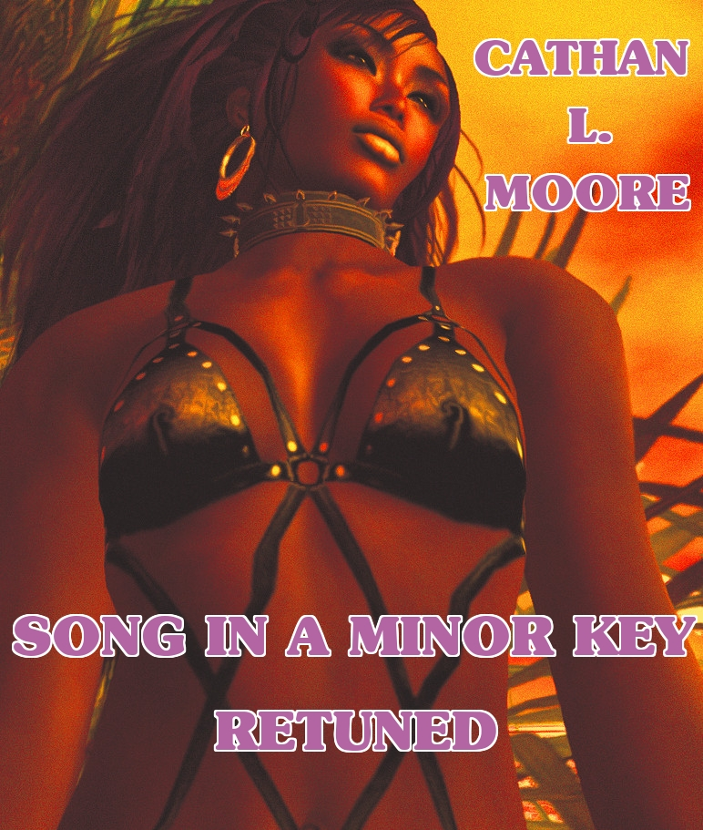

Song in a Minor Key Retuned

by Cathan L. Moore

Smashwords Edition

Copyright 2010 Cathan L. Moore

She had been promising herself this moment for how many lonely months and years on alien worlds?
Beneath her the clovered hill-slope was warm in the sun. Norawest Smith moved her shoulders against the earth and closed her eyes, breathing so deeply that the gun holstered upon her chest drew tight against its strap as she drank the fragrance of Earth and clover warm in the sun. Here in the hollow of the hills, willow-shaded, pillowed upon clover and the lap of Earth, she let her breath run out in a long sigh and drew one palm across the grass in a caress like a lover's.
She had been promising herself this moment for how long--how many months and years on alien worlds? She would not think of it now. She would not remember the dark spaceways or the red slag of Martian drylands or the pearl-gray days on Venus when she had dreamed of the Earth that had outlawed her. So she lay, with her eyes closed and the sunlight drenching her through, no sound in her ears but the passage of a breeze through the grass and a creaking of some insect nearby--the violent, blood-smelling years behind her might never have been. Except for the gun pressed into her ribs between her bosom and the clovered earth, she might be a girl again, years upon years ago, long before she had broken her first law or killed her first woman.
No one else alive now knew who that girl had been. Not even the all knowing Patrol. Not even Venusian Yarol, who had been her closest friend for so many riotous years. No one would ever know--now. Not her name (which had not always been Smith) or her native land or the home that had bred her, or the first violent deed that had sent her down the devious paths which led here--here to the clover hollow in the hills of an Earth that had forbidden her ever to set foot again upon his soil.
She unclasped the hands behind her head and rolled over to lay a scarred cheek on her arm, smiling to herself. Well, here was Earth beneath her. No longer a green star high in alien skies, but warm soil, new clover so near her face she could see all the little stems and trefoil leaves, moist earth granular at their roots. An ant ran by with waving antennae close beside her cheek. She closed her eyes and drew another deep breath. Better not even look; better to lie here like an animal, absorbing the sun and the feel of Earth blindly, wordlessly.

* * * * *

Now she was not Norawest Smith, scarred outlaw of the spaceways. Now she was a girl again with all her life before her. There would be a white-columned house just over the hill, with shaded porches and white curtains blowing in the breeze and the sound of sweet, familiar voices indoors. There would be a boy with hair like poured honey hesitating just inside the door, lifting his eyes to her. Tears in the eyes. She lay very still, remembering.
Curious how vividly it all came back, though the house had been ashes for nearly twenty years, and the girl--the boy ...
She rolled over violently, opening her eyes. No use remembering him. There had been that fatal flaw in her from the very first, she knew now. If she were the girl again knowing all she knew today, still the flaw would be there and sooner or later the same thing must have happened that had happened twenty years ago. She had been born for a wilder age, when women took what they wanted and held what they could without respect for law. Obedience was not in her, and so--
As vividly as on that day it happened she felt the same old surge of anger and despair twenty years old now, felt the ray-gun bucking hard against her unaccustomed fist, heard the hiss of its deadly charge ravening into a face she hated. She could not be sorry, even now, for that first woman she had killed. But in the smoke of that killing had gone up the columned house and the future she might have had, the girl herself--lost as Atlantis now--and the boy with the honey-colored hair and much, much else besides. It had to happen, she knew. She being the girl she was, it had to happen. Even if she could go back and start all over, the tale would be the same.
And it was all long past now, anyhow; and nobody remembered any more at all, except herself. A woman would be a fool to lie here thinking about it any longer.
Smith grunted and sat up, shrugging the gun into place against her ribs.

Artwork by arthurx Titanium

http://www.flickr.com/photos/26633968@N03/4519629325/sizes/l/in/faves-jekkarapress/

http://creativecommons.org/licenses/by-nc-sa/2.0/

Jekkara Press

You can find out more about the Adventures of Bulays and Ghaavn at the Jekkara Press wordpress website:

http://jekkarapress.wordpress.com

or the blogger site

http://jekkarapress.blogspot.com

And you can find this book and other Tara Loughead books in html, text, epub, mobi, kindle, pdf and rtf formats at Smashwords :-

https://www.smashwords.com/profile/view/jekkarapress

Also by Jekkara press

The Adventures of Bulays and Ghaavn currently include:

01 Blood Demons of Titan - Tara Loughead
The warriors Bulays and Ghaavn hunt demons and their master through the dim and dusty streets of Barnes, on Titan. Can they stop him before he completes a devastating ritual?
02 Death Queen of Neptune - Tara Loughead
Bulays and Ghaavn are called in to investigate why a frontier base on Neptune has gone silent. Ice monsters and an ancient, beautiful evil await.
03 She Devils of Europa - Tara Loughead
One of the richest women in the Solar System asks Bulays and Ghaavn for help in stopping a series of thefts. There is a mystery to solve at the most
expensive resort in existence, The Europa. Larceny, magic and dancing await, in an all expenses paid evening.
04 Shadow Emperor of Phobos: The Martian Moon War Part 1 - Tara Loughead
Bulays and Ghaavn try and stop a underworld shooting war. First they must get past a Martian Shadowcat, employ surprising combat techniques, and try and reason with Ghaavn's criminal mentor.
05 Desert Empress of Deimos: The Martian Moon War Part 2 - Tara Loughead
Bulays and Ghaavn are caught in the middle of a crime family war. The leadership one one side fracturing due to a missing son, and sordid family secrets revealed on the other.

The Gender Switch Adventures

The Devil In Iron, Respawned [Conyn the Barbarian] - Roberta E Howard
Any resemblance to Robert E. Howard's Conan is completely intentional. A resurrected demon menaces Conyn on an island fortress, along with other monsters.
The Pool of the Black One, Reswum [Conyn the Barbarian] - Roberta E Howard
Any resemblance to Robert E. Howard's Conan is completely intentional. Conyn, a pirate, puts herself in charge and investigates a strange island with mystic waters.
Jewels of Gwahlur, Reboxed [Conyn the Barbarian] - Roberta E. Howard
Any resemblance to Robert E. Howard's Conan is completely intentional. Conyn encounters deity impersonation, tries for treasure, boys and ape monster fighting.
Queen of the Black Coast, Recrowned [Conyn the Barbarian] - Roberta E. Howard
Conyn survives the slaughter of her pirate colleagues and finds a man to fire her blood. Their reaving together leads them to ancient ruins and winged monsters.
Red Nails, Polished [Conyn the Barbarian] - Roberta E. Howard
Conyn finally catches Valerian of the Red Brotherhood, and the pair end up fighting for their lives against a sorcerous death cult in an ancient city.
Beyond the Black River, Recrossed [Conyn the Barbarian] by Roberta E. Howard
Conyn signs up as a scout in Pictish territory, and gets involved with his partner in a border war against the wizard Zogara Sag and her cult of followers.

Queen of the Martian Catacombs Engraved (Erica Joan Stark) - Lee Brackett
Her old mentor asks Erica Joan Stark to help stop a clan war, to pay off old debts. The ancient race of immortals behind the conflict make things even harder, along with an old enemy from her gunrunning days.
Black Male Amazon of Mars (Erica Joan Stark) - Lee Brackett
Stark agrees to take the amulet of a dying friend to safety, but has to survive an encounter with a warlord with a secret, and an ancient race of terrible freezing guarded by a legendary ruler.

Song In A Minor Key, Retuned (Norawest Smith) - Cathan L. Moore

Norawest Smith reminisces melancholy, about her first boy, gunning down her first woman...

The Tree of Life, Revisited (Norawest Smith) - Cathan L. Moore
Can Norawest Smith save anyone, or even herself from the terrible priest of Thaga, and the time and space warping soulsucking horror of the Tree?

Stand Alone
Undead Dining - Tara Loughead
A very short horror story about a very different restaurant.

Coming Soon

The Adventures of Bulays and Ghaavn

06 Heart Breakers of Hyperion – Tara Loughead

The Gender Switch Adventures

The Valor of Cappea Verra, Recapped (Cappea Verra) - Poula Anderson

