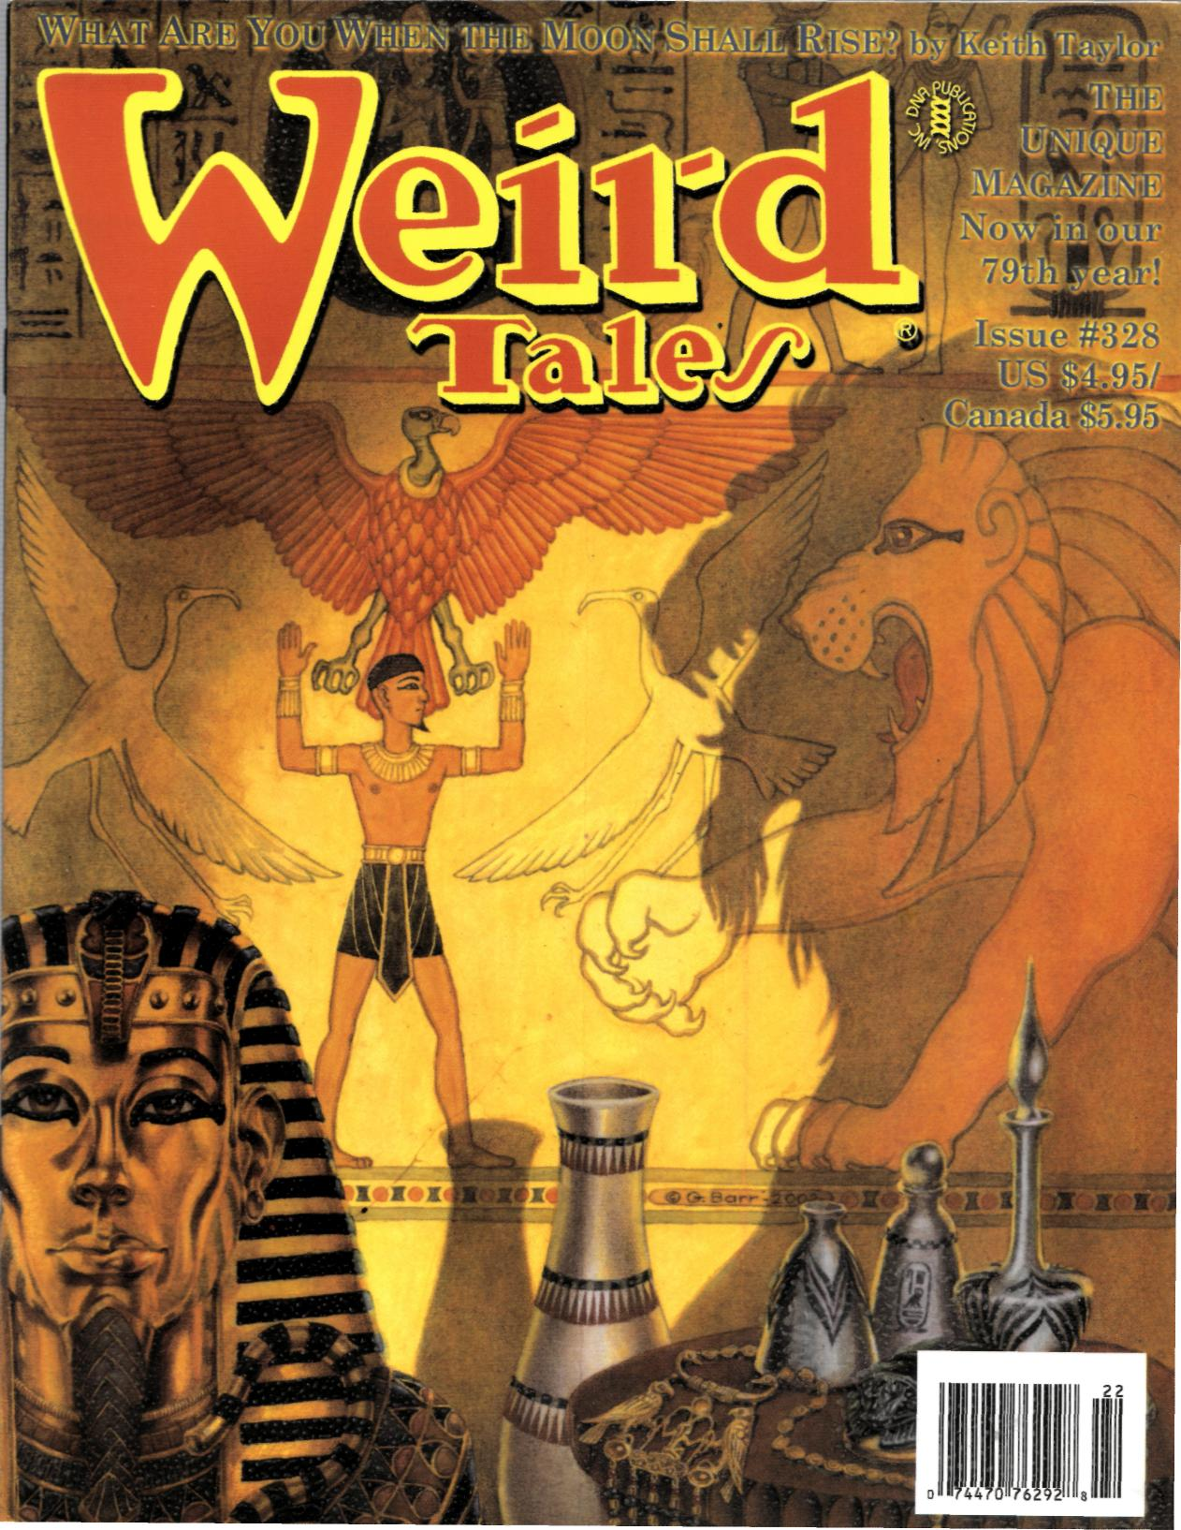



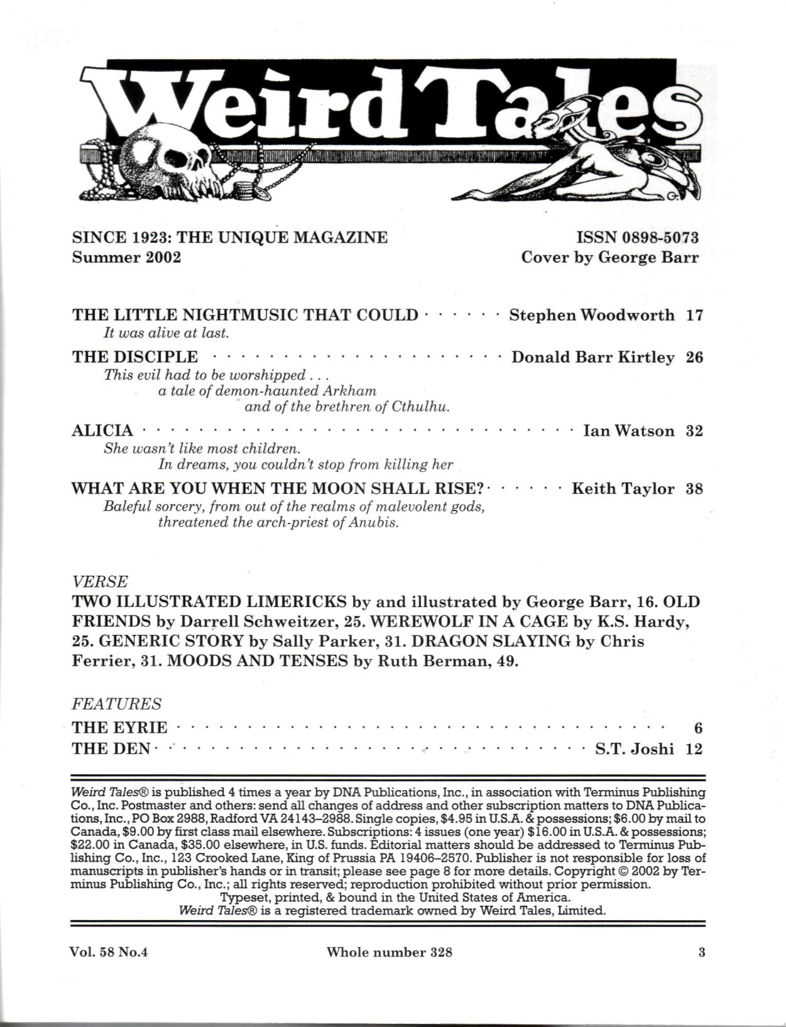
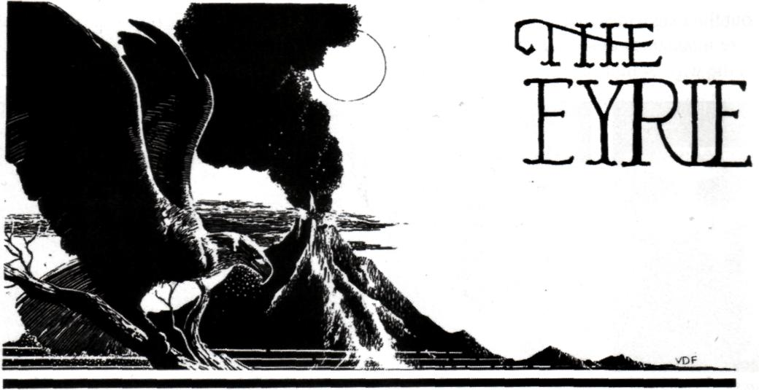

J.R.R. Tolkien
as a Horror Writer
We've had occasion to reread The Lord of the Rings recently, for the first time in 29 years, and this, combined with the recent, very successful Peter Jackson film of The Lord of the Rings: The Fellowship of the Ring, has made us give J.R.R. Tolkien and all he represents (and spawned) a major re-evaluation. Look for the end result in an essay forthcoming in The New York Review of Science Fiction. We will not repeat our conclusions here, save to say that we did not find Tolkien's work, as Michael Moorcock (nowadays the leading Tolkien detractor) put it, "Winnie the Pooh posing as an epic," but instead Winnie the Pooh evolving into an epic, which is a lot more interesting. It is a story that moves from childhood into maturity, from sweetness and light into suffering and darkness, and is ultimately about the process of that movement.
But it also occurs to us that Tolkien was a damned good horror writer. The darkness in his work is essential to its success. Peter Jackson sensed that, and the reason his film version is so successful (other than its very intelligent abridgement of the sometimes meandering storyline) is precisely that Jackson concentrated on the horror elements, not the cuteness. His film has a more uniform and scarier tone than, particularly, the first volume of Tolkien's trilogy.
Tolkien a horror writer? There are doubtless many horror fans out there scratching their heads about now. Isn't Tolkien about sweet elves and cute hobbits and mythopoeic something-or-other set in never-never land? What's that got to do with horror?
For the answer, see Darrell's essay, "Horror Beyond New Jersey," in Windows of the Imagination. It has always been our contention — and part of the agenda of Weird Tales® — that horror is an emotional tone, not a setting or a frame of reference, or even any sort of specific content. (Admittedly, for Weird Tales® we prefer to achieve that emotional tone of horror through fantastic or supernatural content, but we recognize that this is not the only way to do it. Poe's "The Pit and the Pendulum" or Richard Connell's "The Most Dangerous Game" are definitely classics of horror, but not fantasy.)
That being so, there is no reason why horror has to be restricted to the parameters of popular horror-genre paperbacks. A horror story doesn't have to be set in the present, or in any place within the experience of the reader. A horror story should be possible even if set in ancient Egypt, or medieval

France, or a primordial continent in the prehistorical past, or millions of years hence, or even on the planet Mars. We are aware that some masters of the horror form, notably M.R. James, disagreed with us on this specific point. James felt that a ghostly tale set long ago might be exciting and romantic, but the reader feels that anything could happen in, say, the 12th century, so that the reader will never get the this could happen to me sort of creeps from a story in a remote setting.

Our only answer to that is that here, in Weird Tales® (in this very issue, in fact) Keith Taylor has achieved quite effective horror with stories set in Egypt 4000 years ago, and as for all those other settings, Clark Ashton Smith did them all in the pages of Weird Tales® in the 1930s, with his tales of Averoigne, Hyperborea, Zothique, and the vaults of Yoth Vombis. So horror can happen in Middle Earth too, and, rereading Tolkien, we find that it does. A very nice moment occurs in Chapter 5 of The Fellowship of the Ring when Frodo and Sam have crossed the Brandywine on a ferry, and Frodo looks back at the dock on the opposite shore, from which they embarked a few minutes before. He sees something that "looked like a dark black bundle left behind," only it begins to move, crawling about for a second before it vanishes into the darkness beyond the lantern light.
M.R. James could have written that, and it seems to us that if things had worked out just a little bit differently, Tolkien might have become a practitioner of the traditional English ghost story, of which James was the greatest exponent. James was a generation older than Tolkien. The two had similar academic and antiquarian backgrounds. It's easy to imagine that there-but-for-fortune, Tolkien might have attended the right school and been one of the boys to whom James first told his famous ghost stories, which might have inspired Tolkien to go and do likewise.
Certainly Tolkien had a talent for conjuring spooks, such as his famous Balrog, or the Lord of the Nazgul who rides in through the broken gate of Gondor (in Chapter 4 of The Return of the King) to confront Gandalf and very likely defeat him, had not the Riders of Rohan come to the rescue just then. One can argue that Tolkien was over-fond of bringing the cavalry to the rescue, but the potency of the image remains, as does the potency of that "bundle" on the dock or much which is left to the imagination in the haunted mines of Moria.
And certainly the Ring itself is a wonderfully horrific invention, an object which draws out the evil in anyone's nature, so that the story's quest is a race to get rid of the thing before the hero is too corrupted to care.
Now there is much of the fairy tale in Tolkien, and though many have objected that his bugaboos (the Nazgul, et al.) get chased away too easily. We argue that the real struggle, the battle Frodo experiences within himself, to save his own soul before the Ring devours him, doesn't go away so easily, and this is the stuff of genuine horror. Stephen King's Jack Torrance undergoes a similar ordeal in The Shining (in the novel, not so much in either of the film versions) as he has to make one last effort to save his family before the Overlook Hotel can turn him into Something Else.
Horror can happen in the Third Age of Middle Earth or in the 1970s in Colorado. But it's the same and Tolkien had a knack for it.
In generic terms, Tolkien was writing something closer to what we now call "sword & sorcery" (a term which may appear in the next update of the Oxford English Dictionary). Although sword & sorcery books are shelved in a different part of the bookstore than books published as "horror," it seems to us that sword & sorcery, to be any good, almost requires a horror element. Otherwise it becomes a kind of lackluster pseudo-historical fiction, about the politics of imaginary kingdoms, with maybe a little magic thrown in. Robert E. Howard instinctively summoned up the most potent horrors he could in "Worms of the Earth," "The Valley of the Worm," and the better Conan stories. He knew, as Tolkien did, that not only can a horror story happen far away in time and space, but that a genuinely heroic hero (be he Frodo Baggins or Conan of Cimmeria) needs something genuinely horrific against which to square off. This was why H.P. Lovecraft admired Howard. Surely it wasn't for the sword-swinging and furious action, but for the atmospheric descriptions of elder (and eldritch) evils from the dawn of time.
Would Lovecraft have admired Tolkien? The two were very far apart in philosophical outlook, to be sure, and Tolkien had a different aesthetic agenda. Lovecraft would probably have had trouble with cuter and sunnier parts of The Fellowship of the Ring, particularly the first couple of chapters, but he would doubtless have found some of the later sections enormously potent.
Because they are. Because Tolkien, when he put his mind to it, was a horror writer.
We didn't get enough letters to shake a stick at, so voting for The Most Popular Story for issue 328 will have to be delayed and reported next issue. We continue to solicit your letters, votes, and comments. Remember that you can e-mail us at owlswick@netaxs.com, with the subject header of "Weird Letter."
Meanwhile, a few interesting items have come in the mail:
Black Diamonds by Clark Ashton Smith. Hippocampus Press, 2002, 181 pp. Trade paperback, $15.00. What is this? We have to admit that the cover and spine lettering on this book are so badly designed that we had to turn to the title page to discover that it is a previously unpublished novel by the great Weird Tales® writer. It's an Arabian Nights adventure, written when CAS was 14 years old. As such, it can hardly be expected to equal his later masterpieces, but it is very readable and retains a definite curiosity value as it helps to complete the Smith canon. Edited by the indefatigable S.T. Joshi. (Hippocampus Press, P.O. Box 641, New York NY 10156.)
Crypt of Cthulhu #105. What an eldritch delight to have Crypt back on a regular schedule! Crypt has been the Lovecraftian's essential reading for many years now, with its mixture of critical insight, humor, fiction, and just plain weirdness. We will never forget, for example, the issue containing the teleplay of The Cthulhuers, an alternate-universe version of The Honey-mooners in which Ralph and' Ed belonged, not to the Raccoon Lodge, but to a Cthulhu cult. This new issue (which was apparently prepared a couple years ago by the departing editor, Robert M. Price, who will be succeeded by Joe Pulver, Sr.) contains a short-story collaboration between Robert E. Howard and C.J. Henderson, a doubtless controversial piece on Lovecraft as "art" by J.G.W. Russell, a very learned piece by John Shire on "Lovecraft, Lacan, and the Lurking Fear," and even a poem, "Xeroxing the Necronomicon" by the late L. Sprague de Camp. As the transition to the new editorship continues, we watch this magazine with interest. ($6.00 per issue, from Mythos Books, 351 Lake Ridge Rd., Poplar Bluff MO 63901.)
Mythos Collector #2. Not as substantial as Crypt of Cthulhu but making a promising start. Some fiction, an interview with Steven Philip Jones, who has adapted Lovecraft for comic books, and a fascinating feature which tracks the prices of Lovecraft collectibles on eBay and other auction sites. ($4.00 from Dark Tree Press, P.O. Box 748, Boyleston MA 01505-0748.)
Whispers and Shadows ed, Jack Fisher. Prime Books, 2001, 201 pp. Trade paperback, $15.00. We actually have no idea who Prime Books is, but we take it as a good sign that every-time writers start complaining that the short story is dying or that there aren't enough markets, some newcomer will step on stage with something like this well-above-average anthology of original horror stories by Gary Braunbeck, Peter Crowther, Brian Stableford, Jeff Vandermeer, Don Webb, and many more. (Prime Books, P.O. Box 36503, Canton OH 44735.)
The Crow Maiden by Sarah Singleton. Cosmos Books/Wildside Press, 2001, 236 pp. Trade paperback, $15.00. We'd like to review this in detail sometime. Suffice it to say now that it's an original, really superior mythopoeic fantasy which deserves attention and which stands in evidence that sometimes the traditional New York publishers are just not doing their job. (Wildside Press, P.O. Box 301, Holicong PA 18928.)
The Gardens of Lucullus by Richard Tierney and Glenn Rahman. Sidecar Preservation Society, 2001, 273 pp. Trade paperback, $15.95. And now for something completely different, a full-sized book, with color covers, from a publisher previously noted for humorous pamphlets; a swashbuckling, Gnostic sword & sorcery novel with Cthulhu Mythos elements, featuring the Biblical "bad guy" Simon Magus as its hero. It sounds preposterous, but it works. Longtime readers should not be surprised, because Tierney's "Simon of Gitta" short stories have been running in small press magazines for years. This is the first novel-length outing. (SPS would do well to put their address in their books . . . grumble. We happen to know they're the same people who are behind Fedogan & Bremer, and thus may be reached at the F&G address, 3721 Minnehaha Ave., South Minneapolis MN 55406.)
Consumed, Reduced to Beautiful Grey Ashes by Linda D. Addison. Space & Time, 2001, 50 pp. $7.00. A fantasy poetry collection, by a writer who shows genuine lyric gifts. If you like the sort of poetry we publish in Weird Tales®, we think you'll like this. (Space & Time, 138 West 70th St. #4B, New York NY 10023-4468.)
The Other Nineteenth Century by Avram Davidson. Tor Books, 2001, 327 pp. Hardcover, $27.95. The Editorial Horde has something to do with the production of this book, so we can't really review it.
We merely note: the inestimable Avram's tales of magical Victoriana, odd Mittel-europas, and even an otherwise uncollected Adventure of Dr. Engelbert Eszterhazy.
Just arrived too late for a proper review, two original anthologies: 30th Anniversary DAW Science Fiction and 30th Anniversary DAW Fantasy, both edited by Elizabeth R. Wollheim and Sheila E. Gilbert, DAW Books, Inc., 2002, 479 pp. and 440 pp., respectively. Hardcovers, $24.95 each. These are tributes to the late, great Donald A. Wollheim, the pioneering editor of Ace Books and founder of DAW. Q

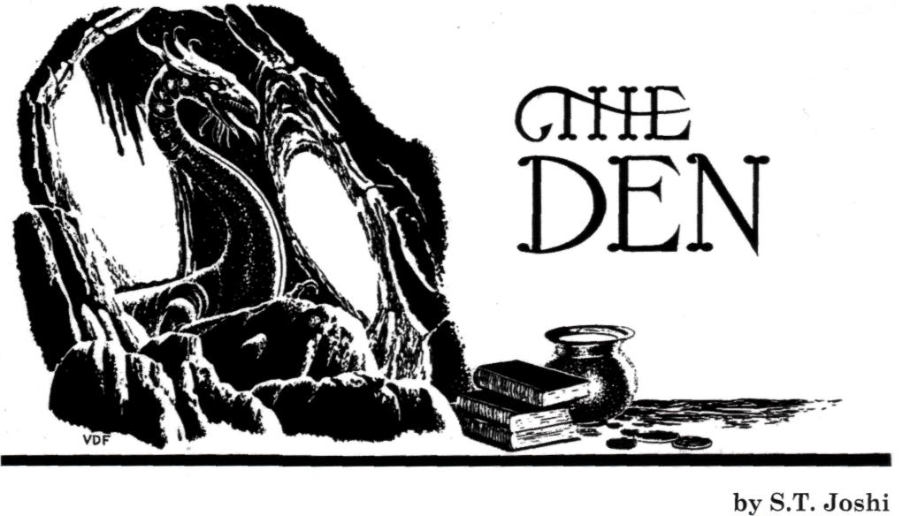

Algernon Blackwood. Mark that name well, my friends, for it may denote the greatest of all writers of weird fiction. Only Edgar Allan Poe, H.P. Lovecraft, Lord Dunsany, and Ramsey Campbell are even within striking distance of Blackwood's towering achievement, an achievement that includes not only such anthology chestnuts as "The Willows" and "The Wendigo" but such little-known novels as The Education of Uncle Paul (1909), The Human Chord (1910), and The Centaur (1911).
And yet, both the life and work of Algernon Blackwood (1869-1951) remain irksomely little-known. The image of the ageing Blackwood — bald, gaunt, leather-skinned, and with deep-set eyes that seem simultaneously grave and impish — is perhaps not as ubiquitous as H.P. Lovecraft's similarly gaunt profile, but it must have fascinated those lucky viewers of the BBC who witnessed it on various television shows on which Blackwood appeared in the last fifteen years of his life. Unfortunately, his work — hundreds of short stories, more than a dozen novels, several plays, scores of essays and reviews, and a number of works for children — has now, in large part, fallen out of print, with only intermittent attempts to bring it to the attention of new readers.
But all that could be changing. And if there is a revival of interest in Blackwood the man and Blackwood the writer, the overwhelming bulk of the credit for it will fall upon a single man — Mike Ashley.
Algernon Blackwood: An Extraordinary Life (Carroll & Graf, 2001; first published by Constable as Starlight Man: The Extraordinary Life of Algernon Blackwood) is the result of nearly a quarter-century's research by Ashley into every possible nook and cranny that could shed any light on this British colossus whose life extended into eight decades and whose literary work spanned more than six. As one who has toiled for an approximately similar period in the research and writing of a biography, I can attest that Ashley's achievement in this book is titanic, monumental, and almost beyond cavil.
Criticism becomes almost an impertinence when faced with a book that displays such massive research, such skilled organization of that research, and, most significant of all, such a remarkable revivication of its subject. Blackwood lives in this book as few other subjects of biographies have ever lived in theirs.
I trust readers will pardon a brief comparison of this work with my biography of Lovecraft — a comparison, I hasten to add, that will only make Ashley's accomplishment stand out in greater relief. The differences in writing a biography of modern life — in occultism, theosophy, the Golden Dawn, and, later, the philosophy of Gurdjieff.
I have no intention of retelling Blackwood's life in small compass here; all readers owe it to themselves to see how skillfully Ashley has marshalled a bewildering mass of fragmentary data into a seamless narrative of a life rich with friends, family (although Blackwood remained a lifelong bachelor), and literary accomplishment. The unexpected success of the best-selling John Silence — Physician Extraordinary (1908) allowed Blackwood to spend the next half-decade in Switzerland, and Ashley is right to remark that "The next five years would see Blackwood produce the most remarkable body of supernatural fiction ever written." The story collections The Lost Valley (1910), Pan's Garden (1912), and Incredible Adventures (1914; my own choice as the greatest collection of weird tales ever written); the novels Jimbo (1909; first draft written years earlier), The Human Chord, The Centaur (Blackwood's spiritual autobiography and the centerpiece of his entire work), and A Prisoner in Fairyland (1913): these volumes and others attest to the truth of Ashley's contention.
The rest of Blackwood's career was, however, a series of fits and starts. Ashley finds more value in Julius LeVallon (1916) than I do; he actually calls it "arguably the best of all his novels." Its loose sequel, The Bright Messenger (1921), is to my mind still less successful; Ashley charitably notes that it is "a courageous book — intelligent, unique, original. Alas, it is not a great book." It is, indeed, rather chilling to read at this point in Ashley's book that "Blackwood had said all he wanted to say." The last three decades of his life were devoted chiefly to plays (notably The Starlight Express, an adaptation of A Prisoner in Fairyland, with music by Edward Elgar), to works for children, and especially to appearances on radio and television. To my mind none of the later works for (or about) children can measure up to the utterly charming and patently autobiographical The Education of Uncle Paul, one of the lost classics of fantasy and a book desperately crying out for reprinting, perhaps in conjunction with Jimbo. Ashley, to my mind, considerably overpraises the late The FruitStoners (1934), saying of it: "Although deeply philosophical, the book is devoid of the oversentimentality of The Education of Uncle Paul, and the verbosity of A Prisoner in Fairyland, and has a stronger narrative drive than The Extra Day, which makes it the most accomplished of his childhood books." Well, perhaps a rereading is in order; however much one may disagree with Ashley's judgments, his opinions are always worthy of respect.
One could go on and on about Blackwood, and about Ashley's biography. The obscure facts that he has unearthed are endlessly fascinating. Who could have imagined that, as a reporter in 1893, Blackwood interviewed Lizzie Borden? that a 1925 revival of the play Through the Crack marked "the first professional theatrical work for Laurence Olivier" (he was "a second assistant stage manager and general understudy")? that Blackwood was saved from death by a German bomb by rushing out of his house to check on some burning sausages? If one must cavil, one might say that Ashley's discussion of Blackwood's works tends a bit too much toward plot summary (necessary in many cases because of their current unavailability) and not enough in the way of analysis. But that analysis can now be left to others — or to Ashley himself, if he wishes to write a companion critical study — since the fundamental facts of Blackwood's life have now finally been charted. One hesitates to use the word "definitive" for any work of scholarship, but it is difficult to imagine anyone writing a more detailed, more exhaustive, and at the same time a more empathic and heartwarming biography. Through Mike Ashley, we come to know Algernon Blackwood, to admire him, and to wish that he had been our own "Uncle Paul."
At this point it would seem to be beating a dead horse for me to make any extensive comments on The Children of Cthulhu: Chilling New Tales Inspired by H.P. Lovecraft, edited by John Pelan and Benjamin Adams (Ballantine, 2002). My hostility to modern "additions" to Lovecraft's myth-cycle is so well-known that any adverse remarks I now make would simply be passed off as "more of the same." And yet, I cannot forbear commenting on at least a few specimens in this book of all-original stories, mostly by young writers.
Let me state at the outset that, if my overall response to this anthology is not very enthusiastic, the fault cannot be placed entirely on the shoulders of the editors. I know nothing about Benjamin Adams, but John Pelan's astuteness as a writer, editor, and publisher can hardly be questioned. Why, after all, he has published two of my own books with Midnight House. I am therefore compelled to assume that the stories in this volume represent the best of a bad lot, and that what was rejected was, on the whole, even worse. One begins to wonder whether it is even possible to write a "Cthulhu Mythos" story today.
I am obliged to single out Richard Laymon's "The Cabin in the Woods" for especial dispraise. Here we have what purports to be some kind of imaginative extension or elaboration upon Lovecraft's "The Whisperer in Darkness," but proves instead to be merely a crude and incompetent rewrite of that story. No new ideas, no new perspectives (except, perhaps, a clumsy attempt at depicting interpersonal conflict) can be found here. Laymon has a particular penchant for what might be called onomatopoeic horror: "I listened and heard a quiet, heavy whup . . . whup . . . whup . . ." and later: "A huge shape of blackness descended upon Arthur: KRAWBOOM!" (Wasn't there once a breakfast cereal with that name? Er, no, that was Kaboom.)
Why is this story in this book? It is not merely sub-professional; it is well-nigh sub-literary. Laymon is certainly not to be classed with the mostly young, hip writers who largely fill this volume. I can only assume that his celebrity and reputation — the basis of which continues to befuddle me, since what little of his work I have read has been uniformly mediocre — impelled his inclusion in a book that is otherwise somewhat short on name recognition. (I am aware that Laymon has now shuffled off this mortal coil and is therefore not able to defend himself — as, in life, he was rather vociferously inclined to do, since he apparently did not take criticism very well. But no doubt his legions of devoted fans will come to his defense by raining imprecations upon my head.)
No other story in the book is quite as bad as Laymon's — or is bad in quite the same way. I could have done without the precious and pretentious stories by China Mieville and Caitlin R. Kiernan. "A Victorian Pot Dresser" by L.H. Maynard and M.P.N. Sims is a hackneyed tale of a tentacled monster and a virgin sacrifice. Tim Lebbon's "The Stuff of the Stars, Leaking" is the pointless story of an unexplained, tentacled sea-monster that has apparently killed off the protagonist's wife. Poppy Z. Brite's "Are You Loathsome Tonight?" has no relevance to Lovecraft at all, being instead a boring story about Elvis's last days; it concludes with a quotation from Supernatural Horror in Literature that has not the slightest connection with the narrative. In Yvonne Navarro's "Meet Me on the Other Side" we learn that Lord Dunsany's Bethmoora is apparently somewhere in Arizona. Matt Cardin's "Teeth" is a lame attempt at mimicking the philosophical horror of Lovecraft's best narratives.
Then there is Paul Finch's "Long Meg and Her Daughters," in which a monster attacks the protagonist in a library — by hurling books at him. In Weston Ochse's "A Spectacle of a Man" we are presented with "visions of Christ on a cross with tentacles"!
But the volume is by no means a total loss. Indeed, the editors' own story ("That's the Story of My Life") is one of the better ones in the book — a grim tale of a weird family in Arkham. James Van Pelt's "The Invisible Empire" is the poignant account of a Colorado mining town; its exact relationship with Lovecraft (aside from its citation of the Necronomicon, under the erroneous translation Book of the Names of the Dead) remains unclear, but it is a fine piece of writing. Meredith L. Patterson's "Principles and Parameters," perhaps the best tale in the book, is an effective tale that combines the scholarly erudition of Lovecraft (a professor of linguistics attempts to translate the Pnakotic manuscripts) with the Lovecraftian theme of ghouls.
And yet, even some of the better stories are marred with irritating flaws. W.H. Pugmire's "The Serenade of Starlight" displays its author's customary flair for prose-poetry, but proves upon analysis to be little more than a partial rewrite of "The Call of Cthulhu" and "The Shadow over Innsmouth." Brian Hodge's "The Firebrand Symphony" is a long and complex tale that brings "The Shadow over Innsmouth" vaguely — but only vaguely — to mind; but it is spoiled by an appalling use of contractions: would've, could've, might've, etc. This may be acceptable in dialogue, but in expository prose it is unacceptably slangy and slipshod. Was there no copy editor at Ballantine who had the critical judgment to fix this? Apparently not, since Paul Finch's repeated use of the solecism "Alright" also passed everyone's notice without, apparently, a second thought.
It is not my custom to review comic books, even the more pretentious "graphic novels," although publishers continue to bombard me with them. But I have now come upon one set of such books that deserve some comment. Eureka Productions (Mount Horeb, Wisconsin) is doing some highly creditable work, especially in regard to popularizing some of the classics of our field. The first issue of Eureka's Rosebud Graphic Classics (2001) is devoted entirely to Edgar Allan Poe, and here we find skillful and effective graphic adaptations of "The Tell-Tale Heart," "Hop-Frog," "The Masque of the Red Death," and others. In some cases the entire text of the story is reproduced. I am heartened by the fact that Tom Pomplun — Eureka's designer and publisher — decided to adapt several of Poe's evocative poems as well, including "Annabel Lee," "The Conqueror Worm" (illustrated by Gahan Wilson), "El Dorado," "The Bells," and several others. I could have done without Clive Barker's story "New Murders in the Rue Morgue" (from Books of Blood), but no doubt marketing factors entered into its inclusion. Eureka has done a number of other handsome publications, and if they continue to feature classic works of weird fiction, then they might justifiably take credit for assisting in educating a woefully ill-educated public.
Books for review can be sent to my home, at:
3158 NE 81st Street, Seattle WA 98115. Q
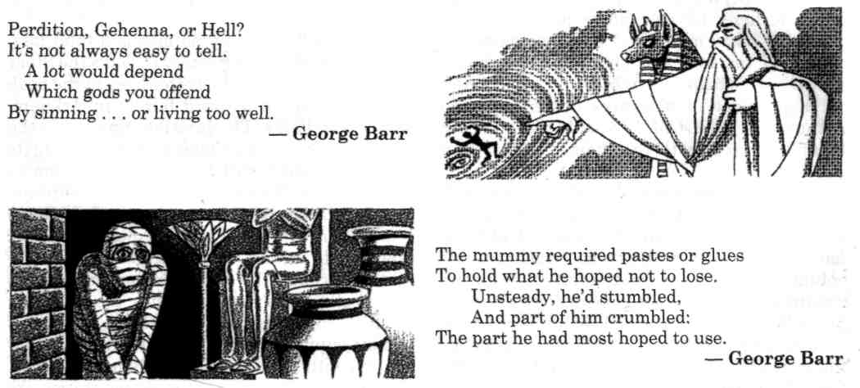

THE LITTLE NIGHTMUSIC THAT COULD

by Stephen Woodworth
illustrated by Tim Kirk

After more than two centuries of existence, Eine Kleine Nachtmusik finally achieved sentience one Thursday afternoon in the living room of Jacob Weiss's London flat.
The melody shivered in the strings of Weiss's upright piano as it awoke, then stretched and yawned for several measures. Bursting forth from the wooden confines of the instrument, it bounded around the dingy living room like an inquisitive puppy, alighting on any object that attracted its curiosity, from the stacks of yellowing sheet music and antiquated magazines on the coffee table to the austere black-and-white wedding photograph of Weiss and his late wife Avi which hung over the mantel piece. Its attention finally returned to Jacob Weiss himself, who hunched over the piano with closed eyes and caressed the keys with liver-spotted hands. That morning, his doctor had confirmed what the old piano-tuner already knew: He was going deaf. His new hearing aid would let him understand what people said to him, but it would never restore the perfect pitch that enabled him to distinguish between a G and a G-sharp. Now, he consoled himself by playing Mozart, the sprightly music reminding him of Vienna before the Anschluss, of Avi and better times.
Sensing his sorrow, the melody licked at his ears to comfort him.
Eine Kleine Nachtmusik — or "Eine," for short — stayed by Weiss's side for the next few weeks. Having evolved from the accumulated thoughts and memories of all the people who'd listened to it over the years, it felt a symbiotic attachment to Weiss, the man whose pathos had given it the final spark of life.
Like any creature, however, the melody soon began to long for the companionship of its own kind. None of the other classical pieces Weiss played on his piano seemed to possess Eine's animation or self-awareness.
So, one morning, when Jacob Weiss went down to the tobacconist's to buy his daily paper, Eine hopped from the piano-tuner's mind into a new host, a purple-haired teenager on her way to King's Cross tube station.
As she descended the stairs into the station, the girl frowned and scrutinized the personal stereo she carried. Although the stereo's headset still blared Blur's "Song 2," she abruptly found her thoughts filled with airy, elegant classical music.
Annoyed, she thumbed up the unit's volume control. The rock music snarled like an angry dog in the headset's tiny speakers, and Eine skittered away at a prestissimo pace. It sought refuge in the first friendly source of music that passed its way.
That source happened to be a buttoned-down advertising executive named Symons, a rather unimaginative little man whose greatest creation was Terry the Talking Toilet Brush for the W.C. Handywipe commode cleaner adverts on Channel 4. Symons was absently whistling a snatch of "I've Got a Lovely Bunch of Coconuts," a song he'd considered using as a jingle for the Krazy Kokonut Konfektion candy campaign, when he stopped at a news agent's to pick up a copy of the Financial Times.
Suddenly, the tune that emerged from his puckered lips turned into the opening Allegro of Eine Kleine Nachtmusik.
Symons glanced over his shoulder with a quizzical expression, then shrugged and continued on his way. Eine followed him down a rattling escalator into the bowels of the Underground.
At the base of the escalator shaft, tunnels branched off toward the Northern, Victoria, and Piccadilly Lines, and there an unshaven man in a faded denim jacket and jeans stood playing a medley of Beatles songs on a battered Gibson acoustic. His guitar case lay open at his feet, and coins hailed into its velvet interior from the hands of passing commuters.
Hoping to make the acquaintance of a fellow melody, Eine tugged at Symons's ear until the adman found himself compelled to stop and listen to the guitarist croon a rendition of "Yesterday." Eine attempted to start a conversation with the song, but the music seemed to be in a fetal form, still waiting to be born.
For his part, Symons couldn't understand why he was wasting his time listening to this shabby troubadour. The adman became even more baffled when Eine prodded him into fishing a handful of pound coins out of his pocket.
"I never tip buskers," Symons announced firmly as he let the coins fall into the guitar case.
The busker gave him a snaggle-toothed grin. "Whatever you say, guv'nor!"
Mystified at his own behavior, Symons found himself whistling Eine's Allegro again as he hurried off down the tunnel toward the Northern Line trains. He drew any number of curious looks from the other tube passengers when he clapped his hands over his mouth to try to stifle his own musical outburst.
Symons finished the Allegro and the Romanza on the ride to Bank station and started on the Menuetto as he strode up Threadneedle Street and into the offices of Drake, Drake, and Shill-ingworth.
"You must be in a good mood," Judith, his secretary, observed, tapping languidly at the keyboard of her computer.
"Hmm? No . . . not really." Symons flushed, as though she'd overheard him singing in the shower. "Can't get this damned tune out of my head. Must've been that concert at Albert Hall last week."
A trill ran along Eine's scales. Concert?
"Good was it?" The secretary squinted at the screen through her flat-topped reading glasses.
Symons shrugged. "Oh, all right, I suppose. The usual, you know — Mozart, Beethoven, that lot."
"Mmm." She proceeded to delete everything she'd just typed. "You'd recommend it, then?"
Symons blinked, as Eine bounced around inside his skull, insisting yesyesyesyesyesyesyes!
"Uh ... yes, I suppose so. If you're into that sort of thing."
"Mmm." She resumed pecking at the keyboard, picking out each letter individually with her index finger.
"Yes . . . well. Fetch the file on the Krazy Kokonut account, and bring us a cup of tea, would you?"
She nodded without looking up. "Soon as I've finished."
Symons grimaced. If only she weren't Mabel's sister... "Right, then. When you get around to it." He trudged on into his office.
Intent on the memo that she was transcribing, Judith had barely noted the above conversation with her boss/brother-in-law.
A moment after he'd left the room, however, she began to hum the same tune Symons had whistled as he arrived, starting at the very note where he'd left off.
Her fingers picked up the rhythm of the piece as they danced over the keyboard, and soon she was warbling the melody in full voice, accompanying herself on the computer with the grandiloquent hand gestures of a concert pianist.
"Urn .. . Judith?"
Her mouth snapped shut, and her hands dropped into her lap as Symons leaned out of his office doorway, staring at her in astonishment. The color rising in her cheeks, the secretary cleared her throat and tried to collect herself. "Yes?"
"The Krazy Kokonut file? And a cup of tea?"
"Oh ... of course. Right away." She pushed her glasses back up to the bridge of her nose and smoothed her ruffled beehive hairdo. "By the way, is that concert still going on?" she asked, trying to sound nonchalant.
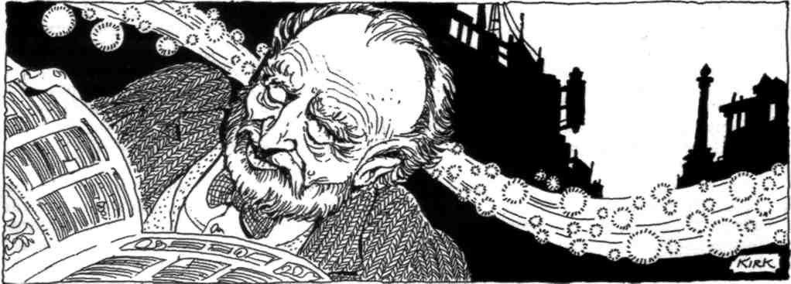

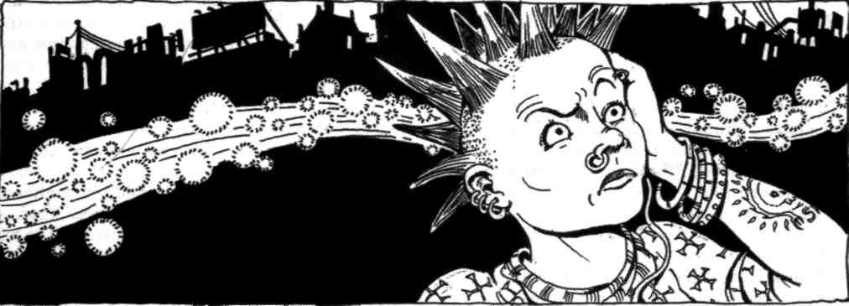

Judith's husband nearly had a fit that night when she ordered him to take her to Albert Hall. Why listen to the symphonic noodlings of some dead Gerry for two hours when there was a perfectly good football match on telly? "It's Chelsea versus Newcastle!" he protested with a mournful expression.

Fortunately, their marriage was a matriarchy, which precluded the necessity for further argument. As they settled themselves in their itchy, velvet-upholstered auditorium seats that evening, however, Judith suddenly felt like she'd rather be home watching the football match as well.
Having incessantly wheedled Judith into taking it to Albert Hall, Eine now abandoned her to explore this majestic, domed temple to Music. Surely here it would find one of its own kind!
Quivering with excitement, the melody swooped down from the balcony to the stage, where the orchestra sat rustling its sheet music and rosining its bows. Snatches of Eine's melody line rose above the din of pre-concert tuning as the gregarious composition visited one instrument after another — now chirping on the flute, now fluttering in the French horn, now skipping along the strings of the cello. The lights in the Hall dimmed and the murmur of voices in the audience subsided as the concert goers focused their attention on the floodlit platform. Eine retreated into the crowd, the better to witness the performance at hand.
A round of applause erupted as the conductor stepped up to the podium. A tall, middle-aged man with prematurely white hair, he smiled, bowed to the audience with Prussian propriety, then faced the orchestra and raised his baton. Eine's tempo beat faster as it heard the opening notes of its own Allegro. Eine Kleine Nachtmusik itself would be the first piece performed that evening!
For awhile, Eine paraded among the rows of listeners like a self-important celebrity. Before long, however, it noticed that many of the concert goers stared at the stage with glazed eyes, slouching in their seats and sneaking furtive glances at their watches. One portly fellow in the loge section actually dozed off for several minutes until his scowling wife swatted him awake with her rolled-up programme.
Eine seethed with indignation at the audience's indifference. Then it listened to the music and realized what was wrong.
The musicians played proficiently, but without passion. Originally written for a chamber ensemble, the composition had been adapted and arranged for full orchestra for this concert, which made the music louder without making it deeper — a serenade blasted through a bullhorn. The final movement ended with clockwork precision, and the audience responded with courteous clapping, although a few Philistines hurried out before the house lights came up in order to beat the rest of the crowd to the bar before intermission.
Immediately following the interval, the orchestra returned and gave an equally perfunctory performance of Beethoven's Fifth. Eine hovered near the stage in hopes of speaking with the great symphony, but it remained dormant, like a slumbering giant.
Moping in the Hall's foyer following the concert, Eine felt its disappointment turn into despair as it overheard the comments of two jaded aesthetes who loitered in the lobby.
"Mozart and Beethoven!" the taller, thinner man sniffed, squirting antihistamine spray up one nostril of his aquiline nose. "They could have given us Schoenberg, Ives, Boulez — something from the Twentieth Century, at least — but what do we get? Mozart and Beethoven! It's criminal, I tell you!"
The shorter, fatter man bobbed his head in agreement, resting his folded hands on his globular paunch. "Now, if they had played one of Mozart's real gems — one of the horn concertos, say — that would have been something. But Eine Kleine Nachtmusik? Shallow, predictable 'entertainment music'! I'll go positively mad if I hear it again."
The tall man switched nostrils and inhaled another geyser of nasal spray. "Well, I suppose you have to dumb down the programme if you want to pander to that lot."
He nodded toward a middle-aged couple, who quarreled with each other as they headed toward the exit. "Chelsea versus Newcastle!" the husband whined to his wife. "We missed Chelsea versus Newcastle!"
"Oh, shut your gob, Ron!" the steely-faced matron snapped as she stalked toward the door.
"Proles!" the tall aesthete sniffed. "No wonder classical music is in such a sorry state."
The two men then wandered off to find a pub where they could mourn the death of culture in the modern world.
Ashamed and alone, Eine slunk out of Albert Hall behind the last of the janitorial staff and spent the rest of the night sulking in G-minor. Drunken vagrants in Hyde Park could be heard singing the melancholy tune in slurred, off-key tones until the wee hours of the morning.
The following day, Eine hovered like a hangover around a bum wh6 slept on a bench in Kensington Gardens. If only it could make those other people understand it the way Jacob Weiss did, Eine thought as it gazed glumly toward the stately dome of Albert Hall. If only they could feel the music the way he did . . .
That was it! Jacob Weiss was the key! Eine's spirits leapt from piano to fortissimo in a single note, jolting the drunk out of his doze like a bugle blast.
Arms flailing and eyes gaping, the bum sat up and glanced around suspiciously. He seized the empty can that lay on the bench beside him and glared at the label. "B-bloody German beer!" He flung the can into a nearby garbage basket and vowed never to drink another lager that was colder than room temperature.
That evening, as the orchestra warmed up in Albert Hall, Eine peered into the thoughts of each of the musicians like a querulous concertmaster. The first violinist was debating whether she should return to university for a business degree, the bassoonist was considering going out for curry after the show, and the first French horn player was wondering what the first violinist would be like in bed. No wonder the previous night's performance had fallen flat! Music was the furthest thing from these people's minds.
Well, Eine would soon fix that. Settling in the head of the first violinist, Eine stretched a tendril of its consciousness toward the second violinist. With a tenuous grip on both musicians' minds, Eine engaged in a sort of mitotic division, splitting itself into two identical clones which suffused the thoughts of their hosts.
The second violinist cast a puzzled glance at the first violinist, as if she'd said something he hadn't quite heard. She, in turn, gave him the same odd look. They shrugged at one another and went back to rosining their bows.
Eine then repeated the process, replicating itself until its hive-like sentience had permeated the third violinist, the cellist, the entire string section, the woodwinds, the brass.
The musicians sat straighter in their chairs, a new sobriety in their expressions as they fixed their attention upon the sheet music in front of them. The whole orchestra was under Eine's influence by the time the white-haired conductor stepped up to the podium for the concert. As the conductor lifted his baton for the first downbeat, Eine took hold of him as well.
With the orchestra under its sway, Eine sang to the audience with the bittersweet resonance of Jacob Weiss's memories. While the gay melody still evoked images of dancing and merriment in old Vienna, it also spoke of the homeland Weiss had fled and would never see again, of the woman he cherished and could no longer touch, of the music he loved and could no longer hear. It said that the joys of this life are as evanescent as the bubbles in an uncorked bottle of champagne, and that we should drink deeply and savor their tickle on our tongues while we can.
As the performance went on, Eine could feel little bits of itself flying off to lodge — glowing — in each listener's memory, like embers cast off by a fire.
When the final movement ended, the audience responded with an awe-struck silence. Then a tuxedoed young man in the front row leapt to his feet, tears streaming down his face, and clapped furiously. The rest of the audience followed suit; the ovation went on for more than five minutes. Eine basked in the whispered praise that filled Albert Hall during the interval.
"Astonishing!"
"Best they've ever done, you ask me."
"Honestly, I don't think I have ever been so moved."
"Entertainment music," indeed! With immense satisfaction, Eine noted that all of the concert goers hastened to return to their seats long before the house lights dimmed.
Then, as the orchestra launched into Beethoven's oft-played Symphony No. 5 in C Minor, something utterly extraordinary happened. Impregnated with the scintillating spores of Eine's consciousness, the people in the Hall began to comprehend the symphony not merely as a series of sounds reproduced by rote, but as an evolving entity of experience and emotion.
And The Fifth stirred and awoke.
Like a breaching Leviathan, it erupted from the orchestra and showered cascades of passion throughout the Hall. The entire audience leapt to applaud the symphony's finale, whistling and cheering as the ovation stretched out to a full fifteen minutes.
With the bashful trepidation of an autograph-seeker approaching a cinema idol, Eine sidled up to The Fifth in the Hall's foyer following the performance. Although the jabbering concert goers were oblivious to its presence, the symphony had settled its imperious bulk in their midst like a king holding court. Eine blurted its own arpeggio of admiration and nervously inquired if The Fifth had heard Eine's portion of the concert.
With regal condescension, The Fifth replied that it had been asleep since 1827, and hadn't roused itself until the second half of that evening's performance.
Asleep? Eine chirruped. Why so long?
Hardly seemed worth getting up, The Fifth remarked with a legato sneer. Most humans can't appreciate a symphony of my caliber. Only my creator truly understood me, and when he died . . . well, I just decided to doze off until an audience came along that deserved my attention.
And that was tonight? Eine asked.
Perhaps . . . perhaps, The Fifth mused as it regarded the concert goers. They seem more receptive. Still a bit dim, but maybe they can be taught.
Eine leapt several octaves in enthusiasm. Brilliant! When do we start?
The Fifth paused for a three-quarters rest — the musical equivalent of a sigh. Perhaps you should leave their instruction to me, it said.
Eine halted in mid-measure. Why?
Because such a responsibility should fall upon a work of gravity and substance, The Fifth replied in a school-masterly tone. I mean, you're a fine little piece for what you are, but. . .
Eine bristled. For what I am? And what would that be?
Well, you know — a divertimento, a pleasant trifle, a form of. . . of . . .
"Entertainment music?" Eine suggested in a peevish pizzicato.
Precisely! So you do understand. Now, if you'll excuse me . . .
The Fifth turned its attention back to the crowd, and Eine slunk away from the symphony, fuming in tremolo. Well, The Fifth would soon see what mere "entertainment music" could do! Eine vowed. Hopping from the head of one pedestrian to another, it left the Hall and started making its way back to the City.
On what seemed like a typical Monday morning, Symons slouched in his chair and attempted to shoot rubber bands into the waste paper basket that sat beside the door to his office. A menagerie of origami animals littered his desk, all meticulously folded from his failed ideas for the Krazy Kokonut campaign.
Drawing a bead on the inside rim of the waste-basket, Symons was preparing to launch another elastic salvo when the office door opened unexpectedly, startling him. He sat bolt upright in his chair and his shot misfired, snapping his sister-in-law cum secretary Judith in her left eye as she stepped into the room.
"Ow!" she said, not unreasonably.
"Oh my God, Judith! Are you all right?" He jumped from his chair and rushed to her side.
Judith lifted her hand from her eye and tried a practice wink. "I'll live, I suppose," Judith mumbled, sounding a bit dazed.
"Good, good. Now, what was it you wanted?" He ushered her to his chair because she seemed a bit unsteady on her feet.
"I ... I wanted to ... to thank you for recommending that concert. . ."
"Thank me? You said you hated it!"
Judith blinked, as if waking from a deep sleep. "Did I? I don't know . . ."
"That's why you put salt in my tea the other morning," Symons prompted her. "Remember?"
"Why . .. yes! That awful concert!" Abruptly recollecting herself, Judith stood and shook a finger at Symons, her left eye winking furiously. "And just wait 'til I tell Mab about you and your rubber bands! You'll never hear the end of it, I promise you."
Her mouth kept moving, but Symons could no longer hear what she was saying, for the sound of violins filled his head. In a starry-eyed trance, he pushed Judith out the door of his office even as she continued to hail invective upon him. "Hold my calls," he murmured, and slammed the door on her shouting.
Hurrying back to his desk, he brushed aside the origami zoo, grabbed his pad of A2 paper and a pen, and began scribbling notes and doodles. He'd forgotten about the Krazy Kokonut campaign for the moment — it didn't suit the music. What would go well with Mozart? Of course . . . Mrs. Schnitzel's Vienna Sausages! Who was in charge of that account? Hendrickson? Well, he wouldn't have it for long! The back-stabbing bastard didn't deserve it anyway.
Symons made a brief trip to the Tower Records store in Piccadilly Circus to buy a copy of Eine Kleine Nachtmusik on CD, then spent the rest of the night at the office. He played the Mozart piece over and over on the portable stereo in his office as he toiled away at his drawing board, with Eine murmuring insistently in his ear.
In the morning, Symons shaved himself in the men's lavatory and smoothed out his rumpled, day-old suit as best he could, then packed up his presentation materials and grabbed the portable stereo. He then marched straight to the executive secretary and demanded to speak with his superiors about the Mrs. Schnitzel account. With evident reluctance, the executive secretary ushered Symons into a walnut-paneled meeting room for an audience with the firm's senior partners.
The Messrs. Drake sat behind a long ebony table, wearing matching Saville Row suits and identical expressions of superiority. Indeed, the only way to tell one Mr. Drake from the other was that the first Mr. Drake combed his hair to the right to cover his balding pate, while the second Mr. Drake combed his hair to the left. Mr. Shillingworth, the company's white-haired founder, sat slumped in an overstuffed leather chair by the window, asleep or possibly dead.
"So you want to take on the Mrs. Schnitzel campaign?" the first Mr. Drake asked dubiously as he surveyed Symons's disheveled clothes and bloodshot eyes.
"Yes, sir."
"You realize, of course, that that is Hend-rickson's account," said the second Mr. Drake.
"Was Hendrickson's account," Symons corrected. "Let me show you what I want to do with it . . ."
He set the portable stereo on the floor, unzipped his portfolio, and pulled out the sketches and storyboards he'd labored over all night. Mustering what little dramatic ability he possessed, Symons held up each paperboard drawing and attempted to convey in words the sparkling vision in his mind.
The Messrs. Drake remained unimpressed. Mr. Shillingworth remained comatose.
Symons cleared his throat and tried to generate some saliva in his mouth to moisten the sandpaper surface of his tongue. "Of course, you don't get the full effect of the concept without the music ..." He set aside the portfolio and picked up the portable stereo, then looked around the room for a place to plug it in.
There wasn't any.
In that instant, Symons's delusory bravado evaporated, replaced by a perfectly rational sense of panic. Dear God, what am I doing? he thought as he scanned the wainscotting in vain for a wall outlet. I must've been mad to try this. Mab will kill me!
The first Mr. Drake glanced quite deliberately at his watch. "If you're finished, Mr. Symons . . ."
Symons set down the stereo unit and stood before his superiors with quivering lips. Just as he was about to prostrate himself and grovel for mercy, though, Eine reasserted its control. Like a salmon determined to spawn, it swam against the surging current of Symons's hysteria and plunged deep into the adman's brain.
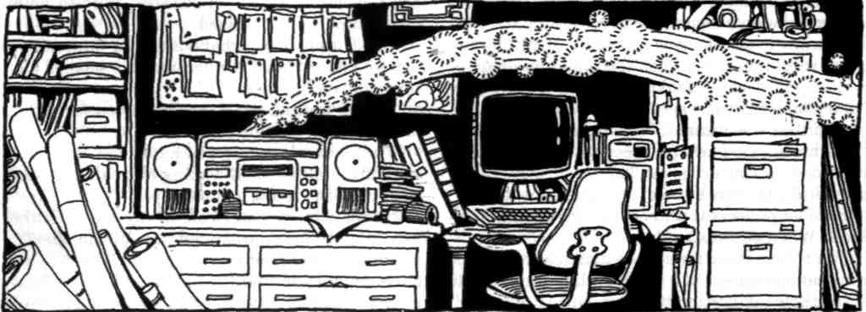

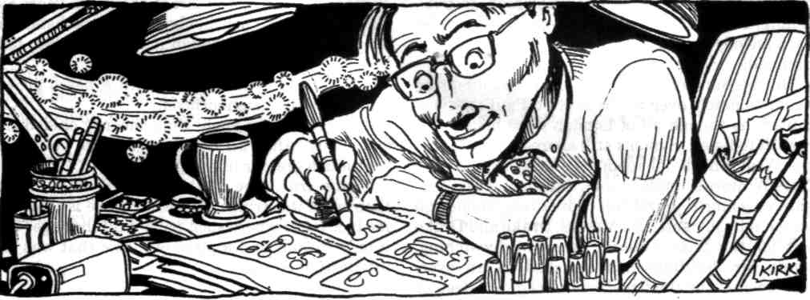

And Symons started to sing the Allegro.

The Messrs. Drake looked at one another in bewilderment. Mr. Shillingworth snorted, and his eyes popped open.
His volume swelling in the meeting room, Symons mimed the playing of each instrument as he imitated its sound. Transmitted by the medium of his voice, Eine reached across the room to infiltrate the minds of Symons's bosses.
Without realizing it, the Messrs. Drake each waved an invisible baton in time to the music, while Mr. Shillingworth bobbed his head along with the melody.
Symons performed the entire Allegro, including the sonata repeat, then fell silent, dumbfounded by what he'd just done. I really have gone 'round the bend, he thought, with a sort of euphoric awe.
He blinked at his three stunned superiors. They blinked back at him, their mouths hanging open. "Well," the first Mr. Drake said after much consideration.
"You . . . certainly did surprise us there, Symons," the second Mr. Drake stammered.
Symons shook his head. "I can explain . . ."
"No need," the first Mr. Drake assured him.
"The account is yours!" both Messrs. Drake announced simultaneously.
"It — it is?" Symons gaped at them as if they were the ones who'd gone bonkers.
"Unquestionably brilliant," declared the first Mr. Drake.
"Pure genius," the second Mr. Drake concurred.
Mr. Shillingworth grunted. Symons took it as a compliment.
"And you don't mind my taking the account from Hendrickson?"
"On the contrary," the first Mr. Drake said.
"Shows initiative," affirmed the second Mr. Drake.
"We clearly underestimated you," the first Mr. Drake admitted.
"You've got a bright future at this firm," the second Mr. Drake hinted.
Mr. Shillingworth coughed in agreement.
"Thank you, sirs!" Symons eagerly gathered his presentation materials, but hesitated as he moved to leave the boardroom. "Oh . . . about the Krazy Kokonut campaign . . ."
"Not to worry," the first Mr. Drake assured him. "Someone else will see to that."
"I believe Mr. Hendrickson may have some time on his hands," the second Mr. Drake rejoined. The Messrs. Drake chuckled. Mr. Shillingworth wheezed. Symons laughed and continued out the door, whistling Eine Kleine Nachtmusik.
The finished spot turned out just as Symons had envisioned it:
An elegant soiree in turn-of-the-century Austria. Women in satin gowns and elbow-length gloves laughing coyly at the witticisms of men with monocles and long-tailed tuxedo jackets. In the background, a string ensemble playing Mozart's nightmusic. Uniformed servants glide through the crowd, serving glasses of champagne, while a fastidious butler strides to the center of the room bearing a silver tray.
A close-up of the tray reveals dozens of bite-sized sausages on toothpicks, which the party goers set upon with delight.
"Mrs. Schnitzel's Vienna Sausages!" a German-accented announcer gushes.-"A Continental luxury everyone can afford!"
The stone-faced butler casts furtive glances left and right, then snatches the last of the hors d'oeuvres and pops it in his mouth when no one's watching, tossing the toothpick over his shoulder.
Granted, Symons took some artistic license in creating the bit — Mrs. Schnitzel's Vienna Sausages were canned in Liverpool, after all — but the sponsor adored the spot, and within a month, the adverts were all over ITV and Channel 4. Eine Kleine Nachtmusik seemed to be the ideal melodic hook for a commercial, for people found it impossible to get the tune out of their heads.
The Messrs. Drake, Drake, and Shillingworth deemed the campaign a huge success and immediately favored Symons with a promotion for his efforts. Feeling inordinately pleased with himself, Symons decided to celebrate his good fortune with Miss Winters, his nubile new secretary, at a very posh West End Hotel. (He'd palmed Judith off on Hendrickson.)
Little did Symons suspect that, as he and Miss Winters frolicked in a bubble bath and toasted his triumph with fat cigars and French champagne, his ubiquitous Mrs. Schnitzel adverts were spreading Eine like a virus through the population. Its hive-like mind humming behind the eyes of a million human hosts, Eine vowed to wake every piece of music in the land, regardless of pedigree or breed. Saccharine pop, punk rock, easy listening, Celtic folk ballads, dance-club techno — let each melody prove its own worth, and The Fifth be damned!
On the Sunday morning when Eine's offspring began to hatch, even the bells of St. Paul's seemed muted, as though all of London were holding its breath to listen. Symons still snored on the bed of his West End hotel room, one arm draped over Miss Winters's ample bosom. Judith and Ron considered going to church but chose to stay home and watch telly instead. The Messrs. Drake and Drake left for the Lake Country to go bird-watching, while Mr. Shillingworth slouched in an overstuffed chair by the fireplace in his den, asleep or possibly dead. Jacob Weiss shuffled down to the tobacconist's for his paper, pining for Eine as for a lost pet.
Few Londoners took much notice when a couple of bobbies discovered an American tourist lying dazed in Leicester Square, deliriously mumbling something about being trampled by a herd of Andrew Lloyd Webber show tunes.
By teatime, however, wild melodies were creating havoc in every borough of the capital: A busker in Euston station found himself wielding his saxophone like a snake charmer's flute as untamed jazz coiled from the instrument. Flocks of elevator Muzak pieces escaped from the lift shafts in downtown high-rises and fluttered helter-skelter through corporate offices, twittering like braindamaged birds. A royal reception at Parliament dissolved in disarray after "God Save the Queen" began berating the MPs for singing off-key. "Anarchy in the U.K." copulated with "Jerusalem" on the front steps of Westminster Abbey, while "Song 2" buzzed the heads of pedestrians in Piccadilly Circus.
The chain reaction of musical awakenings spread out from London to every city and town throughout the great isles of Britain. There were even reports of Catholic masses squabbling with Presbyterian hymns in the streets of Belfast.
With its egalitarian musical uprising in full swing, Eine returned to the West End to taunt The Fifth with its success. It found the symphony sulking in the head of a kindred spirit — a bitter old Thatcherite Tory who seated himself on a park bench in Kensington Gardens every day to glower at passersby and shake his head at the Empire's decline and fall. An elderly widow sat beside the Tory, tossing bread crumbs to the ducks and geese from a paper bag on her lap.
As Eine settled itself into the old woman's thoughts, a little blond girl of about five years old skipped past the bench, chasing an insubstantial Spice Girls tune as though it were a helium balloon that had slipped from her grasp.
Well, The Fifth muttered with a basso growl, there goes the neighborhood.
Don't be such a snob, Eine cheerily chided the symphony. After all, silly songs make you seem that much greater in comparison.
That's true, The Fifth conceded with a vain flourish of its strings. But what place is there for me in a world where such tripe is all the rage? Oh, if only I could find a piece of music that was my intellectual equal! The symphony sounded so lonely that Eine brushed aside the implied insult.
Why don't you come with me? it good-naturedly suggested. If I'm not mistaken, one of the Bran-denburg Concertos is hanging around a cafe down-town.
The Brandenburgs! The Fifth exclaimed, its tone brightening. Now they were members of the Old School! Why, I haven't heard a note from them for two hundred years. As I recall, we were at the court of the King of Prussia . . .
Eine patiently listened to The Fifth ramble and reminisce as the two of them ambled off to join their musical brethren.
The moment they departed, the dour Tory's expression turned from disdain to puzzlement. He glanced at the elderly woman beside him on the bench.
"Excuse me, madam, but... did you just ask me to go to a cafe with you?"
"No," she replied with a coy smile, "but I will if you want me to."
Meanwhile, from quite a long way away (though not nearly so far as most people think), a spirit surveyed the merry chaos of the musical awakening with impish glee. A grin spread across his elfin face as he savored the irony: Although he'd always put his faith in the titans of his progeny — Don Giovanni, Figaro, "Jupiter" and its sibling symphonies — it was little Eine, the runt of the litter, who ultimately achieved his heart's goal, who made the music of the world a species of its own. But, then, the children from whom we expect the least are so often the ones who surprise us the most.
His soul glowing with paternal pride, the Composer smiled down upon Eine, in whom he was well pleased, and waited to see what strange delights the Family of Music would foster upon the Earth.
OLD FRIENDS
We dead leave no footprints in the snow,
and when we summon you to the door, For we are your ineradicable past,
you say it's the wind, or rustling ivy, and your inescapable future.
or a dry branch scraping a window pane.
We wait voiceless in the dark,
in our hunger and our rage,
for you to wander out that door,
Or lean out the window into the night. Darrell Schweitzer

WEREWOLF IN A CAGE
The tent is kept dark The audience files in,
With a single spotlight Amazed by his wildness,
High near the canvas top Awed by his sharp canines,
To simulate a full moon. Teasing his growing hunger.
The beast paces the cage When alone, he secretly prays
Rubbing slyly against Not for the freedom of the wood
The bars, testing them to But for the false moon to set
See if they still hold firm. And give him hands to pick the lock.
— K.S. Hardy

THE DISCIPLE
by David Barr Kirtley

Professor Carlton Brose was evil, and I adored him as only a freshman can. I spent the first miserable winter at college watching him, studying the way he darkly arched his eyebrow when he made a point, or how he could flick a smoking cigarette away into a murky puddle, forgotten the instant it left his touch. I mimicked these small things privately, mercilessly. I don't know why, because it wasn't the small things that drew me in at all. It was the big things, the stories people told as far away as dear old Carolina.
You heard the name Brose if you ran with any cults, and I ran with a couple. Society rejected us and so we rejected them. The more things you give up, the less there are to bind your will. There's power in that, we were sure of it, but it was damned elusive.
I knew the owner of an occult bookstore in Raleigh. He claimed he had actually met Brose. "These other guys you hang with," he said, "them I'm not so sure about. But this guy Brose, he's the real deal."
I studied the man carefully. "You believe that?"
He'd been shelving books, but then he dropped them into a pile on the floor and turned to me with a slightly crazed look in his eyes.
"I've seen it, man," he said, "personally seen it. Flies buzz up out of the rot and swirl in formation around him. He can make your eyes bleed just from looking at him. The guy's tapped into something huge."
I was skeptical. "And he teaches a class?"
"Not just a class, all right? It's this special program, only a dozen or so are admitted, and they get power. I've seen that too. Then they go away. Every spring."
"Go where?"
He shook his head. "Damned if I know. Places not of this world, that's what some people say."
"I don't buy it," I said. "If he's got so much going for him, why's he working a job at all? And what kind of school would let him teach it?"
He just shrugged. "I don't know about that. All I know is that Brose is for real. You can take my word on it."
"Then why aren't you in his class?"
He stared at me fixedly. "Brose wouldn't take me. He said I had no talent, no potential, said I was harmless and should go get a job. It hurt like hell, but that's another reason I know he's legit — what kind of fraud would turn people away like that?"
I had no answer for him, and I'd known a lot of frauds.
I traveled to Arkham, to Miskatonic University where Brose taught. I sought out his office in the deepest corner of the Anthropology building. I sat on a bench there, pretending to read, waiting for him to emerge.
The door opened and I caught just a glimpse of his shadowed chamber, of the brooding, crowded shapes that lurked in there. Then the door was closed again and Brose was walking past me down the hall. I glanced up just as he went by, as if it were an accident, as if it was the motion of his dark sleeve that had caught my eye.
Brose stared down at me with eyes the color of a tombstone. The shadows seemed to lengthen and darken as he passed, and he smiled knowingly. I shuddered, because he had seen me and because I knew just from the look that it was all true. I had found the real thing. Brose practically radiated power. On that day my initial skepticism transformed itself into the most helpless adoration. I enrolled myself in the school.
Winter came. The inside of his office was like some terrible jungle. Loose, shadowed papers crammed the bookshelves, drooping downwards like wild leaves. A filth-choked, and apparently unused, fish tank cast a dim green light. Through the window I saw the lonely stretch of gray-green Massachusetts woods that was called the Arboretum.
Brose leaned back into those shadows of his own making and eyed me severely. "Why do you want to join the program?"
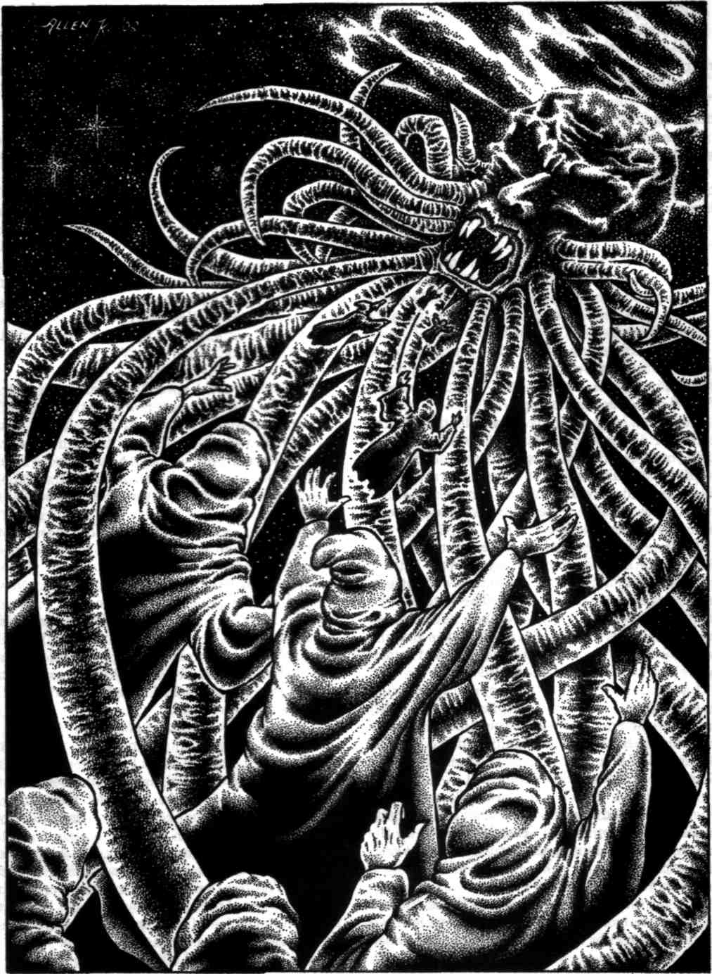
"To study with you," I responded automatically.

"Why should I accept you?"
"I'll do anything," I said. "No hesitation. No regret."
His lips curled into that now familiar smile. "But what have you got already? What are you bringing to the program?"
I knew he meant power. I sighed. "Nothing. Not yet, that is. But you can —"
He shook his head. "If nothing's what you have, then nothing's what you get from me. Go back to literature. It's really —"
"No!" I broke in. I halted then. Breathing was a sudden strain. "I don't have much, that's true. I've lost things in my life." I paused. "So many things, but I've gained something, too. I've gained this rotting emptiness inside me and I can use it. I swear I can use it. All the loss, it can't all have been for nothing." I added softly, "I won't let it be."
Brose watched me from the darkness for a length of time that seemed to stretch into endlessness. Finally he nodded. "All right," he said. "You'll do. I'll go get the form."
I let out a long sigh of relief and leaned back in my chair as Brose stepped from the room. Something on the bookshelf caught my eye, not because it glinted or was bright, but because it was more in darkness and more in shadows than it should have been. I rose from my seat and walked gingerly across the floorboards toward it.
It was a black statuette about a foot tall, carved from some sort of soapy ebony. It was a thing resembling a man, but with eyes that were utterly empty, and a beard of tentacles. The farther down it my eyes traced, the more that noble visage merged into the grotesque, until it was nothing but tentacles. They seemed to squirm and writhe and cling to the base of the statue.
I went to pick it up, to study it closer, but I gasped when I lifted it. The thing was unearthly heavy — heavier than anything that size could possibly be, heavier than I could hold in one hand. It tore itself from my fingers and lunged for the floor, where it thudded and lay still.
"Don't touch that," Brose ordered and I stiffened. He closed his office door behind him and placed a shoebox on his desk. He picked up the statue, with two hands, and returned it to its resting place.
"I'm sorry," I began. "I —"
My voice died in my throat as Brose lifted a small white mouse from the shoebox, dangling it from his fingers by the tail. It squirmed and flailed and sniffed.
"What's that?" I said.
"This," said Brose, indicating the mouse, "is the form. The application form." He paced over to that gruesomely overgrown fish tank and removed the cover.
He held the mouse out to me. "Fill out your application."
I took the mouse by its tail and held it over the foul water. The snowy little white thing tried playfully to nibble my finger.
Brose eyed me intently. It was a test. Of what? Of my willingness? Of my resolve? I let the mouse go. It fell into the water and began to thrash and scream, clawing at the sides of the tank and at all the sticky filth that enveloped it. Water soaked its fur and garbled its cries. Then it died and floated there, spinning slowly, four pink legs hanging down, and its tail trailed behind it.
"Your application's been accepted," Brose said. "Congratulations."
The members of the special program sat in a circle, with Brose at the center, and he taught us.
"There's only one thing you must learn, and that is to bind yourself to something more powerful — to attach yourself to its will. There'll be other lessons, other abilities, other distractions. The binding is all that matters. Never lose sight of that."
There were thirteen students in the class. Most were male, all had sallow flesh and haunted eyes and skinny limbs. Many were involved with cults in and around Boston. They were all from New England, at least. Everyone but me.
Brose crucified a cat. The animal howled and squirmed around on its back, pounding its tail against the desk, but the nails driven through its outstretched limbs held it firm. Blood flowed from its paws, and Brose washed it and washed it until there was no more blood.
He turned to me. "Make it bleed again."
I was filled with an aching desire to prove myself. I wanted him to think I was special — that I was his most talented, most dedicated, most favored student. I would have done anything, endured anything, to make him adore me, the way I adored him.
The cat's eyes were narrow slits, and where the eyeballs met the fur its flesh was pinkish and gummy. The iron nails and the blood were both dark and seemed to run together. The cat had soft little pads on its feet. It was innocent and helpless but I would have made it bleed. For him.
"I don't know how," I whispered desperately.
Brose paced back and forth in front of us all. "To control the body you must feel the mind. Pain is conspicuous. It'll point the way, but don't depend on it. There are greater things than cats you must connect to, greater things than you, and they have never felt pain."
Brose turned to another student, a heavier guy with dark, scornful eyes, and pointed at the cat. "Make it bleed again."
The student kept his eyes on Brose, never even glancing at the cat. The animal began to bubble and ooze and spray little spurts of thick blood from its punctured body.
"Good," Brose nodded. "Very good."
At the end of class we were ordered to pack up our things and move into a sprawling colonial house on the edges of the campus. We would have no more contact with the other students.
"Tell no one what you have learned," Brose admonished us. "The penalty will be expulsion from the program, and worse things."
I met my new roommate later that night. He had already unpacked when I arrived. Our room was small, with hardwood floors and peeling white paint and touches of Gothic architecture around the windows and the molding. I stared at his familiar, slightly heavy face. My bags fell from my hands and dropped heavily on the floor. "You're —"
"Adrian," he said quickly, smugly.
I finished lamely, "— the one who can make the cat bleed."
He leaned toward me, resting his arms across the back of his chair. "I can do a lot of things. I'm the best in the class, and Brose knows it."
"We'll see," I said. I was jolted by the way he seemed to have figured me out. I couldn't believe it was an accident, the way his words seemed calculated to tear at my greatest longing: to be favored, to be adored.
I added, "It was only a cat."
He stiffened. "You think I should've used something bigger?"
Before I could answer I felt a thick wetness on my upper lip, running down my face. I glanced at Adrian, then moved quickly to the mirror. Rivers of blood poured from my nose, breaking into thin tributaries that covered my mouth and chin, streaking down my neck toward my collar.
I gasped and seized a nearby towel, mopping at my face, leaning my head back and pressing the towel against my nose.
"Don't lean back," Adrian ordered. "Keep pressure on your nose. The bleeding will stop." I bent forward and pulled the towel away from my eyes, watching Adrian guardedly with one eye. He smiled.
What a horrible desire, this desire to be favored. So much worse than any other desire — whether for money or fame or pleasure. Those things could be shared with others. To be favored requires that others are disfavored, cast out. A horrible desire, but mine nonetheless.
Each day it became clearer that I had failed in my ambition. Adrian was the best in the class and he knew it, and so did Brose, and so did I. I also knew that I was the worst. I trailed behind my classmates in absorbing those increasingly macabre lessons we received.
If I could not be favored by Brose, I would have preferred to be disfavored, to be his enemy. In reality he was indifferent to me. I was not important enough even for him to despise.
As I walked along the shaded pathways of the college grounds I pondered the strange role that Brose played here. It was clear that the other students, faculty, even the administrators, suspected the dark nature of our special program. They gave us plenty of room when we passed on the sidewalk, and shot us looks full of fear and hostility. They disapproved, but made no effort to stop us. Were they simply afraid of Brose? I couldn't decide.
Brose himself became more and more agitated as the semester wore on, his lectures increasingly frenzied and mad. He raved of nothing but the binding.
"You must learn faster!" He pounded on his desk. "The hour of the binding is coming. It has all led up to this." He took a great, heaving, somber breath. "You must bind yourselves to the impossible mind of the Traveler on the Oceans of Night, the Stepper Across the Stars. If you ingratiate yourselves you will earn a place as His favored disciples and journey with Him forever to those places only He can make by His dreaming."
I glanced at Adrian, but he kept his eyes fixed straight ahead. So now we knew our fate. We would gain the ultimate power we sought by pledging ourselves to this ultimate being.
With two hands, Brose lifted the black statuette out of his briefcase and placed it on his desk. It was denser and darker than any earthly thing could ever be — the tentacled man-thing with its empty eyes. I noticed an aspect of the carving I had not seen before. Among its many limbs, tiny human figures clung lovingly. Such an abrupt transition of scale almost made me seasick. If those men were the size of normal men then that creature must tower to unimaginable heights. The Traveler on Oceans of Night. The Stepper Across the Stars. It was He.
That week I dreamed murky dreams of upside-down cities built from granite and slime. One night I was awakened by the fevered whimpering of Adrian. He scrabbled wildly across the floor, as if something horrid hung from the ceiling overhead.
"What is it?" I asked him, "What's wrong?"
"Oh God," he wailed. His usual swagger had disintegrated. "Oh, can't you feel it? Are you blind and deaf and numb to everything? His boundlessness reaches across the void to poison our dreams."
"What?" I pressed.
Then I saw his eyes and knew that he wasn't staring at the ceiling at all, but at the sky and the stars and the dark emptiness beyond.
"The Traveler on Oceans of Night," Adrian whispered. "He's coming." .
I had failed to win the adoration of Brose, but who was Brose, compared to all this? Compared to this great Traveler? Brose was nothing. He was a small man who lived a small life, pointing others along an exalted path that he himself dared not follow. I had found an object far more worthy of my attention. To be a disciple to such imaginable power, to be favored by the Traveler! I trembled at the thought.
I wouldn't fail this time.
The night of the binding arrived. The Traveler on Oceans of Night was near. His power and his presence was palpable, casting long shadows of blackened ether over the landscape. He loomed imposingly, like a tsunami just offshore. I looked out into the sea of forests, and the trees themselves seemed to quake and tremble, the air charged with magic. I shivered.
We donned black robes and Brose led us deep into the Arboretum, down well-worn trails, among piles of sharp, mossy stones, beneath the thin thorn branches of withered old trees. Brose held that dark stone idol before him and we didn't need light to see, because the statue seemed to suck the shadows out of the ground and pull them into itself.
In the deepest corner of the woods, within a grotto of carved gray stone, sprawled a huge and ancient shrine interwoven with the roots of great, rotting trees. Brose set his statue on the ground and- we settled among the gnarled roots to wait.
I don't know how many hours we waited out there on the cold, unforgiving stones. A breeze began to twist and turn, picking up damp leaves and flinging them about, raising them into great columns in the sky, faster and louder every second until the wind seemed to shriek in pain from the forces tearing at it.
There was a sudden, maddening sense of dislocation, like a dream and a nightmare spun together into a crazy cacophony of unbearable sensation. The shadows leapt from beneath the trees to block out the starlight and wrap themselves around my throat and sink behind my eyes.
The Traveler on Oceans of Night was there, his form stretching upwards to infinity. There was no limit to his dimensions and all of him was far away and yet pressing close around us all at once. He was so enormous, so horrible, so magnificent, that our bodies collapsed into a formless mass and we wept helplessly and without shame to behold Him.
Through that confused jumble of sensation and reality came the voice of Brose screaming. "Bind yourself! Do it now!"
Adrian was first. He rose off the ground, arms outstretched, robe whipping wildly about him. He had closed his eyes and his face was turned to the sky. His expression was one of wild religious ecstasy. One by one my classmates lifted from the ground until they circled in rings around that great being, weaving complex patterns — like flies, I realized suddenly — like flies rising out of the rot to circle around Professor Carlton Brose.
I saw Brose, and on his face was something I had grown to know too well. Indifference. It was all horribly wrong. I imagined I saw that same expression mirrored in the face of the creature before me, on that incomprehensible otherworldly countenance.
I would not bind to Him. I crawled and crawled until somehow I found a rock to hide behind and then I screamed incoherently to my whirling classmates. "We're the flies!" I screamed until my throat was torn and useless. "Oh God, we're like the flies."
Then the Traveler made one ponderous motion with a million of His slimy tentacles and He stepped away towards another star, another dimension, another world He had dreamed.
The night was silent and empty, except for me, and Carlton Brose, huddled against the ground. When he saw me, he said, "You failed the binding."
I seized him by the throat and forced his head down against the stone. "You lied," I growled. "You said you'd make us His disciples."
Brose watched me uneasily for a long time. Finally, he whispered, "The Traveler on Oceans of Night is a great vessel. I would put you aboard."
"As what?" I challenged. "A rat in the hold?"
He closed his eyes and was silent for a long time.
I said, "Or rather, a flea on a rat."
I relaxed my grip for a moment, and in that moment I imagined I saw the dozen bodies of my classmates, sucked away into the bitter black void between worlds, grouped close, their frozen forms twirling slowly, stiffly, in an endless dance among the stars. I shuddered.
Suddenly, Brose seized my temples with his muddy fingers and forced me to look down into his cold, tombstone eyes. Then my own eyes began to burst and ooze, and red blood filled my sight. I screamed out in the night and knew he meant to kill me.
Flailing on the ground, my fingers fell on the dark statuette. I lifted the thing above my shoulders and brought it down with two angry arms. The unearthly weight of it fell into Brose's forehead and it sank and sank deeper, without resistance, until it reached the ground. I pulled it away. There "was a black, gaping hole where the face of Professor Carlton Brose had been.
The empty eyes of the Traveler could see things that humans never dreamt of, but He was blind to the pain of this sad world.
You were the best, Adrian. You were better than me, better at a lie. Are you proud?
A student came to see me today, to beg admission to my special program. He pushed a mouse down into the fish tank and held it in his fist until it drowned.
"Congratulations," I said. 'You have been accepted."
He smiled.
So much cruelty. I could teach the class without it, but I keep the tradition, as I'm sure Brose did, to ease my conscience. It reassures me that my students are evil, that they deserve their fate.
The college hates the special program, but they know it's necessary, and after Brose died I was the only one who could replace him. Dangerous people are lurking around New England — ones who've latched onto darkness, or might — and they need to be taken care of. The harmless ones I turn away.
I've learned the truth Brose knew: it's best to be a big fish in a small pond. Fish can't live outside the pond, and it's not so bad being a fish. Every Spring, until I send them off to die, a new class studies with me. They are enthralled by my meager powers, they long for my briefest attention.
They adore me.
GENERIC STORY
Knock on door. Rescue maiden curvy.
Corpse on floor. Plot goes tipsy turvy.
Crash! Bang! Exit monster gory.
Good guys nervy. You've survived generic story.
— Sally Parker

DRAGON SLAYING
Kill a dragon; From dragon's blood, fresh from a vein,
Chop it up. Physicians make their potions.
There's money in the carcass. The ground-up bones melt away stones
Armorers want the scales for mail And make good fertilizer.
and the hide for leather. Only the flesh goes to waste.
Wizards buy the horns and eyes — Chris Ferrier
Only they know why.
ALICIA
by Ian Watson
illustrated by Russell Morgan

When I squeezed Alicia's thin neck, her palms flapped at me feebly like a pair of tropical butterflies the hue of milk chocolate. And as ineffectually as butterfly wings. Her eyes bulged imploringly although resignedly. There's such pathos about some little black kids, particularly Alicia. She was a delicate girl, no robust cheery piccaninny for want of a more politically sensitive word.
I felt amazed horror at what I was doing, yet I found it impossible to stop myself until after Alicia went limp. At last I could lay her down upon the threadbare carpet where she sprawled like a skinny doll in a scruffy white cotton dress, her legs and arms twisted sticks. My hands had strangled her, these white woman's hands stronger than Alicia's entire body. Stronger even than myself, since killing her was the last thing in the world I would do! Except that I had just done so.
Then I woke up in bed and immediately lunged for the lamp switch. I was so certain that I would see little Alicia lying there on my carpet, which wasn't threadbare but a thick green pile. Of course the carpet was empty of any little black girl. Nevertheless I stared around the room, convinced that I had snuffed out her life between my fingers like the flame from a candle wick. The dream had such a force of reality.
Shivering with shock, I hugged my knees in their nightdress for minutes then minutes more. Where was the partner when I needed him? Not beside me, certainly. Tom had stayed at the party after we argued — after Tom provoked the argument and insulted me so that I stormed out. By now it was three in the morning. Tom would be in some other woman's bed, which I would never be able to prove because our dear host Dominic who was Tom's friend would swear that my partner slept on his sofa or on his floor amidst the abandoned wine glasses after it became too late to wander drunkenly home.
Was it undirectable anger which had made me strangle Alicia because Tom himself was too burly to attack except with words such as "Fuck you, then!" Take my rage and resentment out on a helpless child, a living rag-doll? That couldn't be why. A schoolteacher nurtures her pupils. She cares for them because they're so young and vulnerable and they're still being formed—Alicia was only seven.
It wasn't until Alicia came into my classroom the next morning amidst a stream of noisier kids and seated herself in her usual chair that I finally knew with the greatest relief that I had not somehow murdered her the night before. I walked around the room, greeting and hushing and settling, mainly so as to let myself brush the back of Alicia's head lightly with my hand to confirm her living actuality.
At my touch the little black girl flinched then she looked up at me and for a moment she smiled. Just for a moment. She wasn't exactly given to expressiveness. I don't mean she was autistic, nothing like that. Quiet was the word for her.
Maybe the meaning of my dream was that I had been overlooking Alicia because she was so easy to overlook. Now a teacher's conscience — and a woman's — had given me a nudge. Adopt a more hands-on approach, Jenny Palmer!
It was a chilly January day, although the sun shone through the classroom window past blocks of flats and a derelict factory. A passenger jet was labouring low across London. A class of thirty-five faces regarded me — appalling pupil/ teacher ratio. Black faces and brown predominated. I was obliged to pay special attention to some of the Bangladeshi and Hindu girls who still only had a feeble grasp of English, while a Somali and a Kurdish refugee girl had hardly any English at all. Kids of Afro-Caribbean parents, however, spoke English as a first language and if some of those were from dysfunctional backgrounds at least they expressed this in a tongue we shared.
God, some of the parents! What was Jake's dad ? A yardie, a pimp? His mum, a shoplifter by day, a hooker by night? When the Head Teacher and I finally compelled Jake's mum to come in to school to talk to us about Jake's disruptiveness, we left the woman alone only briefly.
Two minutes later she had disappeared and so had my handbag. Keys to the flat, cash, credit card. I rushed to phone Tom to get back to the flat immediately. Thank god he answered the phone and wasn't with one of his lady friends. Tom arrived at our flat just in time to chase off this black guy who was about to let himself in. Jake's mum must have had a taxi waiting outside the school. I phoned the police immediately after alerting Tom but they turned up twenty minutes late.
I really regretted that bag, a treat for myself from the King's Road, Chelsea. It cost almost a hundred pounds, though I told Tom it only cost ten. If only Jake's mum had just taken the cash and keys and discarded the bag in the street.
Anyway, my main priority wasn't Alicia. Her work was okay. She was just quiet.
On the whole I counted my classroom as a reasonably happy and effective place. I felt satisfied that I was doing something useful — apart from those times when I could have torn my hair out. Always in the fridge at home there was a bottle of wine for when I got back frazzled, with exercise books to mark or reports to write. Tom perhaps to take me out, or take himself out. God knows why I didn't leave him. Inertia, weak will.
Red-headed freckly Sandra Dixon taught the year below mine. She was married to a Maths teacher at the nearby comprehensive school where the little boys we tried to cherish and bring on would become streetwise and soon might be doing drugs. Oh God if only I could have been at a school of little angels somewhere. Dream on. The welfare of non-angels was our responsibility. Sometimes I went out for a meal with Sandra and her Paul whom I frankly found a bit stodgy. Stodgy was probably better than the sort of stimulating mental cruelty Tom inflicted when he wasn't being the gorgeous hero he had once been to me.
... The year before, Alicia had been in Sandra's class. Now Sandra taught Alicia's younger brother Henry who came to school in scuffed brown leather shoes much too big for him so that when he clomped along the corridor he sounded like a slow clog-dancer.
Freckles aside, Sandra was ashen-faced when I saw her in the frosted tarmac playground in her fawn woollen coat, anxiously scanning children as their mums or not-really-my-dads left them at the school gate, or as they arrived alone.
"Thank god, here she comes now!"
Alicia was arriving — hand in hand with her brother, their breath visible in the air. The coats they wore were too big for them so that both kids looked clownish — grow into those, won't they? — but at least they did have coats.
"Jenny, I had such a ghastly dream — it was so real. You won't believe this. I dreamt I . . . murdered Alicia."
Of course I believed her. It was the shock of confirmation of my own dream that made me gasp. The fact that another person had dreamt the same dream.
"How did you murder her, Sandra?"
"With a knife. A kitchen knife. I stabbed her and stabbed her. I just couldn't stop myself."
"Listen, Sandra — " And I told her of my own dream.
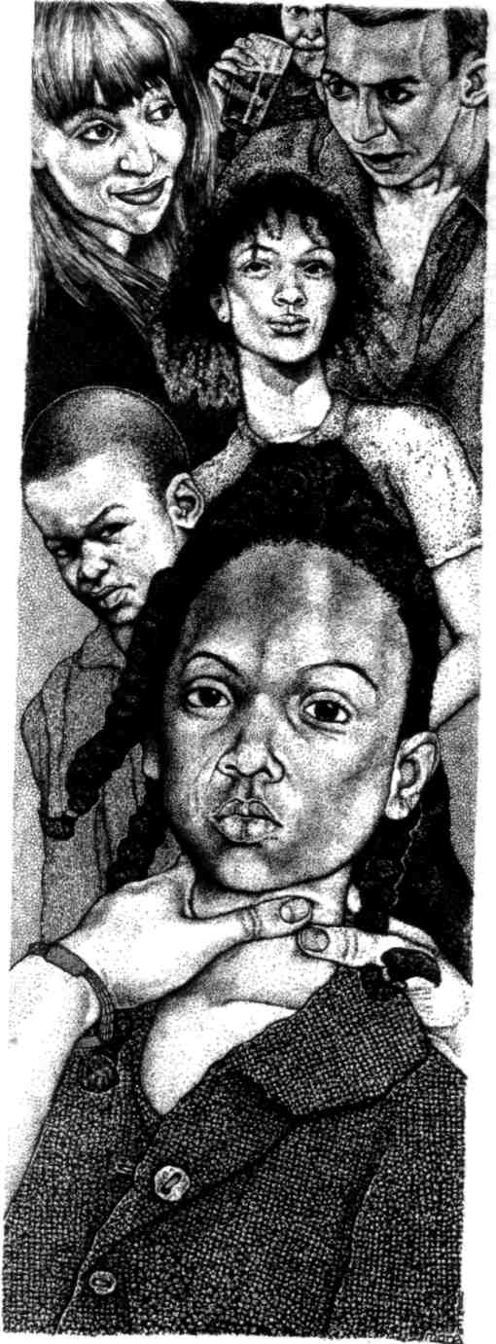
After school Sandra and I went for a coffee together. How could it be a coincidence that we had both dreamed such a dream? Was Alicia uniquely vulnerable so that subconsciously she brought out a beast in us instead of a protector? Was Alicia doomed to be a victim some day and did we both sense the inevitability of this? I imagined other people dreaming similar dreams about Alicia as she drifted through her life obliviously until one day someone acted upon the impulse to end her life. Maybe when she was fifteen, maybe when she was twenty or thirty.

"Like a scapegoat awaiting sacrifice," Sandra said.
"I don't think you sacrifice scapegoats," I said. "You just chase them away."
"Like a victim awaiting sacrifice."
"More like that."
I had a feeling there was something additional that Sandra wasn't telling me, and about which she was upset, but I realized that she wasn't going to broach it.
A week later Henry arrived with a grubby bandage round his right hand. Sandra called me out of my class because Alicia's brother seemed in a fair bit of pain, and it was me who had done the First Aid course.
We took Henry to the little staffroom. When the bandage came off Henry howled, "It hurts!" because skin came off too.
"How did this happen, Henry?"
"Dunno, miss."
I dressed the burn while Henry trembled and moaned.
"I lit Mum's cig in the fire for her," he admitted. "An' I burnt meself. She was angry."
That's when I noticed what looked like a stub mark on his cheek.
What a shit the mother must be, what a dangerous shit. A certainty was forming in me that it would be Alicia's mother who strangled or stabbed the little girl. In a week, in a month, in a year?
"Do we involve the Social Services?" Sandra asked me briskly after sending Henry back to class.
We couldn't leave our classes unattended much longer.
"Do we try to get Henry and Alicia taken into care?"
"What if the case worker has the wool pulled over her eyes and the kids are left unprotected? We can hardly tell the Social Services about our dreams. Kids stand there mute, scared to tell on their mother. Even if they understand they mightn't want to be hauled away from their home whatever it's like. Then later on: Oh, it was just an accident, her falling down the stairs holding a knife! Wouldn't be the first time something like that happened."
Of a sudden I was sure that I was responsible for Alicia's fate because the first dream had been mine.
"I'll call round this evening and visit their mum myself. See what's what."
"If you're sure, Jenny." Sandra sounded relieved. She had something else on her mind, I surmised, but she wasn't telling me.
The house was part of a long sad brick terrace, probably built in Edwardian times for clerks who may have employed a live-in maid, a far cry from now. Several neighbouring houses were boarded up to deter squatters or the smashing of windows. So long as someone was occupying a property that place was reasonably safe from the human wildlife although once vacant it would immediately become fair game. The same applied to cars, all old registrations parked bumper to bumper interspersed by derelicts with flat tyres from which protection had been withdrawn, their window glass in crystals on the tarmac around them. This wasn't a hookers' street, since who would cruise it? At least I wouldn't be accosted as a presumed tart, and besides the cold kept people indoors.
I had envisaged a boozy, fat, foul-tempered woman gone to seed, not a bird-like person with a sort of haunted nervous grace about her. In jeans and an old Bob Marley t-shirt, Joanna Mason was as skinny as her kids. Her raven-dark hair frizzed out as if due to an electric shock. She wasn't exactly youthful-looking, although probably she gave birth to Alicia when she was seventeen or so and was only in her mid-twenties now, but looking more like forty. The inside of the house was pretty much as expected. Dirty dishes piled in a tatty kitchenette smelling of chip-oil. In the tiny lounge laundry hung to dry around a telly, quite like the curtains at a theatre. An Australian soap opera was showing.
Cigarette ends filled a big pub ashtray which could easily have been emptied into the coal fire but hadn't been. Books actually existed, school books to be sure, although that was good — the books weren't exiled to some chilly upstairs bedroom. A picture of Jesus adorned with flowing golden hair hung above the fireplace.
"I'd offer you a drink," said Joanna. "Only I don't keep no drink in the house. Unless tea. Or squash."
So being half-pissed wasn't the reason why she abused Alicia and Henry — who were skulking silently half out of sight, already in pajamas, sneaking unreadable glances at me around the door jamb.
"Thanks," I said, "but I don't need a drink. I came here to talk about your children." The little lounge was quite hot so I loosened my coat. A pile of magazines lay on a chair.
"May I?" When I shifted the magazines to the carpet, they spilled and I noticed several issues of one named Visions featuring articles about Presages, Forseeings, True Dreams. My heart skipped a beat. Did Joanna Mason dream the same dream too? Did she know? Most of what I had been ready to say dropped out of my mind.
"May I call you Joanna? Please call me Jenny."
She nodded warily and after several attempts lit a cigarette with a disposable lighter. Adolescent Australian voices intruded: Why don't you want to go to Jim's party with me? How well do you know Jim anyway, Mary?
I spoke quietly, although because of the telly I couldn't whisper. With the two children listening I could scarcely mention death or murder outright.
"Joanna, I have dreamed about Alicia. It was a very disturbing dream. Another of the teachers dreamed the same dream. Well, similar."
Joanna stared at me and for a moment I thought that she would go blank and that the presence of the magazines was a coincidence. Then she swung towards the doorway and said in a no-argument though not unkindly tone:
"Get upstairs, both of you! Now!"
The children quickly retreated, although I could not tell how far.
She stared at me. "It's the killing dream, in'it?"
She wasn't going to be more specific, but this was enough. She was ready to talk. She wasn't going to clam up and deny everything. God knows, I would have wanted to confide in somebody.
"Yes, yes, Joanna, it is." I whispered as loudly as I dared, "Alicia being killed by strangling or stabbing. I dreamed strangling."
She glanced at the Visions magazine. "Telepathy. You dreamed my dream."
"You dream that you strangle her, not stab her?"
"Strangle, stab, drown in the bath, bash her over the head, take your pick."
"Poor dear woman! How often do you dream like this?"
"Every four or five nights."
"Since when?"
"Months now. If I hurt the kids a bit — doesn't matter which one — this seems to..." She grasped for an image. "Let the balloon down a bit. So I don't burst out and do it. That's what you came about, in'it, me hurting them? No, you came about the dream. There's a reason for what I sometimes does to the kids! It's to save Alicia."
Had Jesus of the golden hair told her to punish her kids? Or some crazy clergyman? Starve the kid to stop her from ever becoming like Mum, knocked up at sixteen because of her female sexuality. Strangle her, stab her, to stop her from growing up and having dirty sex with some man.
Then I recalled the schoolbooks in the room, tokens of care and concern.
Joanna lit another cigarette.
I asked, "Can you spare one?" I had given up months ago but of a sudden I desperately craved a smoke. Besides, this was one small way to bond with Joanna. She tossed me the pack then the lighter. I lit up and replaced the two items close to her.
Exhaling, "I am not mad anyway. Not if you dreamed it too. Unless there's a madness in me that sends out dreams to other people as know Alicia."
By no means as closely as I ought to have known the little girl!
"Maybe it's in the kid herself. Maybe it comes from her, the dreams, if they can touch you too."
"In the dream I couldn't stop myself killing her. As though my body was a puppet."
"Yeah, a puppet, that's it. Who's pulling the strings? Is it the kid herself, wanting to die? Like I read there are lots of miscarriages you never even notices happen. Few weeks old. Your body rejects the life in you cause there's something wrong with it. Only, Alicia got born and stayed alive, and now she's trying to get rid of herself, subconscious like. Or the world's trying to get rid of her. Maybe if she stays alive she'll do something terrible. Cause a war or whatever."
I couldn't imagine passive Alicia causing anything to happen. Joanna must have spent a lot of time trying to think of explanations, however farfetched.
She wasn't stupid, even if she wasn't well educated.
I asked, "Did something bad happen to you just before you had the first dream? Was that when Alicia's father abandoned you?"
Joanna shook her frizzy head. "He pissed off when she was four."
"I seem to be asking a lot of prying questions."
"Feel free. Oh, but we do have fun sometimes, the kids and I!"
How about grandparents to help out?
No, those were Gospel Church people who had rejected Joanna because of her immorality.
Any job, even part-time?
No, unemployment was Joanna's profession. Could have been worse.
Any admirers?
"Who would admire me with two kids hanging off me, eh? Admire me sufficient to set me up on the street and take me earnings off of me and beat me up, like as not."
So she was stuck here in this situation, with no obvious way out. Except perhaps prison. For murder. Subconsciously might she feel that any change would be an improvement in her circumstances?
Fleetingly I wondered what would happen if I took Alicia off her hands. For a while at least. Oh, wouldn't Tom love that! And what an impossible thing for a teacher to do. What would the school say? How would I explain myself?
Still... for a sort of holiday?
Being a teacher wasn't any rest cure! What with after-hours admin and meetings and class preparation at home in the evening I would be neglecting Alicia as well as depriving her of her own home and her brother. The poor kid would be lost and bewildered. What did I have in common with her? Tom would think I had gone mad and he would make his displeasure felt in no uncertain terms. He might even walk out. At least then I would have precipitated something rather than just gritting my teeth and dithering.
No no no. A nonsense idea.
Of a sudden I shivered, for it was as if something had brushed the back of my head and my neck ever so softly. What had I felt? I tried to tune my senses. Joanna was quiet, quiet, and the actors on TV were the only voices, burbling about personal relationships. Joanna and I were two women with little in common yet, somehow, much. Most of it was sorrow, inner sorrow. My own sorrows about Tom's behaviour, the humiliation which I swallowed, hers about loneliness and hardship.
And then ... it was as if ghostly hands reached out between us to touch and link us, Joanna and me. Hands of the heart or the soul, as it were. This was so strange, so touching in all senses of the word, so intimate and yet nothing at all was being said.
To speak might be to dispel those hands like smoke, less visible even than smoke. Such a special and delicate moment this was. I wished it to stretch out for minute after minute, silently.
I realized that little Alicia was standing in the doorway, gazing at us. Passive, pathetic. So passive, at this moment, it was as if she was only partly present, part of her elsewhere.
Like a sleepwalker the girl advanced — hands stretched ahead of her, palms facing forward as though to feel her way.
In Joanna's eyes was a dawning of wonder, as I imagine there was in mine. She seemed to understand that some change was taking place, some transformation. She remained quite still. Joanna and I had already shared dreams — how often do women dream of so much only later to be disappointed! We had shared horribly, to be sure — and yet now . . .
Alicia turned her palms so that one hand invited her mother to clasp it and the other hand invited me. I realized only then with astonishment that I must figure as a sort of mother in Alicia's life — she spent as many hours a day in my presence as she spent with her real mother. The year before, Sandra must have figured similarly.
Wordlessly Joanna, Alicia, and I all joined hands.
And I found myself experiencing Joanna at some even deeper level, in a way so very different from my experience of Tom even when we were first together and making love so closely, our breath mingling, him so attentive to my sighs and cries that it seemed he studied me so as to draw a map of my existence by listening and touching. This was a kind of miracle — not a Jesus miracle but a very human one, of our humanity intensified. That touch on my head and neck, that had been the way I touched Alicia in class to reassure myself.
Was this how our ancient ancestors had experienced each other before anyone learned to speak? Maybe here was an inkling of how human beings might communicate with and understand one another in the far future, gracefully exchanging thoughts and feelings by scarcely a touch.
I knew that I was in the presence of something both precious and fragile. Perhaps Alicia was a throwback to ancient ways of feeling when a group shared preconscious impulses like a flock of birds all wheeling or swooping at the same moment, or like a shoal of fish. Or maybe she was a presage of the future, of a time when mere proximity would suffice for communication to occur. Empathy, wasn't that the word for it? Sympathy times ten. Alicia was a vehicle for empathy.
Oh, this was so very much more than ever I had expected from nurturing the young — that one day one of the young would reward me so uniquely! I could have shed tears of joy.
Could Alicia consciously suspect what she was causing? Surely to know and to act upon that knowledge would have required far more will power than was hers.
As if shattering an illusion, all of a sudden Alicia snapped at me, "Fuck you, then!"
I recoiled, the moment ruined.
But no, it was my own voice that I had just heard — imitated by a child! It was exactly what I had said in sheer frustration to Tom the adulterer, Tom the humiliator, with whom I stayed out of weakness and because I had such a busy job to occupy my mind except during the long summers, yet there was always autumn to look forward to.
And then Joanna looked at me and said, "You need to leave him, you know, your bloke. He ain't no good for you no longer. You're your own person, not his to take you for granted and do you down. And you working so hard to earn money and trying so hard even when you're crying inside. Coming here tonight, like."
She said it, not the actors on TV. They had been saying something vaguely similar a few moments ago in their Australian voices but she wasn't parroting their words, I swear she wasn't. Joanna had reached into me, at some deep level.
Alicia was so passive that she put up no resistance to the world. Therefore currents could flow through her, currents of thought and feeling originating in people close to her. Alicia had voiced my own turmoil, seemingly oblivious to it herself. I had stormed out of that party, enraged — and the violent dream had reached me.
The feeling of being a puppet could very well mirror Alicia's own passivity or else how we needed to give up some self-control to achieve such insights. Joanna's negative feelings — born out of her despair at her own situation — these had flowed into Alicia and had been amplified and returned to her mother again, over and over again perhaps.
Yet now for the first time there was a flow of a different kind because both of Alicia's mothers, her real and her proxy mother, were present and emotions had somewhere new to flow to.
Yes, both of her mothers. No longer was an absent father needed or missed.
Alicia smiled at me as she had smiled that day in class.
"I shan't be hurting the kids no more," whispered Joanna. "Oh no. And I won't be having the nightmare, not any more. Alicia's my treasure. Will you come back and see me again, Jenny?"
"Of course I'll visit you! But listen, Joanna, I'll be getting a flat of my own — a different flat, just for me. And for you to come to visit, the three of you."
Something bad must have happened to Sandra, something she hadn't wanted to confide, something that made her wild inside. Could Paul conceivably be having an affair, and Sandra had discovered?
Paul might seem a bit dull to me but he obviously hadn't seemed dull to Sandra or else she would not have married him. Other women might fancy him, or he them.
I might only need to touch Sandra at school in the presence of Alicia and I suspected that I would know her secret and could comfort her. In future we might all know each other's secrets if we wished.
Men's secrets too? Maybe not; maybe this would remain something for us women.
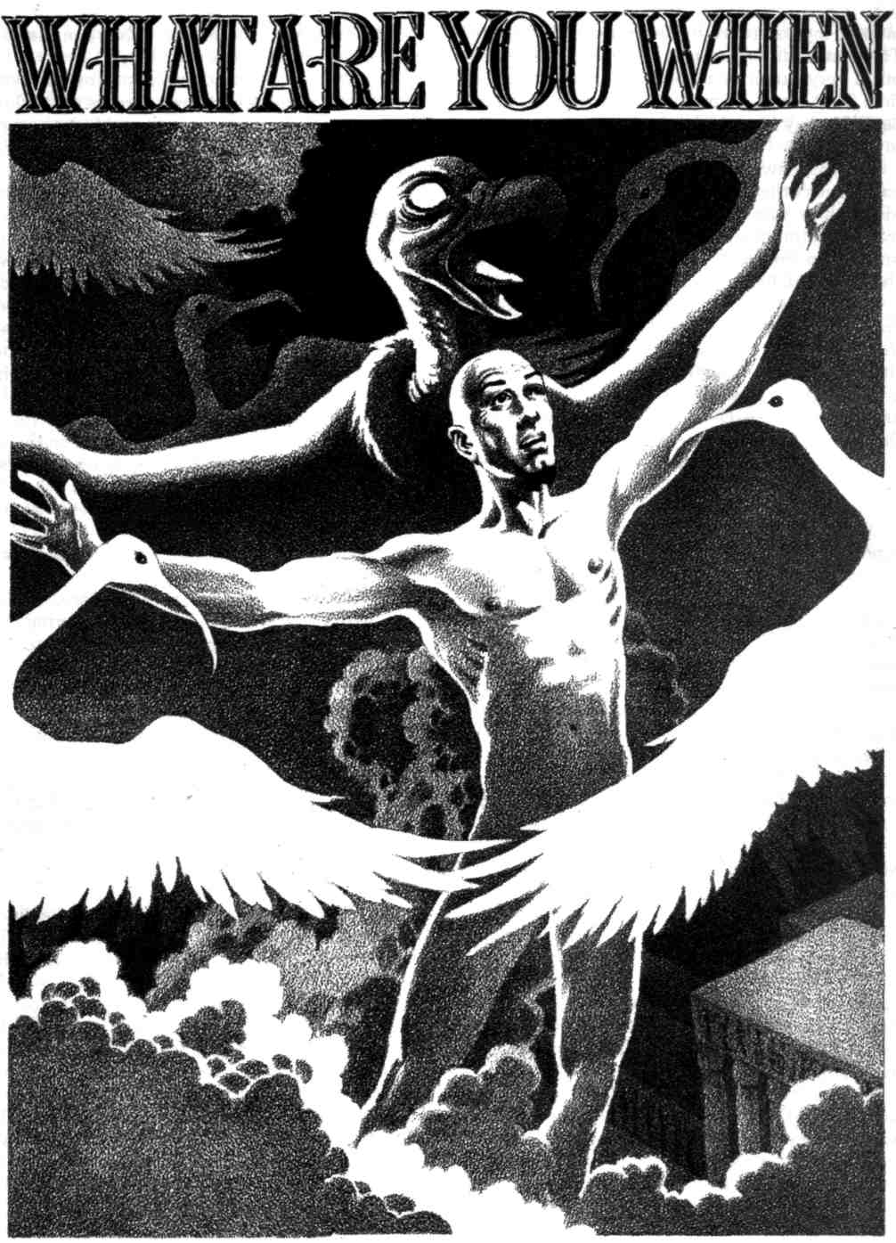

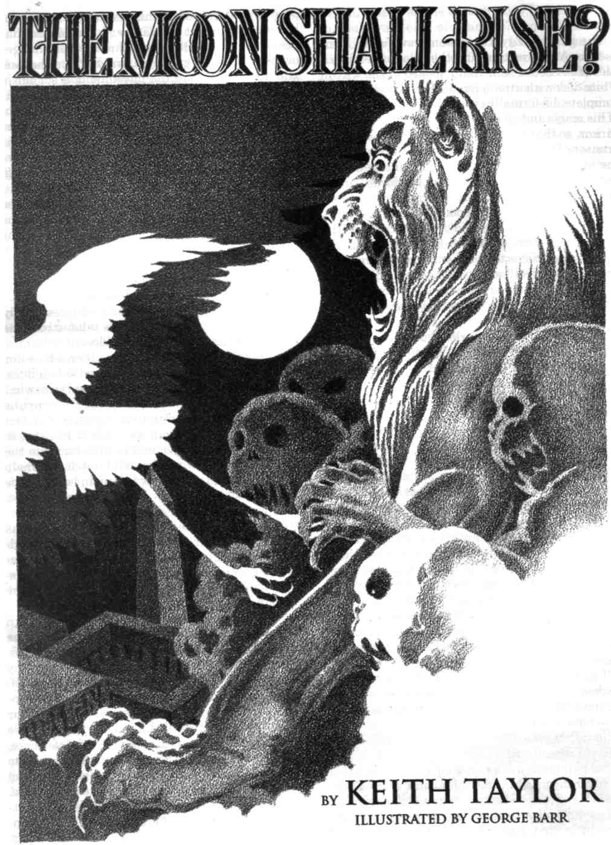
The gibbous Egyptian moon grew fuller. Ramose the Archpriest, pacing the colonnaded balconies of his house near Abdu, looked at the waxing white disk with utter hatred. Monthly when it was complete, he formally cursed it with all the power of his magic and all the intensity of a never-ending rancor, so that it quivered and turned a sanguine crimson. It had always recovered, so far, during the hundred years of his enmity. Kamose lived in the desire that some month it would falter and perish.

This, to be sure, would not be the time.
"I am weakened," he said grimly. "Conflict with that demon brought me wounds that will not quickly heal. Nevertheless I will curse the moon as usual, and you will assist me in the malisons."
The young lector-priest who was accompanying him gulped. "I fear to do that, holy one. The — the power of Thoth—"
"— did not disturb you when you sought to steal his scrolls of enchantment," Kamose snapped. "You ignored warning after warning. Tell me not of Thoth's power, Amenufer. Except that I have driven a bond and taken service with a god of equal puissant wisdom, the priests of Thoth would long ago have brought upon me such a doom as would make seething vapor of a bronze statue. Glory to Anubis, Chief of the Hill of the Viper!"
The lector-priest seemed reluctant to affirm that utterance. Kamose looked at him forbiddingly. This foolish youth had, in his view, caused him trouble enough.
"You hesitate, 0 Amenufer? You owe me life — more than mere life. But for me, you would have incurred the anger of Thoth, as I did. You know now what comes of that! Also, you are no longer a priest of Thoth, if you forget, but a priest of Anubis. That's to say, one of my priests."
'Yes, holy one. Glory to Anubis, I agree. But will he not protect you? Must you curse the moon? Does it not offer provocation?"
"I protect myself. The best defense, as common wisdom says, is attack, and for the priests of Thoth the most favorable time to work ill against me is by strong moonlight. Accordingly, I rebuke and confound its source."
Amenufer offered no further argument.
The pair made a complete contrast, in the day or by silver moonlight. Amenufer came of royal kindred. Handsome, slender, young, scholarly to a degree not quite healthy for his years, he knew very little that had not come from scrolls and papyri, and craved nothing so much as arcane knowledge. In fact he was much as Kamose had been at that age. But the Archpriest had changed over the decades, greatly. Lean, harsh, vehement and austere, he had the physique of a soldier or chariot driver rather than a priest, and indeed he had travelled with armies on campaign. Except for his well-kept hands he could hardly have been more unlike a scribe. And his reputation as the greatest and darkest of magicians resounded more loudly throughout the Two Lands than his integrity as a priest.
The conflict with a demon that he mentioned had indeed left him haggard, his faintly oblique eyes sunken, ringed with darkness. The young lector-priest had noticed. Despite his efforts to hide it, one could see that Kamose moved deliberately, with careful effort. If so much incapacity was manifest, how much had he successfully hidden? Amenufer wondered if the Archpriest really would recover from the demon's talon-stroke, as he had prognosticated he would do.
He sagely kept the doubt to himself — or thought that he was doing so. Kamose found the stripling's doubts, hopes, and fears somewhat easy to discern. Amenufer's hunger for arcane knowledge had caused trouble before, and in fact he had gained more than was wise or healthy, so that Kamose had felt bound to take him into the Temple of Anubis where he could watch the whelp closely. A cousin of the new Pharaoh, he had to be managed diplomatically — to a certain extent. Still, Kamose's long-established power and his favor with that same Pharaoh meant that he was not obliged to bear with Amenufer's perilous curiosity, or his impulsiveness, or lack of subordination, past certain limits. And Amenufer did possess enough sense to fear the Archpriest, when he remembered to be afraid.
"I have received gifts from the Temple of Thoth before, which showed strange properties at some phase of yonder ruined world," Kamose said remi-niscently. "Once they introduced a servant into my household who had inherited the curse of shape-shifting from his parents. He became a killer leopard at the rising of the hunter's moon. He slew four of my guards and mauled a half-score others ere he died. He was meant to eviscerate me, of course, and came near it." Kamose had been forced to defend himself with a spear on that occasion, and in fact had been the one to deliver the death-blow. He saw no reason to mention that. He had outgrown such puerile boastfulness by at least a hundred years.
Amenufer said with a certain skepticism, "How did they dare, holy one?"
"Ah. This was long ago. I had not become the Archpriest of Anubis then, but some thought I was rising too swiftly. Besides, the priests of Thoth had their own reasons to disapprove of me, reasons you know. On a different occasion they sent me a mar-velously wrought jeweled collar, which came puta-tively from the Viceroy of Kush. A little too mar-velously wrought, with magic, in its fashioning. When demilunar light fell upon its links, it tightened and strangled the wearer. I ensured in advance that it would be around someone else's neck. But a praiseworthy attempt."
Amenufer's tongue thickened in his mouth, and he found these remarks difficult to answer.
Kamose lifted his face to the source of that silver light flooding his estate, and the surrounding desert. Men made endless legends about it — and men were fools, as always. The sun-god was averred to have made Thoth his deputy and representative upon the coming of night, and to have allowed him to create the moon so that there should still be light after sunset. Thus his titles included "Lord of the White Disk" and "Measurer of Time."
All foolery. He had no more made the moon than Kamose had. The Archpriest knew that white orb for what it was, the blighted cinder of a world. Nevertheless, Thoth was its lord, as he was the divine patron of wizardry, mathematics, and writing. His priests could work their most potent magic by the full moon's light.
"A praiseworthy attempt at that stage of my career," he qualified.. "It would be somewhat obvious now. But something is sure to occur in this month, when the priests of Thoth think me enfeebled."
The priests of Thoth did not merely think it. They knew it. Discreet for once, Amenufer forbore to declare that aloud. Besides, he disagreed with the first part of Kamose's assertion.
"I'm less sure, holy one. The Archpriest of Thoth, Beba —"
"— is pompous, righteous, dull, timid, and opposed to plotting, no doubt because he would do it very badly. Yes, O Amenufer. I know him. Yet someone bolder than he, at some rank in his temple's hierarchy, is plotting. Someone hatched the plan to discredit me by stealing the late Pharoah's heart scarab. It surely was not Beba."
"Do you know his name, holy one?"
"I shall, in time, provided I survive the full moon. After all, what should I do, were I a priest of Thoth, emetic as the thought may be, and wished to. make an end of Kamose? And knew that Kamose is now in retreat at his mansion near Abdu? An assassin's knife or garrote? Poison?"
"You joke with me," Amenufer protested. "All men know you are immune to poison, holy one."
"And have I not warned you before against believing what "all men know"? But assume it is true. I am guarded by temple soldiers and by entities not mortal. We may discard those possibilities, if my adversary is not a complete fool. There remains magic. Come, Amenufer, you are a trained lector-priest, and lately belonged to the Temple of Thoth. What magic would you employ?"
"The sorceries of Thoth call for spoken or written spells. I should use the latter. Who spoke a hostile incantation in your retreat would be likely to find dire fangs at his throat before he had finished."
"How would you introduce a written curse or spell to my retreat, and keep me oblivious thereto?" Kamose asked gently. "Bear in mind that I expect such a thing."
"There must be many ways." Amenufer could think of several at once, yet he did not wish to seem too fertile in invention where spells to Kamose's disadvantage were concerned. "I, I have heard of sending a secret message tattooed on the scalp of a courier, after letting the hair grow to cover it. It might be done thus."
"It might; it has been." Kamose spoke dismiss-ively. He had employed the trick himself in the reign of Usermare, Rameses the Great, while sending spies among the Hittites and the Syrian princes. In these days it was hackneyed and well-known. (If it sprang to Amenufer's callow, academic mind, it had to be extremely well-known.)
"Ill-wishers of mine," Kamose said, "have even inscribed curses on walls of this mansion which were to receive new murals, and then plastered over them, prior to the painting. They intended to creep out and scrape off the plaster at night, before moonrise, so that the White Disk at its height would touch the curse with its radiance."
The smooth comely face before him showed consternation. "But then, holy one — but then —
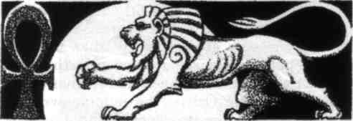
nation without equal — the latter being a special domain of his patron, Anubis.
Kamose bowed low before the image and altar. The statue of Anubis stared enigmatically forward. As always, the scarlet tongue lolled from his narrow black muzzle and a dagger glittered in each of his hands, while the traditional viper of royal doom coiled about one forearm. This puissant lord of tombs and necropoleis equaled Thoth in power, and Kamose had rendered him long, impeccable service.
With expert dignity that concealed his desperation, he burned incense and asked the god's blessing. Bowing again, he turned about, looking towards the chapel door. Sunken in the floor was a bowl-shaped divination pool, rimmed with malachite and lined with blackened silver — a metal somewhat scarcer than gold in Egypt. It had been filled to the brim with water from a sacred temple lake. Incised at the bottom was a formal image of the god, striding forward.
"Lord of Tombs," Kamose intoned, "Announcer of Death, you who foresee destiny, give your servant knowledge of those who would undo him. Whom do you see? Whose shadow falls on the future? What is the instrument of their design against me? 0 Guardian of the Balance, Opener of the Ways, Master and Giver of the Secrets of Embalming, reveal it!"
The water grew limpid and transparent as air. Anubis's image moved, walking forward and passing from sight, to be succeeded by a procession of other divinities. Kamose had given offense to only a few of them; with most of the great ones he stood in favour, particularly Isis, mistress of magic, and Set the Defender, fierce lord of storms and the desert.
These and others appeared, moving through Kamose's intent field of vision, until at last — inevitably — Thoth, ibis-headed and crowned with a lunar disk, presented himself. The water of divination roiled, clouding over, as though the divine scribe was determined to obscure any enlightening sign. No doubt he was. Thoth knew unequivocally that Kamose was not his friend. The potent corrosive curses he leveled against the moon each month gave steady reminders of his hatred.
Kamose controlled that hatred. He coerced his spirit to clarity in the face of that most detested of all sights to him, ibis-headed Thoth, and gazed more intently into the water.
Kamose's patron returned, long jackal's muzzle grimly shut, confronting Thoth face to face in his representation of a formal image. For a moment the water cleared to the transparency of air. Above the heads of the two deities Kamose saw — briefly — a hieroglyph of a crouching lion, silver-white, with strange shadowy markings like those on the moon. Its visage appeared deformed, the profile malign and menacing.
The visions vanished, and the sacred water darkened. Mephitic bubbles rose to its surface. Anubis had given his votary a warning, and Thoth, apparently, had prevented complete or clear revelation. Kamose's lips thinned with bitterness, and he mentally reviewed a new phrase or two for adding to his curses against the moon.
The moon. And a lion white as the moon, bearing shadows like those of that blighted, devastated corpse of a world. Very likely a demon. Although Kamose believed — with reason — that he knew every demon in the Underworld, there were fiends of other realms and transmundane spheres with which he was not familiar. This might be one.
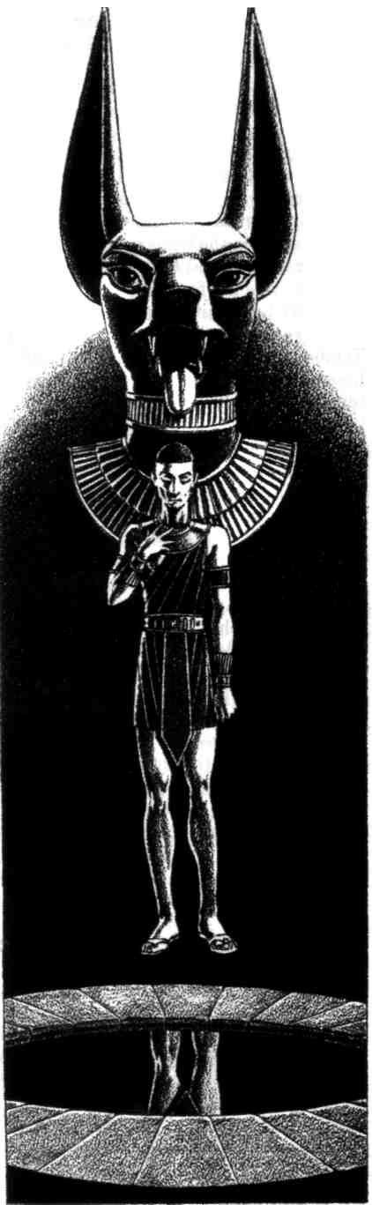
Anubis had warned him of it, despite Thoth's interference. And Kamose trusted the Lord of Tombs. And Thoth's intervention confirmed, to a high degree, the involvement of his priesthood and temple — which in turn meant a written or inscribed spell to invoke the demon at the most potent time. Thoth, after all, was lord of both magic and writing. The most potent time would be the full moon. It always came back to that.

Kamose sat cogitating, while behind his grim face his brain chilled with an onset of fear. His enemies knew his weakened state, and they had prepared a doom for him. They had more realistic hopes of bringing it about now than at any time for decades. Well, he still had his wits, and greater arcane knowledge than all of them combined.
He quelled the fear. Fear was worthless; it had never in all of time achieved a thing. While the water of divination often did, it had surely not achieved much today. Kamose's facial muscles stood out starkly through his skin as he reviewed the alternative choices he knew. The most promising one — was the most desperate, also. More than two decades had passed since he last employed it. Did the present situation warrant such a measure?
He concluded that it did.
III
Kamose sat in the great thronelike chair in his hall of audience. He wore nothing but black sandals, a pleated black kilt and the skull-cap which hid his hideously burned pate whenever he did not cover it with a ceremonial wig. Only his chief apprentice accompanied him. This man, a renegade priest from the Faiyum, wore a macabre goat-mask through which he breathed with effort, having stuffed it with sachets of protective herbs and spices. He would need them.
At the Archpriest's left, a small charcoal brazier glowed scarlet. He held a crystal casket in his right hand. The apprentice's masked gaze shifted in trepidation between the casket and the brazier — and he was a man of far stronger nerves than most.
"Watch me closely," Kamose commanded, "with your eyes and your wizard's senses. If my body moves or cries out, you will know that your aid is needed, and then — you must approach me and open that bottle you hold. Ensure that I breathe its vapors in, but for your life do not breathe them yourself, or doff that mask within this hall."
"I apprehend, holy one. Must you do this?"
"It appears so. Now be still."
Kamose opened the casket. It contained shimmering jetty dust — the pollen of a lethal flower which had grown in former ages of the world and been rare even then, which men had called the black lotus in vulgar parlance. Now it was extinct by any name. To Kamose's knowledge, greater than any other man's sorcerous knowledge, he possessed all of the dreadful dust which remained.
He measured five pinches over the glowing brazier, and leaned forward to breathe the smoke which arose in a thick, constant ribbon from the coals. The apprentice held his breath in fear, even at his distance, and within the protective mask. The effect of that atramentous dust in its first stages was a deathlike trance and such ghastly, burning nightmares as would leave most men insane. Some even averred that they were not mere nightmares, but glimpses of a monstrous reality beneath the bubble-thin skin of that which normal humans perceived and called existence. The apprentice did not know. He had long been completely aware, though, that his master was no normal human being.
Kamose's body arched in his black seat of power, slowly growing rigid. The lips lifted from his teeth in a grinning rictus. His heart hammered wildly, stumbled, then beat with leaden slowness. His breathing all but ceased. The smoke from the brazier drifted towards him, wreathing about his head in close eddies like some noxious coif. Like a live and predatory thing.
The apprentice watched with morbid fascination as the grisly nightmares his master experienced racked his body with slow, tetanic rigors. Once, he screamed appallingly out of his trance, and at the mere sound, the apprentice twitched in a spasm. He had read in ancient papyri that these nightmares increased a man's sorcerous powers and inured him to the fear inspired by demons — but he wondered if it was worth the price and if, should he ever dare them himself, his mind would survive.
The stage of nightmares passed. Kamose drifted on a great dark river. Here and there it bubbled, and the bursting turgesences vented sounds like wails of utter despair. Along the vague shore, spirits struggled, sometimes in formless conflict with each other, sometimes alone, always sloughing memory, essence, self in a sliding descent to nothingness.
The river itself flowed to the same destination. Even the monstrous fiery serpents which reared out of its waters, bringing ruin and swift annihilation to all they touched, were but manifestations of the river's force, doomed at last to the same end as their prey, for all their power and violence.
Running its course, the river spilled out into emptiness, a vast terrible void. It diverged in a multitude of aimless waterfalls, which in turn became a dreary mist, thinning to infinity. Willing it ferociously, Kamose retained form, assuming the shape of a scarlet vulture, a burning shape with wide ragged wings, drifting through nullity towards — cessation, oblivion.
He was not alone.
Something else existed, a monster of deeper darkness whose presence was instead an absence, its vast coils stretching through the void, the serpents that had infested the river being as threadworms beside it. This was the essence of annihilation and chaos, the end from which no new beginning comes, before which even time dissolves. Men gave it a name. Apep, the Destroying Serpent, they called it, and withdrew their thoughts from it in terror.
The immense blank head hurtled towards Kamose.
He did not flee. Nothing successfully flees from Apep. If Kamose truly confronted the Destroying Serpent, he was doomed, for all his potent magic. If, instead, it should be a vision of the black lotus, he might survive. With a scream of raging defiance, he flew straight into that gape an infinity wide, and vanished.
Vanished — from the void — and appeared again, drifting on wings of burning scarlet above his own estates near Abdu.
His ghostly eyes saw magic as distinctly as fleshly eyes see the spots of a leopard. Whatever was sorcerous in nature blazed with a scarlet fire akin to his own, from his personal galley moored at the canal quay, to the approach of a caravan of strange beasts with stranger drivers, plodding in a line far out in the western desert — and all inscribed or written spells, no matter how minute, no matter in what fashion concealed. The vulture's eyes saw everything.
He perceived the hieroglyph of a demon lion, close beside the main courtyard of his mansion.
That? So that is the way they introduced it!
Someone had been both devious and flaunting at once.
Kamose yearned to strike his vulture's beak into the culprit's liver and devour it by gradual degrees. He would, in time. Figuratively or literally, he would do it, after he had recovered his entire capacities.
Flying shapes whirled around him suddenly, flocking out of the waxing moon. They no more had flesh-and-blood substance than did he. They were spirits, lunar elementals in the shape of sacred ibises, the birds of Thoth, their slim curved bills sharp as lancets. Kamose's touch was fatal to them, and when the edges of their pale wings touched him, they shriveled as in a searing fire — but they also slashed his spirit, his ba, as if they had been honed sickles.
Kamose smote them with wings and talons. His great vulture's beak sheared heads from black necks, and though they were spirits, elementals, they perished nevertheless. Still, there were too many. Despite sending them down like blown leaves, Kamose weakened. Each stab of a down-curving ibis bill felt like a spear-blow. His former lordly glide turned to desperate flapping. He sank lower in the dark sky.
His estates, the canal, the river, rose around him. Something waited there, shackled to the earth — something that roared. Kamose knew much about desolation. He recognized the empty hopelessness in that roaring.
The sacred water had shown him a hieroglyph of a demon lion. Now he beheld the being itself. It bulked huge, thrice the size of a bull, moon-white and shade-grey. Its massive paws were swollen and deformed. Nodules of leprosy marred its visage. A demon of disease, one of many that stalked the earth, like Namtar the plague fiend he had conjured once in far-off Babylon.
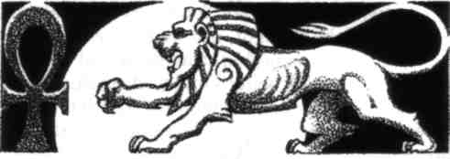
Kamose's enemies had gained control of this one. Lunging against its shackles, it roared again, showing teeth like pickaxes and a gullet like a cavern. These were emblems, a manifestation in visual shape of a monstrous reality, but the thing's urgent craving to swallow him was no emblem. It was fact, it was truth. The multitude of ibis-bills stabbed at him, driving him to the lion's maw.
Let them succeed, and Kamose knew he would become the lion-fiend forever, a foul shape of the night whose touch brought leprosy — and worse, far worse, a subject of the god he bore such complete hatred.
Frenzied, he turned on the flock of spirits, ripping and breaking them, scattering them for a few precious moments. In that time of respite, he screamed from his vulture's throat, "Bring me back!"
His fleshly body arched on his throne of power, and those same words burst from his human mouth as a command. The masked apprentice obeyed at once, dashing to his master's side, tearing the waxed stopper from the bottle he held. Its contents, phoenix blood on which basilisks had breathed, bubbled out in curious golden fumes.
Kamose's body sucked desperately at that amazingly potent distillation. As though carried on a desert storm, his ba appeared in the audience hall, visible to the apprentice's eyes — which, trained and inured though they were, flinched from the bright, terrible scarlet of its master's spirit shape. The great vulture settled over Kamose's human form and, merging with it, found safety from the dread, imminent peril which had threatened him.
Kamose's faintly oblique eyes focused on his apprentice. "You did well," he said thickly. "Leave now."
The apprentice left, on the instant. Even his mask might not have protected him from those vapors, had he dared linger. There were perhaps three other magicians in the world who could have breathed them into their lungs and survived.
Fatigue filtered through Kamose's flesh and bones like poison. The demon's talon-marks throbbed on his torso. Nevertheless, he smiled, and it was not a smile his enemies would have found reassuring.
"Clever," he whispered. Too weary to speak the words aloud, he thought, if it had succeeded.
Someone had expected that he would seek to discover the spell being employed against him. Someone had invoked the power of Thoth to baffle his attempt at divination. The same schemer had foreseen that Kamose would leave his body when other measures failed, and that same person had sought to merge Kamose's soul forever with a demon of hideous illness. Almost with success. Had Kamose been less skilled and prepared, there would have been no "almost."
Was this the end of it? Perhaps. But Kamose thought not. The actual spell, the hieroglyph of the white lion, still existed on his estate, waiting for the moon to enter its full phase — accursed orb of Thoth!
Now, though, he knew where it was. He would concede it had been introduced and concealed in a clever fashion. Indeed, someone had organizing talent. Kamose thought about it, his look wholly malign. Neither that nor any other characteristic the person possessed would save him, once Kamose's spies uncovered his name. And already it was clear that it could only be someone highly placed in the Temple of Thoth.
A matter for later. Kamose sat brooding on the fate he had just escaped, while the vapors of phoenix blood dissipated from his hall. His enemies had invoked a doom, the lion of leprosy, which he now inferred had its lair on the moon — hated world of barren desolation! Nor had he seen the last of the demon yet.
Until it appeared, he would content himself with his periodic cursing of its abominable lair. Alas, alas that he was weakened, and his maledictions would carry less corrosive efficacy on this occasion. Not on that account would the passion behind them abate, however; not on that account would he omit them.
Never.
IV
The rising moon was a perfect milky circle. Kamose, gaunt and sunken-eyed, raised his face towards it with a glare that to his witnesses seemed insane. His massive, powerful chief apprentice, no longer masked, frowned across his heavy face. The steward of the household swallowed, hands moving restlessly as though he yearned to cover his ears. Kamose's newest acolytes, Amenufer and Reni, young men both and cousins of the new Pharaoh, glanced at each other with a mutual wish to be elsewhere — and their temperaments differed so greatly that it was rare for them to be in such perfect accord. A small group of scribes further down the portico set down their master's words with shaking hands, in a crimson ink blended of viper's poison, myrrh, and blood.
"Ancient my enemy, moon of desolation, fall from the sky and depart! Ancient my enemy, moon of baneful sorceries, fall from the sky and shatter! The knives of the gods dismember thee. The storms and whirlwinds of Set's Majesty destroy thee wholly. The fire of implacable Sekhmet the Lioness consume thee. Horus the Falcon avenge me upon thee and make thy name to perish out of time. Be thou feeble in the sky before Ra. Be thou devoured in thy passage through the Underworld by the great Destroying Serpent. The Lord of Terror who prepares the slaughter-block and dost feed upon the inward parts, he shall fasten thee in fetters, he shall cause thee to fall helpless into the Lake of Fire..."
The words spat and erupted from Kamose's writhing lips. He invoked demons whose very names were unknown to most sorcerers. He prescribed dooms and torments beside which slow dissolution in acid would have seemed a delight. The air curdled around him. The rising moon trembled as though seen through heat haze; a sullen, hectic crimson tainted its whiteness.
Kamose, chanting his imprecations, hoped wildly that this would be the time — the month when that abominated world shattered like a plate and left the sky forever. Hatred, black yearning made him almost believe it, though he had attempted the same thing so many times before in his full strength, without success.
Rubescence faded from the moon's surface. It continued to rise. Livid with disappointment, the Archpriest waited in the shadows of his balcony, a walled courtyard before him, his newest garden beyond it. The leaves themselves ceased rustling, as though in dreadful anticipation. Moonlight streamed down.
A tonitrous roar boomed over Kamose's immense estate. He had expected it. Reni and Amenufer saw his skullcapped head turn steadily to the left, looking towards the garden. Then, aghast, they saw a huge white shape leap atop the wall, a lion, but monstrously greater than any lion of a sane or normal world. The garden wall crumbled under its weight, tipping it into the moonlit courtyard.
Yellow eyes in a deformed visage fixed a hellish stare on Kamose. It trod purposefully forward on disease-swollen feet. The two lector-priests, who had endured the merest incurious flicker of the demon's gaze, recoiled shaking, but other than that, found they had been stricken immobile. They stood filmed in chill sweat.
The creature roared again.
It made another deliberate step towards the long balcony.
With a single leap, now, the demon would be able to reach it and fall upon Kamose. Very clearly, that was its purpose. Reni and Amenufer had the same terrified thought in their minds; what would Kamose do? He was acknowledged the greatest magician of Egypt, upper and lower combined. What would he do?
He did nothing at all.
The lion of leprosy crouched for its leap.
Smoothly, then, with hardly a grate of stone, the entire courtyard tilted on massive pivots, the side which faced Kamose and his minions tilting upwards, to expose a cuboid of deep blackness beneath. Sliding backwards, away from them, the demon fell into the pit. The courtyard paving fell back into place, with the ease of precise counterweighting and the irresistibility of hundred-ton granite slabs. A muffled, terrifying roar came from beneath the paving.
Amenufer cried out, and Reni voiced a smoking military oath. Even the chief apprentice goggled like a yokel; he had been ignorant of the device. His master had lived three times his years, and the courtyard had been constructed before he was born.
"Come, "Kamose said calmly, but sweat of relief dewed his own countenance as he left the balcony.
They followed him in haste down hidden stairways and passages. A reek of boiling tallow filled the air as they neared Kamose's objective, an annular corridor where great heated crucibles stood in niches, evidently having just been emptied through conduits into the stone-lined pit below the courtyard. The foreman in charge of this function bowed low as his Archpriest approached.
"It is done, holy one. The monster does not seem much affected, though, and the deluge we gave it would scald an elephant to death!"
"I did not expect it."
Amenufer babbled, "Perhaps — perhaps it can even break out of this prison, after the way it shattered the garden wall!"
"Perhaps," Kamose answered, "provided it could gain a secure footing. Difficult, when it is ankle-
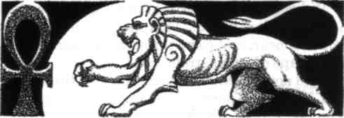

deep in boiling tallow. When a demon takes material form, it becomes subject to many restrictions of matter."
"But with time, holy one —" Reni began.
Another of the demon's roars vibrated through the rock corridor walls. It sounded desperate. Not triumphant, menacing, or ireful — but desperate. Kamose showed bleak satisfaction.
"Time," he repeated, "is what I have gained while it slips and scrambles. In darkness, my children — in utterest darkness. There is sorcery and power in moonlight. This demon is a creature of the moon. Without access to moonlight, it falters, it weakens, and soon will be moribund." He smiled. "Simple solutions are often most efficacious. Mighty spells — should be saved for when they are truly needed."
"How did you know, holy one?" Reni asked, with greater awe than he had shown his Archpriest on any former occasion. His princely rank made him bumptious, and even a fearful encounter with a lamia (from which Kamose extricated him) had not wholly cured that. "That yonder monster would come through the courtyard?"
"A lesson for later. Now, witness, and be sure the monster ceases to exist. Before long, let us hope, since its outcry makes such indifferent music for mortal ears."
The striving horror roared again. Already its noise grew discernibly weaker. Kamose waited with arms impassively folded
Epilogue
Reni and Amenufer were related to the royal clan, after all. Kamose found it politic to treat them with courtesy, even though one might be a headstrong, bombastic reveler and the other a scholarly lackwit. Therefore he gave them the honor of supping with him in private. His chief apprentice joined them, also, a man worth a hundred of either princeling in Kamose's view. However, he did little of the talking. Both younger men were afire with triumph and relief. No doubt their own parts in the story would become more central when they recounted it to their boon companions in future.
"Did you divine the threat in the sacred water, holy one?" Reni asked. "That the demon of leprosy would appear, and come through the courtyard in that shape of a monstrous lion?"
"I did not. A hostile influence marred the divination, O Reni. I perceived nothing, then, but the hieroglyph of a crouching white lion — a clue, indeed, but a somewhat ambiguous one. It became necessary to quit my fleshly body and seek further illumination in the spirit shape of my ba."
"A perilous measure," Amenufer said, showing off his occult knowledge before Reni, whose interests ran far more strongly to women, gambling and the hunt. "In spirit form one is vulnerable to evil magics that would have little effect on a magician in his corporeal house."
"I am glad to have you tell me," Reni said. Lector-priests were trained in magic, and despite his neglect of those studies, he knew that much.
"It proved most perilous this time," Kamose agreed. "My enemies desired and awaited such a step, and they sought to trap my spirit, bind it forever within the form of the demon of leprosy—vile eternal torment which gives a sure indication of their regard for me." His eyes glittered. "I shall ascertain the name of their leader and give him suitable proof of my regard, at some appropriate time."
"But they failed, holy one," Reni said, after an uneasy pause. "I presume you did learn where the spell to manifest the demon was concealed? Somewhere in that garden beyond the main courtyard?"
"Presumption," Kamose answered dryly. "The spell was the garden itself, which is new. It was constructed during the past two years, by my orders, yet in my absence." He spread a sheet of papyrus on a low table adjacent to their supper. "Here is a plan of it."
They stared uncomprehendingly for a few moments. The intellectual Amenufer grasped what he was seeing first. In competitive haste, he gabbled his revelation out.
"Yes! The whole garden is a hieroglyph — of a crouching lion! The gate and porter's lodge, here, form the mouth and muzzle, while these planted shrubs above it are the mane! The fishpond, here, is an eye. This approximate oblong of the main walled garden forms the body, and so it continues. These flower beds form the auxiliary glyphs. They hid it by making it too large to see!"
"True," Kamose said curtly. He drank strong dark wine that had not been drawn from earthly vines or trees. "They, whoever they may be, would be gratified that you admire their ingenuity. Still, they were unsuccessful, and there will be trails to follow in the discovery of who planned and designed this garden, who oversaw its construction."
"I do not understand how you had so cunning and huge a trap prepared for the demon, holy one." Reni puzzled over the question. "Did you perhaps make it by magic in one night, after you discovered the secret of the garden?"
"You, supposedly a priest, ask me that! I did not." Kamose's debilitated condition at present made that impossible, though he had no intention of sharing the information. Besides, even at his best, with demons and genii to perform his will, he could not have created such a mechanism in a single night. "I constructed the courtyard trap long ago," he explained, "and not for demons. I foresaw the possibility of some large band of armed invaders swarming into it, daring to assail me in my own mansion. Libyans, perhaps." He added in the tone of a careless pleasantry, "It is not the only surprising device to be found on these estates."
While they considered that, clearly finding it a disconcerting notion, Kamose himself poured them a further drink. The callow dolts took it as a matter of course, the mere due befitting their princely rank.
They were mistaken; the draught was nepenthe, which would cause them to forget the events of the night, though they did perhaps owe it to their standing that the liquor had not been fatal in its effects.
Kamose believed in keeping his secrets.
MOODS AND TENSES
Genies speak always in the optative Of what is to be wished.
Werewolves, witches, and wizards all must take Transformational Grammar 101.
It's a prerequisite.
On the green and winding road to Fairyland, If you this night must go,
Follow the transitive verbs.
Two-headed giants argue a dilemma: Whether to be plural or singular first person. They never achieve agreement of adjectives.
Mocking Robin Goodfellow turns To insubordinate clauses.
Gods prefer the subjunctive,
To avoid the bringing into existence
Of such gossip as even gods
Like to dish up when they meet
Over a bowl of nectar.
The indicative isn't quite
As dangerous as the imperative.
But if they don't want a word
To muddle their creation
With additions in the absolute,
Subjunctive's safer.
Spirits of the dead, Haunting the midnight moon,
Speak always in the past.
— Ruth Berman

