A TREATISE ON THE SUCKER EFFECTS OF

THREE CARD

MONTE

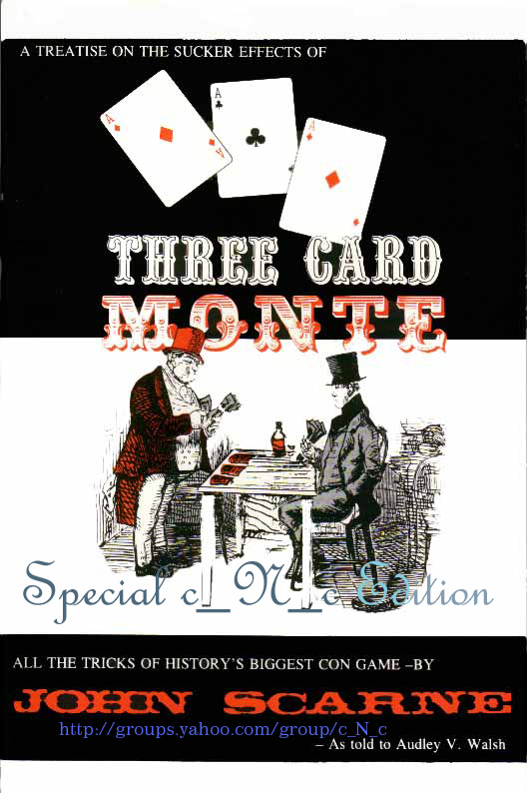

CONTENTS

Definition of Gambling Terms. . . . . . . . . . . . . . . . . .8
Foreword .........................……………………………........9
Introduction . . . . . . . . . . . . . . . . . . . . . . . . . . . . . .10
Grifter's Signals. . . . . . . . . . . . . . . . . . . . . . . . . . . .12
Familiar Phrases in Gambling . . . . . . . . . . . . . . . . .13
Three Card Monte . . . . . . . . . . . . . . . . . . . . . . . . . .15
Series of Deceptive Moves . . . . . . . . . . . . . . . . . . . .19
Bent or Crimped Corner, Grifter Method . . . . . . . . .21
The Flip ............................……………………………......24
The Flip Change . . . . . . . . . . . . . . . . . . . . . . . . . . .26
Grifter's Marked Corner . . . . . . . . . . . . . . . . . . . . .27
Scarne's Monte Slide . . . . . . . . . . . . . . . . . . . . . . . .28

Scarne's Triple Climax. . . . . . . . . . . . . . . . . . . . . . .30
Scarne's Method of the Crimped Corner . . . . . . . . .33
Scarne's Marked Corner. . . . . . . . . . . . . . . . . . . . . .35
The Stamped Ace . . . . . . . . . . . . . . . . . . . . . . . . . .37
Scarne's Method of Torn Corner . . . . . . . . . . . . . . .40
Scarne's Push Over Change . . . . . . . . . . . . . . . . . . .41
Mexican Turn Over . . . . . . . . . . . . . . . . . . . . . . . . .42
The Daub ............................……………………………....45

DEFINITION OF GAMBLING TERMS

ACE-A dollar. A good-humored individual, a sport.
BERRIES-Money-one of the terms a gambler uses when speaking of the balls to play.
BLANKET-Used sometimes in place of a table. Also means overcoat.
BLOWOFF-Climax.
BREEZE-Scram or screw; in other words, make an exit.
BUCK- Another term for dollar.
BULL- A policeman.
BUM STEER- Bad information.
CASE NOTE- Another way of saying the last dollar.
CHICKEN FEED-Silver coins, contemptuous term for small amount of money.
COME-ON-The guy who leads the suckers on. The shill working a crowd with the grifter.
DICK-Another way of saying detective.
DO-RE ME-A fancy way of saying money or funds.
FIN-Meanings are two-a hand or a five dollar bill.
FLY-COP-Another nice way of saying detective.
FROG-Still another way of saying dollar.
GRAND-Everyone knows this means a thousand "bucks."
HAMDONNY-Burned out pugilist.
HEP-Wise to.
JACK-Money.
JOHN-Another way of saying sucker.
JOHN LAW-An officer of the law.
KALE-Once again we say "money."
KICK-A pocket.
LAY-OUT-The gambling equipment.
MARK- Did you ever hear of an easy-mark?
MUG-Sap-a gent not looked upon with respect-a palooka.
NICK-To make an impression on a bank roll.
OAKUS-Wallet.
PALOOKA-Hanger-on-One who does not know what it is all about.
PIG-Also a wallet-made of leather.
POKE- Pocket-book.
QUEER-Counterfeit money.
QUEER SHOVER-The fellow who passes counterfeit money.
SAW BUCK-Ten dollars.
SIMOLEON-Once again we say dollar differently.
SUGAR-Money, of course.
VEAL CUTLET-Overcoat spread over knees as playing table.
YAP-Stupid victim.

FOREWORD

John Scarne is known and praised by the world's best magicians for his clever manipulation of cards. It is doubtful if there is another card man in the country who can entertain and mystify as John Scarne. His effects are of a lightning nature and done with the ease and control of a master. His "Card in the Pocketbook" is a masterpiece and imitated by many. There is no doubt that he is the greatest table worker we have in the world today. Gamblers have offered him enormous sums for some of his table workings.

John Scarne started his career as a boy and is still a young man. He has appeared before and entertained the Presidents of these United States and celebrities all over the world. Being of a creative mind, he has originated and perfected many beautiful card sleights, and after many requests he has at last consented to give to his admiring friends this series of original moves and sleights under the heading of "Why You Can't Win, a Treatise on the Art of Three Card Monte and its Sucker Effects."

And in compiling this book, we feel that the lay man will at last have obtained a thorough knowledge of
the reasons why he can't win, and the magic fraternity will be getting a series of manipulative moves that have been closely guarded by gamblers and three card monte men (better known as grifters). Furthermore
we can honestly state that after careful research there is no book that deals with the subject as thoroughly,
as you will discover after reading these pages. Hoping that John will favor us in the near future with
another series, I remain, Sincerely,

V. Walsh

INTRODUCTION

Three Card Monte and its sucker effects--a marvellous topic for thorough discussion. I don't know how far back in history this game goes, or who invented it, but I do know that it is one of the best means of exhibiting your proficiency in the art of dexterity. No doubt it is closely related to the three shell game, which developed from cups and balls, and they go way back in history. I read in some history book that Nero did some clever moves with cups and balls, when he was not playing his fiddle.

Now, before we go any further into this discussion, let's get acquainted with the types of people we will meet during said discussion. First, there is the Grifter --better known as three-card man or monte worker. Three-card man we call him, but to the mob he is known as a broad tosser. He is the gentleman whom you see standing behind a small table or packing case, in fact behind anything that he can use, providing he can attract a crowd with his cry of “Step this way, gentlemen."

During the recent N.R.A'. celebration and parade in New York, the "grifters" were very much in evidence. Mingling with the crowd, they managed to attract the attention of on-lookers with their come-on tactics, and many of the lambs were shorn of their wool so smoothly that they were hardly aware of it. Many are the ways that games start. A familiar method is to ask a spectator to hold out the newspaper he is reading. Cards are spread on it and with the efforts of the "shills,'' a crowd collects, interest runs high when the apparent simplicity of the card moves going on in front of them impresses them, the spectators put their money up and get cleaned, as it were.

[I This refers to National Recovery Act, an effort of F. D. Roosevelt to improve the economy. The year was 1933.]

Almost anything will serve as a table top for the grifter. Sometimes, the back of one of the boosters will serve, while his arm-pits serve as convenient nooks or wells for certain necessary card changes. Win? Try to do it, brother! You haven't a chance.

The "grifter" is ably assisted by a group of followers knows as "cappers," "boosters," "shills," the latter name being the correct one. These gentlemen travel around with him at all times. The clever "grifter" has clever "shills." This group you will find in any place where there is an opportunity to make money--at race tracks, on trains, carnivals, ocean steamers, even among society and better known clubs. "Shills" working at these places dress accordingly. One of these "shills" is usually known as a "ham-donny"--a third rate pugilist who goes along as strong arm man for the mob. He is the gentlemen who tells you to "scram or screw" if you should put up a holler after you have been gypped or cheated. No doubt you have read or been told that the "grifter" will let the spectator win to encourage betting. This is wrong. It has never been known that the "broad tosser" gave the sucker an even break. The winning spectator is always a "shill." Nobody has ever beat a "grifter" at his own game. It is impossible. (Incidentally there is one exception that is hardly an exception to the rule-up to a short time ago, a mob was working on ferry boats around New York. They let suckers win, but after close examination, it was discovered that the winnings paid by the mob was counterfeit money, or "queer" money, as it is called by them. It was a clever way to get rid of the "queer. ")

The reason why you can't win--the "shill" himself never knows where the winning ace is until the signal is given to him by the "grifter." After that if you are lucky enough to place your hand on the winning ace the "shill" will place his hand on any other card. The "grifter" grabs the "shill's" money, thereby killing your chances of winning, because only one person can play at a time. The "grifter" will say, "Money in hand or no play." If you give him your money first, then place your hand on the right card, he will say, "Double the bet?"
The "shill" will then say, "I double the bet." You get your money back and the "shill" wins, thereby keeping the money in the mob. The "grifter" will say, "Double the bet," if you have your hand on the wrong card. If you do, it is O. K.; if you don't it's O.K.--you lose anyway.

GRIFTER'S SIGNALS

After dealing the cards in Three Card Monte the shill never knows where the winning card is, until signalled to him by the Grifter. Each mob of monte workers use a code of signals of their own and the most prominent used codes are as follows:

THE CALL METHOD

When winning card is in center the Grifter calls:
"I pay 20 to 10 on the Ace."
When the winning card is on the right he calls:
"I pay 10 to 5 on the Ace."
When the winning card is on the left he calls:
“I pay 2 to 1 on the Ace."

THE HAND METHOD

The Grifter after dealing will leave his hand or hands on the board in the following manner:
When the winning card is on the left his right hand rests on table.
When the winning card is on the right his left hand rests on the table.
When the winning card is in center both hands rest on table.

THE HEAD METHOD

When winning card is in the center he looks up or straight ahead.
When the winning card is on the left he looks toward the right.
When the winning card is on the right he looks toward the left.

FAMILIAR PHRASES IN GAMBLING

Hipe

The word "Hipe" means to cheat. Using the word in this discussion of cards will mean to over-throw. For instance, if you hold two cards in your hand, the winning ace on the bottom, in the act of throwing the ace to the table you hipe. In other words, you do not throw the ace but throw the upper card. That is hiping.

Shills or Cappers

Arouses enthusiasm in the game. He is the encourager, the plugger, one who encourages you to enter into a game of chance. Also known as a booster.

Money Bag

Money bag used by the grifter, made of a piece of chamois approximately 8 to 12 inches in diameter. It is interlaced around the edge with a cord made so that in case of emergency all he has to do is grab the string and pull. The bag then automatically closes up. The grifter will also have a duplicate money bag filled with paper which he keeps closed in his pocket, to be used in case of emergency or attack by a gang of town rowdies who may be hanging around the carnival or fair grounds where he may be. No doubt he has taken many of them over and they are waiting for the opportunity to take him. As a rule they have somebody watch him and if they are satisfied that he has enough money in the bag, they will "gang" him. He will grab up his original bag and change it for the dummy which he will throw away. The gang will naturally go for the dummy bag, giving him and his shills the opportunity to make their get-away.

Under-throw

When two cards are held for dealing monte in the right hand, by throwing lower card you are underthrowing.

Over-throw

When two cards are held for dealing monte in the right hand, over-throwing or hiping means to throw or deal the upper card. The action during overthrow is same as under-throw, thereby cheating the spectator or sucker. (See hipe.)

THREE CARD MONTE

In taking up the art of Three Card Monte, it will be necessary to really start at the very beginning. Evidently a lot of my readers know the manipulative moves of the art of dealing cards for Three Card Monte, but to everyone who knows, there are thousands who don't know. So it will be my sole purpose in this chapter to illustrate and instruct the first preliminary moves of Three Card Monte.

This effect is easy to do and requires very little preparation, but lots of practice. The three cards, namely, two red cards and one black card. are preferably two aces of diamonds and one ace of clubs. The ace of clubs is used because of the small pip. When using the ace of spades you will notice that somebody usually gets a glimpse of the ace due to its extra large pip. The reason we use the ace of clubs, therefore, is to do away with this possibility. We recommend the three cards named as the most efficient. To those who know the moves and sleights, we recommend that you read through casually. To those who don't know the moves, take heed, because through these moves the rest will come easy, because finesse is essential.

It will be well at this time to get out your three aces, lay same upon a table and follow each move closely,. As I have the cards in front of me face up, there are the ace of diamonds, the ace of clubs, and the ace of diamonds, reading from left to right. I find it helps to turn cards over and mark them as follows:

Ace of clubs in center, No. 1; ace of diamonds on left, No. 2; ace of diamonds on right, No. 3. Now crimp the cards as follows: pick 3, lay it on 1, pick up 3 and 1, lay them on 2. Right thumb at center inner edge, second right finger at center outer edge. Pick up cards off table, crimp cards by putting left thumb at left edge, center, left second finger on right center edge of card, draw up with right hand holding left hand stationary, thereby crimping cards. Lay cards back on the table, and there should be a crimp approximately 1/4 inch. (Photo 1.) Replace cards on table 2, 1, 3. Before we go any further into this lesson, it will be necessary for us to learn to overthrow or hipe and underthrow cards properly. Pick up 3 at the raised, crimped corners, thumb at inner end, first finger at outer end. Lay 3 over 1, left edge of cards touch, right edge of card 3. is elevated approximately 1/4 to 3/8 inch. Pick up both cards from the table, 1 is between thumb and second finger of right hand. (Photo 2.) This is the correct position for holding cards for overthrow and underthrow. Practice throwing the lower card, pick it up properly, and throw it properly--throw is made with a down motion--and draw to the right. Notice position of fingers holding 3, after throwing 1. Bear that in mind. Looking at it closely and you will discover that second finger is away from the cards, thumb and first finger are holding 3. This may not sound much, but is very essential in these sleights. Now picking up 3 and 1 as explained, with a downward throw, sweep right hand to the right and release or hipe 3 from between first finger and thumb.

The important part of this sleight is to bring first finger to No. 1 or lower card, after throwing 3 card, which is released by number two finger, creating the idea or effect that the lower card has been thrown. If you will look back in this first lesson or explanation you will note after reading first part that I suggested watching position of hand after releasing lower card. Fingers at this time should be in exact same position as that. You may find it easier to grasp 3 with thumb and third finger. It's a matter of preference. I use first and second finger for these moves because when coming to the part in the series of crimped corners, I find my method easier.

Now, let's try again. Lay cards out 2, 1, 3. Pick up 3 between first finger and thumb and show (right hand). Lay over 1, then pick 1, remaining 3 and show. Turn cards face down towards table, approximately three to four inches over table. Now hipe or throw 3 card. It would be well to spend some time on this sleight before reading further.

This is the most essential sleight in the book and everything depends upon it. It would be advisable to go back and review this lesson and get the correct angle. Don't forget, it is a downward movement to the right with the right hand. Remember to extend the first finger to No. 1 card, withdrawing second finger. On the movement, this change of finger is done after hiping and during movement to the right. Movement to the right is not over 3/4 inch.

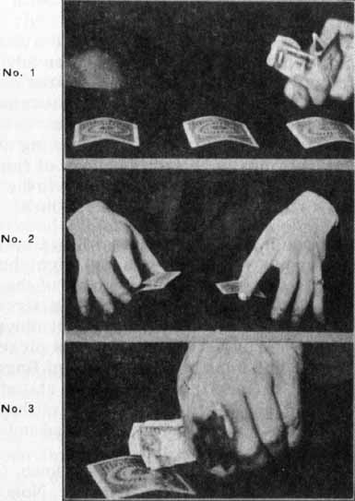
No doubt you have spent considerable time on the underthrow and overthrow with the right hand. It will be well to take up the movement of the three cards now. Lay cards as suggested in first part of lesson, No. 2, 1, 3. Now the correct movement for the three cards is as follows: 3 is picked and shown. I will not bear on the subject of fingers at this time due to the first lesson. As stated, pick up 3 card and show. Pick up 2 with left hand and show. Retaining 3, pick up 1 as explained and show.

After cards are shown, turn faces down. (Photo 2.) Hipe 3 to center 2 to right, 1 to left. Now cards are in position 1, 3, 2. It is the first preliminary move in the art of Three Card Monte. You have now made movement as if to throw ace to center, red card to right, remaining red card on left.

NOTE:--No doubt you have noticed and wondered why the money was being held in the left hand while dealing the cards as in photo No. 1. Well, there are two good reasons. The first for atmosphere and to have cash ready to pay bets (?). The other and main reason, to hide a marked or crimped corner. See Scarne's "marked and crimped corners"--where this can be used to good advantage. (Photo 3.)

A SERIES OF DECEPTIVE MOVES

Start with Cards No. 3, No. 1, and No. 2

NUMBER ONE
a Pick up 2 and show--(Right hand)
b Pick up 3 and show--(Left hand)
c Lay 2 on 1, pick up and show--(Right hand)
d Hipe 2 to left.
e Throw 3 to center.
f Throw 1 to right.

NUMBER TWO

All Red
a Pick up 1, lay on 2--(Right hand)
b Pick up and show--(Say red)
c Throw 2 to center
d Lay 1 over 3--(Right hand)
e Pick up and show--(Say red)
f Hipe 1 to left
g Show 3--(Say red)
h Throw to right

NUMBER THREE
All Black
a Pick up 3, lay on 1--(Left hand)
b Pick up and show--(Say black)
c Hipe to center
d Show black card--(Left hand) (Say black)
e Throw to left
f Pick up 2--(Right hand)
g Lay on 1
h Pick up and show--(Say black)
i Hipe to right
j Show black--(Say black)
k Throw to left

NUMBER FOUR
a Pick up 2, lay on 1--(Right hand)
b Pick up and show
c Pick up 3 and show--(Left hand)
d Hipe 2 to center
e Throw 3 to right--(Left hand)
f Lay 1 on 3 and show--(Right hand)
g Hipe 1 to left
h Show 3, throw to right--(Right hand)

NUMBER FIVE

All Right Hand

a Show winning Ace in center
b Pick up 2, lay on 1
c Pick up both--(Right hand)
d Hipe 2 to center
e Retaining 1, pick up 2
f Hipe 1 to center
g Lay 2 on 3, pick up--(Right hand)
h Hipe 2 to left
i Lay 3 on 1
j Pick up
k Hipe 3 to center
l Drop 1 to right

NUMBER SIX

a Pick up 3 (Left hand), and 2 (Right hand) and show
b Lay 2 on 1
c Pick up and show--(Right hand)
d Throw 1 to center
e Lay 3 on 1, pick up, show--(Left hand)
f Hipe 3 to center
g Drop 1 to left
h Lay 2 over 3
i Hipe 2 to center
j Drop 3 to right

NUMBER SEVEN
One Hand Deal

a Pick up and show 3 (Right hand), between thumb and 1st finger
b Lay on 1, pick up card, show between thumb and 2nd finger
c Lay both on 2, pick up, between thumb and 3rd finger, show
d Hipe 1 to left
e 3 to center
f 2 to right
g You can show cards each time if you prefer, but not advisable

NOTE: When working before an audience or before friends after they have picked out the winning (?) card, which turns out to be another, don't at any time show them where the winning ace is, just gather up the cards and start again. Follow this hint and keep them in suspense at all times.

BENT OR CRIMPED CORNER
Grifter Method

EFFECT: The Bent Corner is a sucker gag used by the grifter and shill to take over the wise ones, or suckers that are looking for a sure thing. The method is as follows: After the grifter has won a few times and his audience are laying low, the grifter will glance away from the table as if looking for the approach of a policeman or constable . His shill or confederate will reach over and pick up the ace, show it and turn up the left corner, thereby making it a sure thing. The grifter turns back to the table and does not notice bent card and deals cards. Naturally the suckers bet on a sure thing and lose.

EXPLANATION

I will now explain the grifter's method. Look at photos No. 4 and 5, showing method of bending corner with third finger. I find this last method more practical with bridge cards. The card can be crimped, taken out and put in another card at the will of the performer as follows: To crimp card, pick up card between thumb and second finger. Third finger rests next to second finger on top at edge of card, little finger reaches out and grasps corner and with an upward press bends corner as third finger presses down. If you soften corner of card you will find it much easier during practice. Don't break card. (See Photo No. 4)

To take crimp out, hold card between thumb and second finger, third finger grasps card over edge and draws up while little finger presses down, taking crimp out. (Photo No. 5.)

Photo No. 6, hold card between thumb and first finger. Second finger grasps card over edge and presses up.

Photo No. 7, hold card between thumb and first finger. Second finger grasps card over edge and pulls up. Third finger presses down.

To take crimp out and put it in another card, lay cards out as in Photo 1. That is, 3, 1, 2, in front of you, upper right corner of ace or 1 has been crimped. Two is picked up by right hand and shown as the hand is turned over to pick up the ace or 1. Two is crimped as shown in Photo 4 and is put over the ace which is picked up and shown. The crimp in upper card cannot be seen due to the ace in front of it, which is also crimped.
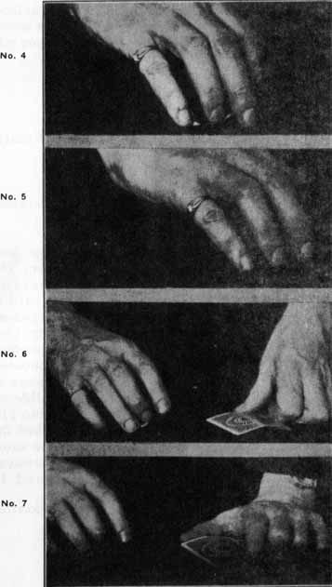
The left hand picks up No. 3 and shows it. Hipe top card or 2 to left, and during the action of throwing 3 take crimp out of ace. See photo 5. The crimping and uncrimping of cards is a very difficult piece of business, but after it has been practiced before a mirror or before a pal who will be honest with you and criticize you when necessary, you will be well paid for your trouble.

THE FLIP(?)

The Flip (?)--Three reasons for the question mark:

1. I don't know what to call it.
2. I don't know who gets the credit for it.
3. The look of query on the faces of spectators after its execution.

The Flip is sort of Mexican Turn Over, but done with two fingers, thumb and second finger. The cards are crimped as for Three Card Monte, face down on the table. To execute this flip, card is gripped between the thumb at inner end and second finger at outer end at right side of crimp. (See Photo 8.) Card is raised and laid over the other card. (Photo 9.) Lower card is gripped between thumb and third finger, upper card is released as lower card is jerked up, causing it to slide off lower card (Photo 10), and turn over (Photo 11). If done fast, the effect is that you have pushed the card under and flipped it over. It is used the same as the Mexican Turn Over. Many clever moves can be accomplished after you have mastered it.

NOTE--Be sure and change fingers as you do after hiping in Three Card Monte.

The Flip is followed by the Flip Change.
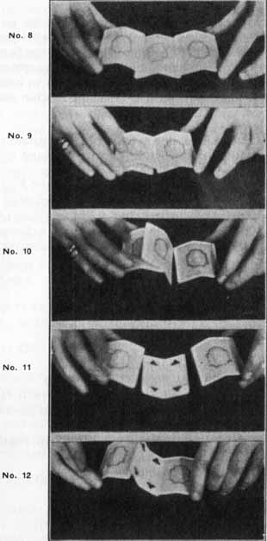

THE FLIP CHANGE

After you have made the flip and have the card face up on the table (Photo 11), and you still want to further bewilder the spectator, retain the facedown card in right hand, between the thumb and second finger, push it about one-half inch in under the face-up card and with a jerk-up motion turn face-up card over (Photo 12.)

As card falls face down (Photo 8), continue towards left with card in hand. As you get about twothirds over lower card (Photo 9), drop upper card, grasp lower card between thumb and third finger and draw to right. This complete manipulation is done very fast. The faster, the more bewildering. After you have become proficient, you will acknowledge the move as the sleekest in your repertoire.

MOVES WITH FLIP AND FLIP-CHANGE

Cards No. 3, No. 1, and No. 2

For quick deceptions:

a Pick up No. 3 and show--(Left hand)
b Pick up No. 2 and show--(Night hand)
c Insert 2 under 1 at right side and turn it face up, using right edge of 3 as a stop to prevent 1 from slipping.
d As you turn I face down, execute the flip-change getting 1 in right hand.
e Lay 3 over 2 (Left hand), pick up.
f Hipe 3 to center.
g Drop 1 to right.
h Drop 2 to left.

NOTE:--When working on the slippery type of table, use card in left hand as a stop, that will
prevent card from slipping. For instance, in the Flip, have card in left hand rest against edge of card to be turned over. In Flip-Change, lay left hand card on the edge of face-up card and by pressing down you will elevate the right edge of card to be turned over. (See Photo No. 12.)

After you get proficient in the Flip and Flip-Change, try this: Have No. 1 in center face up, No. 3 in left hand face down, No. 2 in right hand face down. Lay 3 on edge of 1, elevating right edge, turn 1 over with 2 and as 1 falls over let 3 drop so that it falls under 1, then grasp 1 with left hand and draw to left, at same time grasp 3 with thumb and third finger of right hand and draw to right. Throw 1 to center, 2 hipe to left and drop 3 to right. This is a very deceptive move and throws off the "knowit-all." Try it. Practice the series of moves shown on pages 19, 20 and 21, using the Flip and FlipChange.

DRIFTER'S MARKED CORNER
Using the Flip and Flip-Change

EFFECT
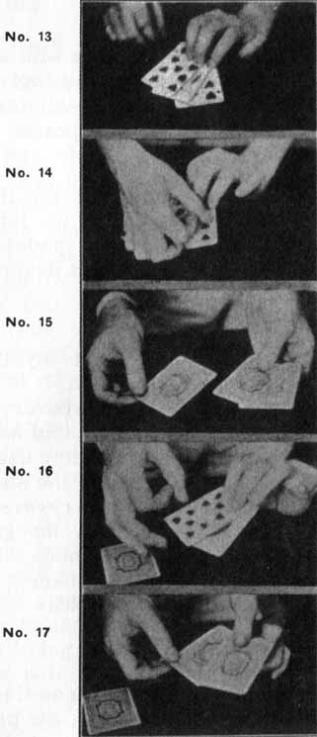
Card in center has been marked by shill at his left corner on back. Drifter turns this marked card over and it proves to be the winning ace. Ace is then turned over and cards are dealt around, after which the players naturally pick the marked card and--JUST and.

WORKINGS
Cards are dealt and ace shown once or twice. The grifter turns his back, shill reaches in and marks card in center, apparently the ace, but the ace happens to be on the grifter's right at this time. The grifter picks up the ace in right hand and executes the FLIP, showing the ace face up in center. Marked card is now in his right hand face down, fingers covering the marked corner. After letting the players see ace in center, grifter executes the flip change, bringing ace back into the right hand and marked card in center, back up, showing marked corner. Drifter then deals cards and collects.

SCARNE'S MONTE SLIDE

EFFECT:
Three cards are held in left hand, face up, ace in middle. Each is snapped with first finger of right hand and laid on table. Try as they may, they cannot locate the ace. This is an effect you can work all day but still fool them.

EXPLANATION:
First Method--have three cards in left hand, face up, not crimped, as in Photo 13. Take notice of the way the hand holds cards, fingers on top and thumb underneath. As you can see, the cards are arranged--9 of hearts on bottom, ace of spades center, and 10 of diamonds on top. Follow very close with cards in hand. Reach over with right hand and with first finger snap the 9 of hearts at outer left, Photo 14, calling name of card; turn the hand over, showing back of cards and snap again, repeating, 9 of hearts. Take it out (don't show face) and lay on table, face down, Photo 15. Turn cards in hand over again (they now see that you really took the 9 of hearts. If you had shown it they would have become suspicious). Now snap ace the same way, calling ace of spades, Photo 16. (Now the important move.) As you turn over, push with thumb and draw back with fingers, causing cards to change places. Snap apparent ace of spades as you did the 9 of hearts, calling ace of spades. Take out, Photo 17, and lay on table, face down. Keep last card face down. Snap it and say 10 of diamonds and lay on table.

This effect will have to be done with speed and confidence. Try it again and you will fool yourself. To further bewilder the know-it-all fellow, use the Mexican Turn Over, to turn cards face up, throwing his theory all off.
NOTE:--This effect can be used for the TORN CORNER. Lay all three cards on table after snapping, pick up apparent ace of spades, tear off corner, etc.--(See TORN-CORNER description.)

SCARNE'S TRIPLE CLIMAX

This is the sleekest and most mystifying of monte effects in Scarne's collection. It is an effect that is left to the spectator to discover, and then to fool him. Apparently it is a stupid mistake on the performer's part. The performer uses a deck of one-way back cards, preferably the showy back bridge card. When the card is reversed it is noticeable at once. When used by the grifter he uses a back that is not too conspicuous but noticeable enough when brought to the sucker's attention by the sly nudge and whisper of a shill.
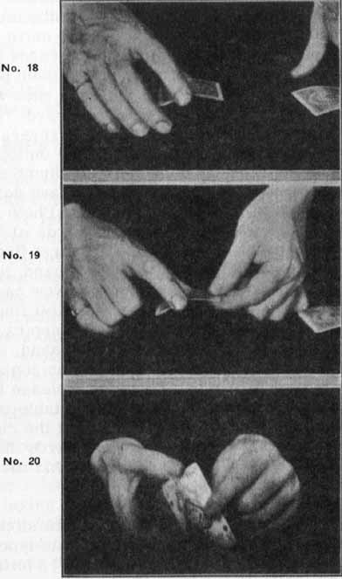
EFFECT

Three cards are dealt as per Three Card Monte (design on backs are all one way), the performer after a few throws picks up the ace and shows, and in laying it back reverses the ace. Due to the showy back of the card, the wise spectator will at once notice the change, after cards are dealt again, he picks the reversed card and!--that's all, and...? We leave the rest to your imagination.

NOTE: While performing at one of the better clubs Scarne was offered $250.00 for the secret, by a gambler who was in the audience.

EXPLANATION:
(Use cards with showy one-way backs.)
The three cards are laid on table face up, after turning them over and dealing a few times, showing a few of the other effects in this series, pick up the ace and show, and lay it back on the table, reversed. Pay no attention to your stupid move, let the wise ones see it, then pick up the cards and deal. Leave reversed card as it is, let them pick it the first time, by this time the wise ones will tell the others all about the reversed card. Now you have two cards one way and one reversed. Pick up one of the other cards, lay on top of reversed card. Pick up both between thumb and first finger of right hand at ends. Keep face down, hold card about two inches from table, Photo 18. Reach over with left hand and take cards at left edge center between thumb on top and first finger underneath. Photo 19. Let go with right hand, turn left hand over, showing ace on bottom. Now cards are held in left hand, ace showing, first left finger will be in front, left thumb in rear. Keep cards in that position, reach over with right hand, and take cards again between right thumb on top and finger on bottom of cards, Photo 20. Release left hand and bring cards face down toward table, and deal. You will notice after practice that the right hand has made a revolution, but cards have apparently not been reversed. Practice this move. I know it will be your best bet.

When working the effect before men of the slicker type use angel or bicycle back cards. This type of fellow is always looking for some defect on the backs, and he will recognize the one way backs and they can't help seeing this "gross error" on your part. If you have a confederate, let him point out your dumb error, on the quiet.

NOTE:--This revolution has to be perfected by you before you can do Scarne's Marked and Crimped Corner.

SCARNE'S METHOD OF THE CRIMPED CORNER
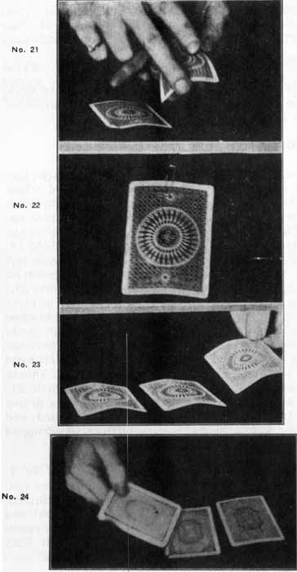
EFFECT:

Same as grifter's crimped corner.

This effect is a very clever piece of card `work for the club worker or card man, for an impromptu effect it cannot be beaten.

EXPLANATION:

Have corners of cards soft, but not broken. Lay three cards No. 3, 1, 2. You reach over and crimp the ace or 1, pick up 2 and show with right hand; now bring right hand with 2 card over 1 and pick up. See Photo 18. Bring left hand over, thumb on top and first finger under at center of card as Photo 19. Release right hand and turn cards face up with left hand. Now turn right hand over bringing thumb on top and second finger on bottom. (See Photo 20.) Crimp 2 or upper card with third finger of right hand, hipe 2 to center. One is retained in right hand which reaches over and picks up 3 card. Both cards are then grasped by left hand underneath between thumb and second finger. First finger of left hand is in center of cards curled up underneath. Thumb and second finger slide to rear of cards as Photo 21. This action takes out crimp in ACE, which is drawn off with thumb and first finger of left hand, and dropped to left, Photo 23. Remaining card is dropped from right hand at right of table.

NOTE:--If you find it difficult to put crimp in No. 2, use this method. While telling player to crimp ace, point with left hand to corner of card to be crimped, with right hand pick up 2 and drop to your side, and crimp corner. After they have crimped ace, reach up with 2, lay on ace and proceed as explained. This action can be done very slow and deliberate.

SCARNE'S MARKED CORNER

This effective card manipulation is used by John Scarne with great success. The action is impossible to follow (if performed right). Scarne has mystified the best magicians with this effect. Follow the movement and practice each move before a mirror until you get it correct. When you have it perfected there is nothing better as an impromptu card effect to fool the wise ones. The action is similar to Scarne's crimped corner, and if you have mastered that effect this will come easy.

EFFECT:

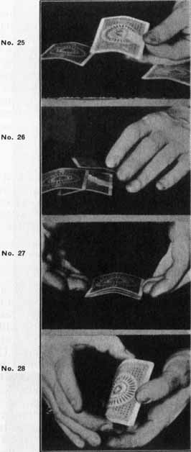
Three cards are laid on the table as in Three Card Monte; after you do the moves of same you ask someone to mark the corner of the ace with a pencil, giving them an opportunity to see the ace. After you have dealt the cards they pick up the marked one--but?

EXPLANATION:

First of all, let's take up the marking of No. 3 card which will be used as the other card to take the place of the marked ace. Method No. 1--a duplicate marked card is held under coat with a pin (see Photo 22) and paper clip at position where it can be released and palmed, in left hand. Card is placed in clip so that it can be palmed, back to palm and marked corner at root of left little finger. After you have laid the cards out 3, 1, 2, take 2 with right hand and turn cards face up (as in Mexican Turn Over), when turning 3 allow it to fall to floor (while flipping cards, get duplicate card palmed in left hand). Retaining 2 in right hand, reach down with left hand and get 3. Place left hand over 3, pick up and as you are coming up reach over with right hand containing 2 card and get palmed card. Throw both on table face up, and at same time put left hand in coat pocket, leave card, bring out pencil and hand to player. Pick up ace and let him inspect it. Now have him put it face down on table and have him mark it on the back at his lower left corner. While attention is on him, turn over 2 and 3, getting 2 over 3, hiding your mark. After ace is marked, pick up 2, then 3; hipe 2 to right, retain 3 in right hand, then lay 3 over ace or marked card and proceed with revolution. After which both cards are taken at inner left corner, between left thumb on top and fingers underneath, right hand reaches over and removes upper card which is dropped to center. The card in left hand is dropped to left. NOW THE IMPORTANT MOVE--AS YOU LAY LEFT HAND CARD DOWN, THUMB IS DRAWN OFF CARD IN A SLIDING MANNER, REMOVING MARK PUT ON BY PLAYER. (See Photo 23.)

Method No. 2 for marking corner; have piece of carbon paper in left hand coat pocket and when you reach in to get pencil, get a small quantity of black on left thumb nail, hand pencil to player with right hand. Pick up one of the other cards by left inner corner between thumb on top, with fingers underneath. Using this card as a pointer (Photo 24), show player where to mark the ace and at the same time your thumb is leaving a duplicate mark for the change.

THE STAMPED ACE-SCARNE'S METHOD

EFFECT:

Three cards are laid out as per Three Card Monte. Ace is picked up and shown, then a postage stamp is wet and applied to left side center. After cards are dealt, the spectator picks stamped card as ace. But`? what a climax! This is Scarne's pet effect.

EXPLANATION:

Lay cards out No. 2, 1, 3. Take postage stamp or use piece of paper about one inch by one-half inch. Wet about a half inch of one end and apply to left center edge of ace or 1 (Photo No. 25), (be careful not to wet both sides). Show ace before and after you apply stamp. The best way is to pick up ace between thumb and second finger of right hand at long ends. Lay stamps on left edge and press on with left thumb and first finger. Have cards crimped. Let stamped card fall to table, pick up and show 3 card and lay on ace so that left edge rests over crimp and above stamp. (Photo 26.) Next pick up and show 2 card. Lay it on top of 1 and 3. Now as you lay 2, draw back 3 so left edge falls below stamp. Even up cards as in Photo 27. Then pick up all cards between right thumb and the second finger, at ends; bringing left hand under cards at sides and pressing same between thumb and second finger, thus giving the appearance that you are crimping them a little more (Photo 28). The cards are held in right hand. Make motion of overthrow, but drop lower card to left, then drop next card to right and top card in center. The move fools the wise ones as they see an overthrow and still see a plain card next. This gives the appearance that the stamped card is still the bottom card. You can use the glide with this effect, in this manner. Hold the cards in left hand, show ace on bottom, then turn face down, push back bottom card or ace and draw out stamped card, then draw out ace and drop upper card. This is a very easy, but mystifying, card effect. Practice before a mirror before trying it in front of an audience.
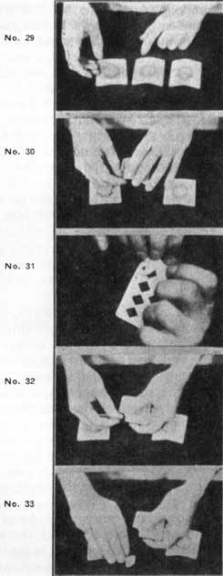
In first demonstration, don't draw back No. 3 card under cover of 2, leaving the stamp on ace and go through move as above. Then you ask them to pick the ace and they will naturally pick some other card, thinking there is some trickery, then you turn the stamped card and show that it is the ace, laugh and make some smart remarks. Do it over and change the stamp as explained.

Another method of laying cards on stamped card. have cards No. 2, 1, 3. Stamped card or 1 card is in center of table. Lay 2, left hand, on 1, let about 3/4 of an inch of 1 card project out on right side. Pick up 3 card, right hand, bring toward 1 and 2, allow it to slip under 2, push 2 and 3 together over ace. Pick up as explained.

NOTE:--Put a little more moisture on stamp than necessary for ordinary purposes of sticking. This will keep it from sticking too fast.

SCARNE'S METHOD OF TORN CORNER

EFFECT:
After doing one or two of the past effects, Scarne makes a few throws and shows ace in center each time. lie throws again and picks up center card. Tears off corner and throws same on table, face up. Said piece is the corner of the ace of spades. He then throws cards and has spectator pick ace. Upon examination, spectator discovers that he has red card without corner.

EXPLANATION:

First, have one corner of another ace of spades.

Second, have it some place near right hand where you can get it, between thumb and first and second fingers (Photo 29). Note: Best bet is to have it under- vest held by pin and paper clips as in Photo 23. Reach up with the two fingers and thumb of right hand, and get it while you pick up the red card which is now in the center, with left hand. See Photo 30. Reach for upper right corner of card with fingers of right hand, get piece under corner of card as Photo 31. This photo illustrates appearance from bottom angle. Retain card at this corner with right hand. Release left hand and bring left thumb to upper edge of card or top, a little to right of center, fingers curled up underneath, first finger tip at left edge of piece underneath. Now with an upward motion of the right thumb and two fingers tear off corner of card. (See Photo 32.) Draw back lower piece with right thumb and throw upper piece on table face up (which is the corner of the ace of spades), dropping torn card on the table, Photo 33. Remarking that this ought to be easy, nonchalantly put right hand in right trouser pocket, getting rid of piece, and throw cards with left hand. A wow of an effect! Try it and see how easy you take them over.

SCARNE'S PUSH OVER CHANGE

Three cards are held in left hand, face up, between thumb on top and fingers underneath-RED CARD, BLACK CARD, RED CARD. Each card projects towards the right about one-half inch, keeping cards face up, take out the red card towards the right (calling name as it is drawn out) between the thumb and first finger of right hand at inner right corner, thumb on top. Now tap black card in left hand with card in right hand and call the name of card, Photo 34. Turn cards in left hand over. When turning cards over, push with thumb and draw back with fingers, changing the position of both cards. Again tap projecting right card, Photo 35, and drop card in right hand to table at right. Reach up with right hand and take projecting card, drop in center. Drop remaining card (the ace) in left hand to left of table.
NOTE:--This sleight is done very fast, and can be used in many card effects.
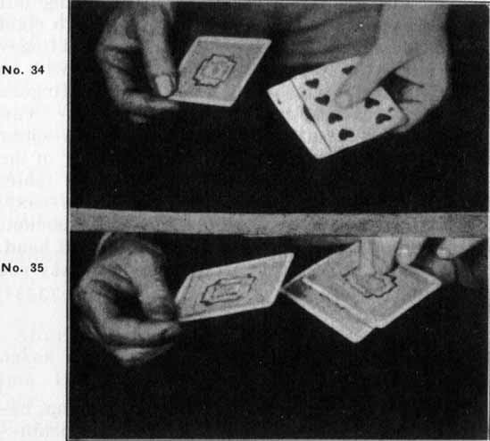

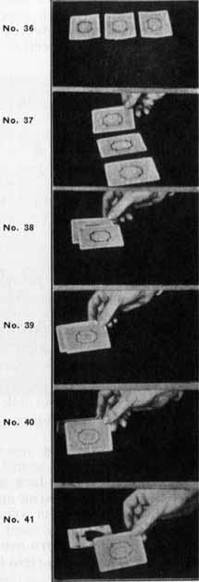

THE MEXICAN TURN OVER

This sleight is referred to in every book on cards, but I have yet to see it fully illustrated, and considering it to be one of the prettiest dodges, I present it as an added feature.

EFFECT
Cards are laid out as Three Card Monte, cards are crimped just the opposite way (see Photo 36), after grifter moves cards around, you touch the card that you think is the winner. Grifter, to show you that everything is above board, does not touch that card with his hand, but picks up another card, which he inserts under your selected card and turns it over, and proves your selection wrong.

EXPLANATION:
Lay cards out on table as (Photo 36), card to be turned over is in center, card on right is picked up at inner right corner between thumb and first finger (Photo 37). It is inserted under center card at right side about one-half inch in from inner edge, see Photo 38. Second finger is kept right next to first finger, when under card has been pushed up to about one-quarter inch from edge of upper card the second finger will come in contact with upper card.

IMPORTANT--At this contact draw the thumb to the position above second finger on upper card, keeping first finger under lower card (see Photo 39). Continue the movement towards the left, thumb and second finger carries away upper card (the selected one), first finger turning over the lower card. See Photos 40 and 41.

NOTE:--Crimp in cards are hardly noticeable, just enough so card to be inserted can get under, without pushing upper card all over the table.

NOW TRY THIS MOVE ON YOUR FRIENDS

Have cards 3, 1 and 2 on table face up, pick up No. 3 with right hand as explained, slide under No. 2 turning it over (follow through with wrist, turning 3 over). (See Photo 42.) Keep in right hand, turn face up again, then slide 3 under 1. Turn over, making change. Follow through, keep 1 in right hand, face down, and drop to left.
THE DAUB

The daub box is a small tin box about one inch wide and one-quarter inch deep. Some times there is a pin attached to it, so that it can be pinned to the body at a place of advantage, where the finger tip can be applied to it in an unsuspicious manner. The daub material is a composition of powdered paste made in two colors--red and blue. The daub will not show on the fingers, and will not flash on the cards as it is not greasy. (But it is permanent, which makes it bad for monte workers.) The daub can be toned down to where it is practically invisible to the layman.

A one-color daub has been put on the market, called the Golden Glow. It can be used on red, blue, green, or brown cards. This daub is different from all others, inasmuch as it leaves a golden stain, which has the appearance of a nicotine stain, and is impossible to detect. (One of the slicker players puts this Golden Glow on his moustache and when he wants a supply he reaches up and twirls the ends--not bad.)

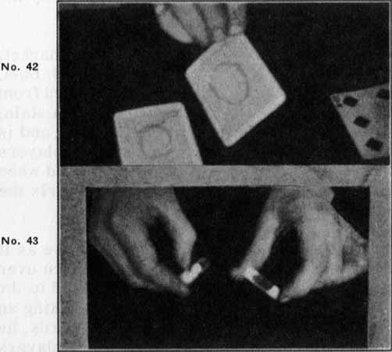
For Monte, black is the best color to use as it has to be seen by the players about to be taken over (or gypped as it were). It is usually applied to the cards by a shill, who is supposed to be taking an unfair advantage of the grifter. In other words, he is supposed to be in league with the other players and is going to put one over on the grifter, thereby giving his fellow players an opportunity to win big money (which they don't do). See Grifter Marked Corner page. There are two very good daubs for this purpose, a soft lead pencil and a good grade of black carbon paper. The latter is folded up and kept in the vest pocket. It leaves a daub that is very noticeable and it can be wiped off as in Scarne's Marked Corner (page 35). When the fingernail is applied to it, it will leave a line such as a pencil would do if applied to a card. For the pencil daubs see Photo 43.

For heavy daub cut pencil as on right.

For nail mark cut pencil as on left.

Rouge and pastels make a good daub. Wax crayons should not be used as they leave a high gloss and can not be removed with ease.

Now that you have the dope
Don't get energetic,
'Cause fools and wise guys
Seldom win.
It's really quite pathetic
For gamblers lose
Tho' babies need shoes.
But here's to fun and good tricks.
...How poetic!

