How to simply & beautifully convert PDFs to Mobipocket format

Tools

- Iceni’s Gemini & Adobe Acrobat (full version, not the ‘reader’) or Gemini Solo (standalone)
- Microsoft Front Page
- Mobipocket Office Companion 2.0

I presume here that each of the applications above is installed. You can obtain demos of Gemini Solo (produces partially garbled content) and Mobipocket Office Companion 2.0 (14 day trial) from the company’s websites. Adobe Acrobat and Microsoft Front Page applications are only available for purchase.

1. Convert PDF to html

I will show how to do this using the Gemini plug in for Adobe Acrobat, if you have the standalone Gemini program, the process will be much the same.

Below I have opened Adobe Acrobat and loaded in the Ebookman Users Guide. Note the Ebookman Users Guide has user password protection so if you are trying with this file, you will need software like Advanced PDF Password Recovery Pro.

Now navigate to the Gemini Plugin and select ‘pages’ as shown below.

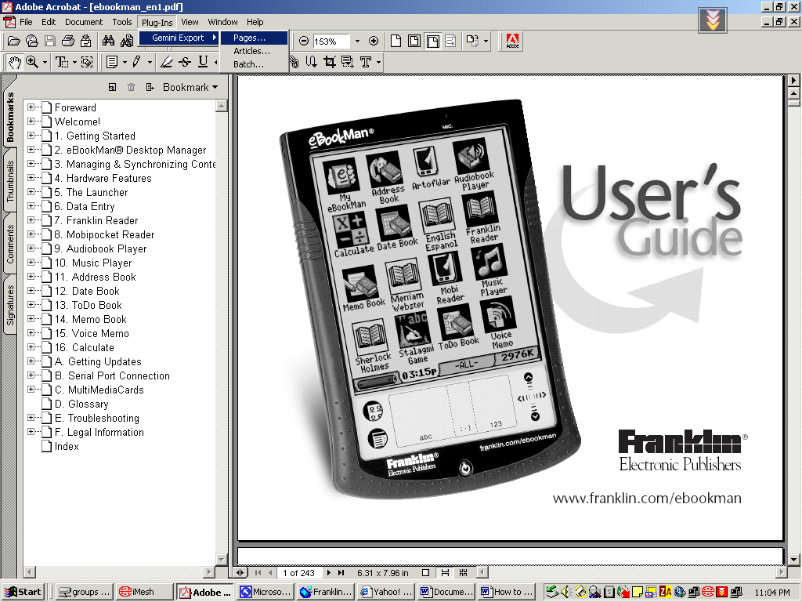

The following dialog appears. Select the ‘All’ pages radio button then click the ‘options’ button.

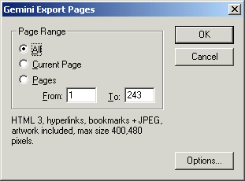

Next set the options for each of the tabs as shown in the pictures below.

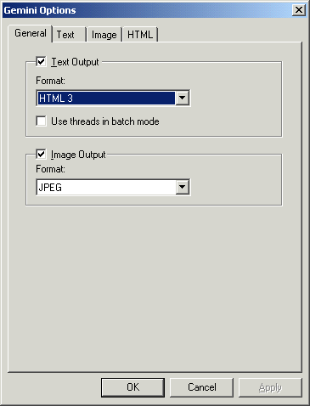

In the next dialog you may or may not want the “Insert page breaks” option checked. It puts in page breaks (i.e. horizontal rules) in your html file exactly where there are page breaks in the PDF file.

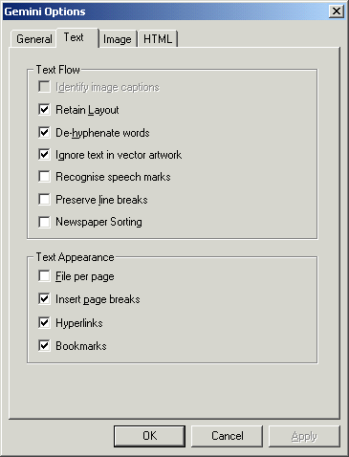

Next set the image size. Bear in mind that the Ebookman screen size is 200*240, but this is not a limitation. If you set image sizes larger than this, later when you export to Mobipocket reader, it will display an ‘in text’ preview of your image that is beautifully shrunk to fit the screen. Then if you click the image you will get an image as big as you ask for in the dialog below. E.g. here the image size is set to 400*480, twice the Ebookman screen size.

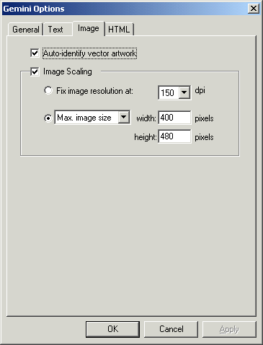

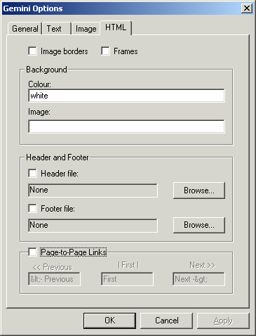

Now click on ‘OK’ and you will be taken back to the previous dialog, where you should click ‘OK’ again which will bring up the ‘Save’ dialog below. Here I choose to save the html output to the desktop for convenience.

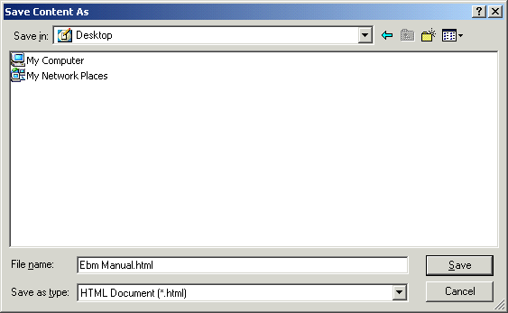

Click ‘Save’ and you will see the conversion dialog.

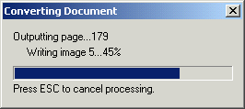

Wait until this has finished processing, then close Acrobat (or Gemini Solo).

2. Export HTML to Mobipocket (For viewing on PDA)

Open MS FrontPage and load in your html file.

E.g. Below is page 50 of the Ebookman Users Manual.

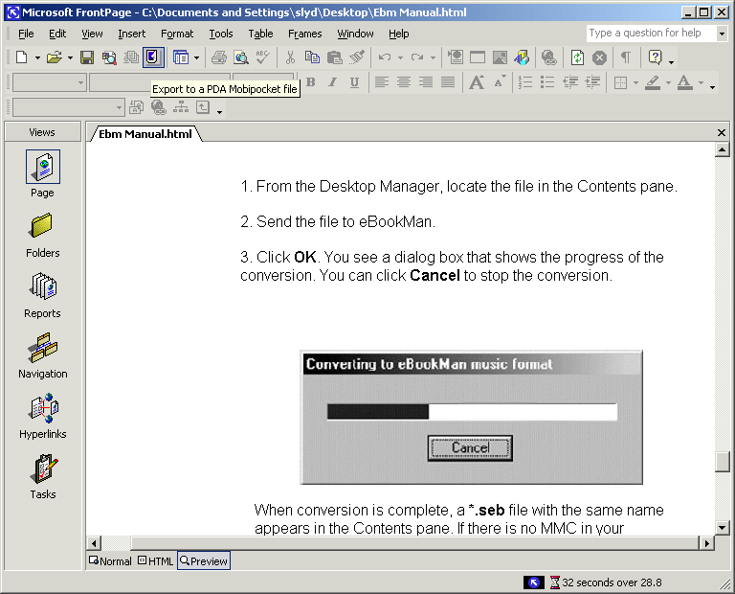

Click the purple Mobipocket icon just below the ‘Insert’ and ‘Format’ menus and the following dialog appears.

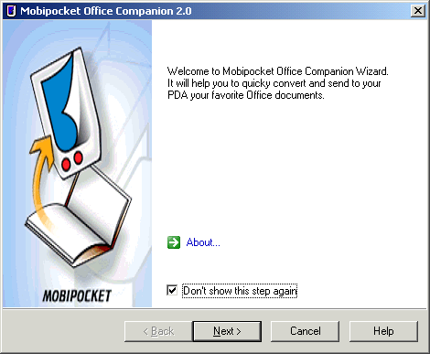

It’s probably a good idea to click the ‘Don’t show this step again’ checkbox, so you’re not bugged next time.

Click ‘Next’ and the following dialog appears.

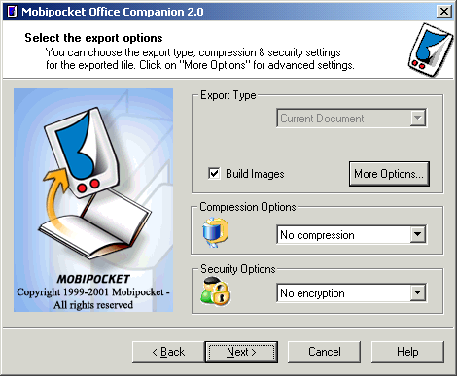

For now, just click ‘Next’ again and the processing begins.

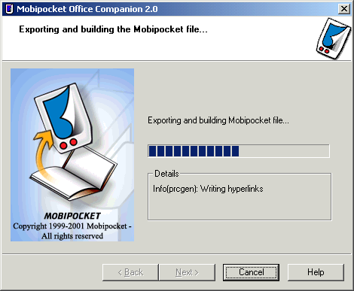

Next the following dialog appears.

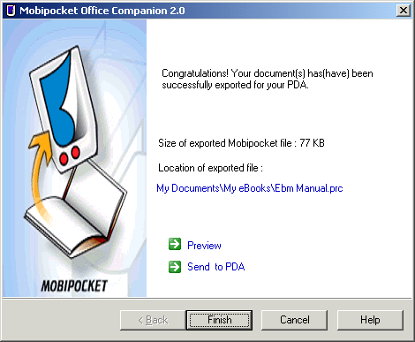

Simply click ‘Send to PDA’ (or you might like to preview beforehand).

Shown below is our outputted file in the emulator (i.e. preview).

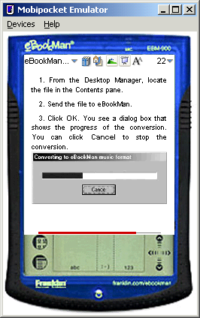

To view the image in this text a little better, simply click it, and you will be taken into image mode, where you see a zoomed version, which you can drag with the ‘hand’ tool. Note that the image mode is not that important for the above image as we can see if reasonable well ‘in text’; however it is invaluable for more detailed images

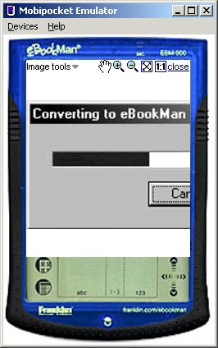

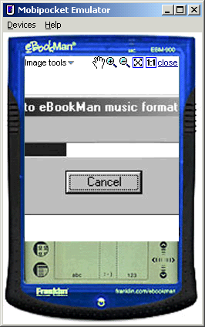

That’s it. Good Luck!

