A Chromepunk Anthology

By M. Bennardo, illustration by Linus Persson
4/7/03

1. Ignition
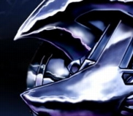
Three times in one day, Ford Grundling had spat blood. Never, never, never had he imagined that the Kaiser could be so hard to kill. They'd been naive, he supposed, the whole American lot of them, to think that the Teutonic discipline of death and waste-laying was anything less than a birthright. God, those men could kill -- and kill by the tens of thousands.
Above the trenches, starbursts of artillery lit the sky, dissolving into green and red and orange streaks. Grundling's ears were full of whistling from the soaring shells -- or his right ear was full of whistling, anyway. His left ear was full of water from when he had slipped in the sludge at the bottom of a blast crater during his last charge. He had lost his bayonet and he had come close to drowning as he floundered in the hole. He would probably get pneumonia now, or at least an ear infection.
Somebody needed to do something to bust the stalemate soon. It seemed to Grundling that there had to be a limit to the number of men who could die for a single piece of earth. With every detonating shell, the ground itself seemed ready to stand up and give itself over to whichever side happened to be closest at the moment. It wasn't even worth the fight anymore -- now they were only buying a morass of blood.
In the distance, Grundling heard a new sound. It wasn't the rat-a-tat of the machine guns, nor the dull shocks of the artillery. It curled through the air, wheedling and guttural like the sound of a snake coiling around and around a metal lamppost. "What is it?" Grundling asked. Leaning forward, he lifted his field glasses.
A shell erupted overhead, spraying no-man's-land with color and light, and Grundling saw what the sound was. Two hundred yards out in the cratered wilderness, a pack of chrome wolves jumped up and down, preceded by their great spinning mouths. At the next moment of illumination, Grundling got a better look. He could see now they were motorized bicycles with enormous tires in the front and back. Earnest men in spiked German helmets crouched behind their thick handlebars, riding up and over the broken terrain like ships bucking coastal waves. They were coming on fast, and there were a lot of them.
The heavy-caliber machine guns all around leapt to life. Grundling swung his own gun around toward no-man's-land as well, but absolute darkness had returned. In the blackness, the banshee roar of a thousand combustion engines Dopplered louder and closer with every passing heartbeat.
It seemed only two breaths until the sky was lit again, but already the line of wolves was suicidally close, lunging at the bewildered machine gunners. The earth in front of Grundling was alive with dancing chrome tracers of reflected light. He wanted to fire, but by the time he was able to command his wits, he was already among them -- smelling their sharp gasoline breath and falling down underneath thick treads that stamped a tattoo of blood and grease across his mutilated body.

2. Combustion
For three solid seconds Ram was aware of nothing except the ground rushing past and the blue-flame sting of combustion, pure exhilaration like a shot of whiskey suddenly bombed down his throat. It opened his eyes, it cleared his sinuses, and it rocked him hard from his thighs to his shoulder blades. Good God, it hurt -- it hurt like a hundred rock hammers tapping at his spine. It hurt, but it was a pain he could get used to. It was a pain he could grow to enjoy, a pain he could get addicted to.
"Oh, yeah." Ram's belly cooled as the combustion dwindled to a slow burn, and he wiggled a moment in light-headed vertigo. His eyes glazed, he opened his mouth, and his skin erupted in big round beads of cold sweat. It felt as good as vomiting.
Bat ran up to Ram, holding his hat tight on his head, coat flapping in the electrified and fume-sweetened air. "Good God," he whooped. "Ninety-seven miles an hour in three seconds."
Ram constricted his lungs and belched out a balloon of carbon dioxide. "I want to do it again."
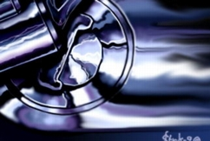
Out of the corner of his eye, Ram saw the metal tubes gleaming and quivering all through his body. Bat reached out to touch them. "You're a beautiful man," whispered Bat. "A beautiful machine." After the war, Ram hadn't thought that anybody would ever call him beautiful again. The bombs and the gangrene had made him only half a man -- but Bat had reversed all that. Now he was more than a man, a perfect primitive god carved in chrome. "We're going to change the world together," said Bat. "We'll make those highways sing."
Ram slid away from Bat's hand -- a reflex -- but the other kept pace, holding him tight. Ram turned over his engine three times, six times, nine times, feeling the hot gasoline roar in his veins and his belly again leap into flame. He arched his chassis and spread his axles, chrome glinting everywhere under the sun. Ram never wanted to taste morphine again -- he only needed premium gasoline and a flat desert to incinerate.
Ram shifted gears in a heartbeat -- in a revolution -- and suddenly his tires gripped the sand tightly. "Good God?" he said, the taste of rust and lubricant on his tongue. "I am your God now, man."
Bat fell back from Ram's coughing body, startled, and Ram exploded across the desert, chrome trimmings shining like molten velocity in the heavy air. In five seconds, Bat had all but vanished in the heat haze, and Ram's back rattled out two simultaneous melodies of pain and life. Rising over a dune, his wheels left earth for an instant and he hung stately and weightless, big tires spinning lazily and slicing the air, until he smashed down again with a hatred for stillness and silence, and a fever of one hundred and thirty miles an hour.

3. Clutch
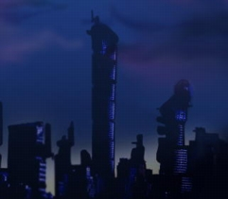
Saint Magnum hated chromepunks. Them and their bodyrockets, ripping up the city streets a hundred times every night, exploding in nitrous fireballs on the honest highways. He hated them all -- the andrettis, the earnhardts, the jamesdeans, all of them. It was his job to hate them. That'd been drilled into his brain years ago and now nothing else revolved in him but hatred, hatred, hatred, three thousand times a minute.
He licked asphalt and concrete as he rode, tasting for the telltale alcohol compounds of the chromepunks. The streets were still and silent, all of the honest fords and hondatoyotas at home for the evening, idling monstrously like hungry dogs in garages up and down the streets. In these lawless midnight moments, seven hours away from either rush hour, the chromepunks slunk out of their homes and stepped into their own particular suicide dreams.
Andrettis were low and flat, like an aerofoil on ball bearings. The earnhardts were longer, boxier, and when they crashed they tended to punch their way through walls before exploding. But Saint Magnum hated the jamesdeans most of all. This was something he had learned himself -- they hadn't told him to hate any of them more than the others. That extra-sharp hatred was probably just Saint Magnum's last shred of humanity slipping through the gearshafts and pistons, as it did from time to time.
Saint Magnum paused on the street above a rainbow slick of oil and gas. There was a jamesdean out that night. He could taste it, not four minutes gone. Saint Magnum swerved off again down a boulevard, sweeping across dotted lines and solid lines, searching for the bodyrocket. Something rushed past him in the night, going so quickly that he saw it as nothing more than a momentary interruption of the streetlamps against the pavement. It was the jamesdean, playing chicken like the cocky sons-of-trabis always did.
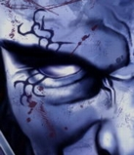
Saint Magnum spun in the street and roared off in pursuit. He could see the jamesdean splitting the illumination of the streetlamps off its chrome body, humming along next to the concrete median. A cloud of steam-hot exhaust waggled behind in a diffusive white dance. Saint Magnum punched himself harder still, stripping the tread from his tires in an unraveling rubber trail. No jamesdean could ever outrun the maniac energy of his turbocharged eight-cylinder. Oh, how he wanted to grind that chromepunk in his grille. It boiled his oil just to think of it.
Three seconds later, Saint Magnum was only twenty yards back. He spread his grille, tasting nothing but the sweet stench of burning hydrocarbons and seeing nothing but the mesmeric play of yellow lights against the silver-blue chrome of the jamesdean. Saint Magnum pulled up behind the bodyrocket and licked his bumper lips. The valves and gear shafts in his mind spun faster and faster, spark plugs flickering with anticipation. He could see the chromepunk inside -- hunched over the gearshift of the bodyrocket. Saint Magnum had been like that kid once, but now they had made him better and faster. He wouldn't even mind the blood splashing his mudflaps.
The chromepunk turned around for a split second, his helmeted face staring at the giant beast behind him. Saint Magnum was too close to miss now -- he shut his eyes and reached out, working the grinding peristalsis of his gullet, rows of chrome teeth flashing bright and wicked in the night.
There was a sound that Saint Magnum had never heard before, and then his engine suddenly seized up. His entire chassis shook and Saint Magnum spun to a stop, flinging off momentum and kinetic energy. His eyes rolled back in their sockets and he idled -- shuddering and coughing -- for a moment. The jamesdean had sprayed him with additives, with additives and lead. It left a repugnant taste in his mouth that no amount of oil seemed able to wash out.
Cold and quiet on the asphalt street, Saint Magnum shuddered again and tried to find his way to first gear. A single human thought wound its way around his engine. He'd been slamming head to head with the chromepunks for over a year now, and Saint Magnum didn't think he'd ever kill them all -- but he could see clearly enough how he was going to die. Fenders would meet in the street one night, and Saint Magnum's crumple zones wouldn't be enough anymore. He'd lie on his roof, wheels spinning, leaking transmission fluid onto a totaled bodyrocket. With his last revolution, Saint Magnum was sure he would see the chromepunk in his fireproof jumpsuit climbing out of the wreck and slipping away into the darkness -- alive and free to walk away.

4. Exhaust
Forty years ago, Rush had been their last best hope. Now he was older than asphalt, and so was his machine. He'd be lucky to make it up the onramp, let alone all the way down the highway. But he didn't want to make it all the way down anyway. He simply wanted to pack it all in on the same spot where he'd first blown it all out in a pretty hothouse bloom of exhaust and aerodynamics. It had been twenty years since he'd even been on the highway, but he still felt that he belonged. He belonged there more than those damned soulless atomic ghosts did, anyway. But they'd killed his way of life, so they might as well kill him too.
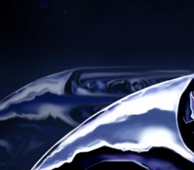
Rush strapped his goggles on his face. Long ago, they had pushed deep lines permanently into his cheeks and forehead from riding too long at three hundred and fifty miles an hour. That was what they did back then, back when he was a god. They had done three hundred and fifty mph on combustion engines and rubber tires and asphalt roadways. Now they'd changed it all -- even a commuter could do five hundred without blowing his radiator.
Rush's machine kicked to life underneath him. It was an engine with a chrome cage that held a seat and a set of wheels. Everything else that added weight or drag or drained power was gone. There were no headlights, no mirrors, no airbags. Hell, the best cars forty years back hadn't even had brakes. Those boys had just kept going, burning their fuel in a hellfire digestion until they had run out of gas or road or guts. That was how records got set.
Nowadays, it was a science. They didn't smear one another all over the highways anymore -- after all, that would mean a meltdown on wheels and nobody wanted to be responsible for that. Well, nobody except Rush.
Rush checked his watch. They'd be coming down in half a minute. All he had to do was drive up the onramp in front of them. He would never be able to keep up, and they would never be able to stop in time. He imagined getting slammed in the tailpipe by half a dozen atomic landjets doing eight hundred and seventy-five miles an hour. It would turn the night into day, unchaining all those nuclear reactions and stirring them together. But Rush didn't really care about that. He just wanted to hit four hundred mph before he died.
Eyes glued to his speedometer, Rush slammed both feet down against their pedals. His machine squealed with an archaic blast of adrenaline and screamed up the onramp. Coming up against the highway, he checked his right-of-way. For the moment, it was clear. Rush slammed into a blur -- and then he was gone.
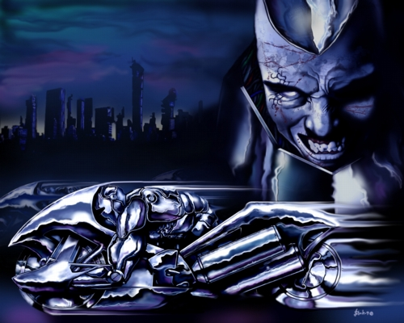
Illustration © 2003 Linus Persson

Copyright © 2003 M. Bennardo

M. Bennardo was recently a student of Case Western Reserve University, where he studied business management during the day and English at night. Now graduated, he continues to segregate his activities according to the time of day, and is gratified to observe that they each bring their own particular compensation. For more about him, see his website.
Linus Persson started his career after time in the service. He currently works as a web designer and finds himself struggling to stay awake after long workdays and nightly art sessions. While he started with oil paintings, he now prefers the medium of computer art; his subject matter ranges from portraits of athletes to hospital signs, but he prefers anatomy studies of people and SF/fantasy motifs. In his spare time, Linus is also a movie buff and a music lover.

