The Túrin Prose Fragment

An Analysis of a Rúmilian Document
by Arden R. Smith
In Appendix E to The Lord of the Rings (III:395), Tolkien says regarding the alphabets in use in Middle-earth during the Third Age:
The alphabets were of two main, and in origin independent, kinds: the Tengwar or Tîw, here translated as 'letters'; and the Certar or Cirth, translated as 'runes'. The Tengwar were devised for writing with brush or pen, and the squared forms of inscriptions were in their case derivative from the written forms. The Certar were devised and mostly used only for scratched or incised inscriptions.
The Tengwar were the more ancient; for they had been developed by the Noldor, the kindred of the Eldar most skilled in such matters, long before their exile. The oldest Eldarin letters, the Tengwar of Rúmil, were not used in Middle-earth. The later letters, the Tengwar of Fëanor, were largely a new invention, though they owed something to the letters of Rúmil. They were brought to Middle-earth by the exiled Noldor, and so became known to the Edain and Númenoreans.
The history of the Tengwar is told more fully in the "Appendix on Runes" (TI:453; see also LR:173-74):
The oldest [Elvish alphabet] is the Alphabet of Rúmil. This is a final cursive elaboration of the oldest letters of the Noldor in Valinor. Only the completion and arrangement of this system was actually due to Rúmil of Túna; its author or authors are now forgotten. Though originating in Túna it is called 'Valinorian' because it was mainly used for writing of Qenya, and was later ousted from use among the Noldor by the alphabet of Fëanor. It is said still to be used by the Lindar of Valinor; but is not in general use among the Qendi.
The Alphabet of Fëanor was partly derived from this, and partly devised afresh to fit a different system of writing (from left to right). Its actual author — in all forms except the later modifications to fit the changed conditions of Noldorin after the Exile, which were made after his death — was Fëanor. He constructed it both as a general phonetic alphabet, and devised special arrangements to fit the characteristics of Qenya, Noldorin, and Telerin. This alphabet is the one generally used for Qenya, and for all purposes by the surviving Qendi.
Based on these passages, then, the following assumptions about the form of the Rúmilian letters (or sarati, as they are called in WJ:396) may be made: (1) they are not "runic" in shape, (2) they must bear at least some similarity to the Fëanorian letters, and (3) they are not written from left to right, which means that they are most likely written either from right to left, in boustrophedon (i.e. with lines alternating left to right, right to left), or vertically, which is in fact how the Rúmilian letters are generally written.
No further descriptions and no samples of this alphabet have hitherto appeared in the published corpus of Tolkien's works, but, as Tolkien himself states in a letter of 14 January 1956 to a Mr. Thompson, "There is hardly any reference in The Lord of the Rings to things that do not actually exist on its own plane (of secondary or sub-creational reality): sc. have been written" (L:231). Indeed, Humphrey Carpenter even mentions a document written in this alphabet (Tolkien: A Biography, Boston: Houghton Mifflin, 1977, p.100):
Realising that he had entered a new phase of his life, Tolkien began (on New Year's Day 1919) to keep a diary in which he recorded principal events and his thoughts on them. After starting it in ordinary handwriting he began instead to use a remarkable alphabet that he had just invented, which looked like a mixture of Hebrew, Greek, and Pitman's shorthand. He soon decided to involve it with his mythology, and he named it 'The Alphabet of Rúmil' after an elvish sage in his stories. His diary entries were all in English but they were now written in this alphabet. The only difficulty was that he could not decide on a final form of it; he kept on altering the letters and changing their use, so that a sign that was used for 'r' one week might be used for 'l' the next. Nor did he always remember to keep a record of these changes, and after a time he found it difficult to read earlier entries in the diary. Resolutions to stop altering the alphabet and leave it alone were of no avail: a restless perfectionism in this as in so much else made him constantly refine and adjust.
In August 1992, Christopher Gilson, Carl Hostetter, Patrick Wynne, and I had the opportunity to look through the Tolkien papers in Oxford's Bodleian Library, but the aforementioned diary was not among the papers that were available to us there. We did, however, find other examples of the Tengwar of Rúmil, the most extensive of which is presented here.
The Túrin Prose Fragment (MS. Tolkien S1 (VII) fol. 15r) is written on one side of a 102x166 mm slip of paper cut from a proof-sheet of the Oxford English Dictionary. Portions of the entries for "sweetner" and "sweetning" are printed on the verso, where Tolkien has written a rather disorganized list of Rúmilian characters (without values). The slip has been bound into one of the notebooks containing the original manuscript of The Book of Lost Tales, labelled "Lost Tales F", along with a slip in Humphrey Carpenter's handwriting (S1 (VII) fol. 16), reading, "Transliteration into Alphabet of Rúmil of passage of story beginning at top of page 5 of MS. Done in version of the alphabet in use circa June 1919 (as appears from the 'script' diary). HC." Page five of the manuscript (fol. 14r) corresponds to the published version of The Book of Lost Tales, Part Two, p. 72 line 39 to p. 73 line 21. This Rúmilian fragment is mentioned by Christopher Tolkien as evidence for the date of the "Tale of Turambar" (LT2:69).
The facsimile of the text given below is accompanied by an exact transliteration, an edited transliteration, and a table of the Rúmilian characters used in the text with notes on the usage of those characters. In order to facilitate the comparison of the Rúmilian sarati with the Fëanorian tengwar, the table is based on the usual arrangement of the Fëanorian system as found in Appendix E to The Lord of the Rings (III:396-99), but without the sixth tyelle (nos. 21—24), which is superfluous here. The values assigned to this matrix correspond to the Westron/English values of the tengwar. Vowels, diphthongs, carriers, and punctuation marks appear below the consonantal grid. Variant forms of a character are freely interchangeable unless otherwise indicated.
The symbols representing the phonetic values of the letters in the exact transcriptions and the character tables have their normal English values with the following exceptions and additions:

č = IPA [tʃ] = ch in English child
þ = IPA [θ] = th in English thin
š = IPA [ʃ] = sh in English shoe
x = ch in German Bach, Scottish loch
ð = th in English this
ž = z in English azure, s in English treasure
ɣ = gh, the voiced velar fricative, a sound similar to the Parisian r
ɲ = ny in English canyon
ŋ = ng in English ring
ʍ = voiceless wh in some pronunciations of English when
- = short carrier
= = long carrier
@ = the o-curl doubling carrier
(1) = character of indeterminate value; see note 1, etc.
{ } = character deleted on original
[ ] = character not appearing in the fragment but logically reconstructible
Ø = character unknown for this mode

Examples of the values of the vowel symbols are given in the table of characters.
Facsimile
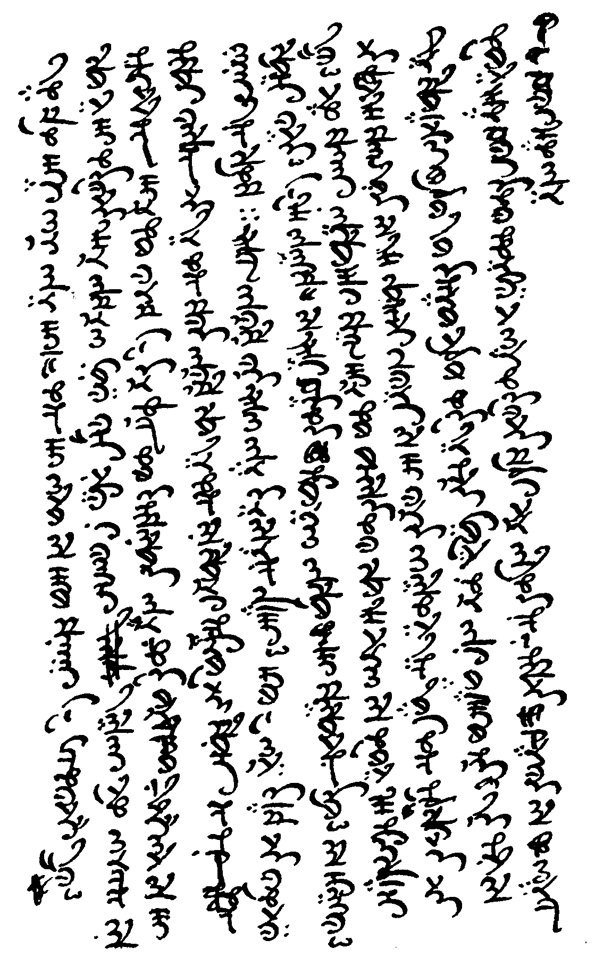
Bodleian MS.Tolkien S1 (VII) fol. 15r ©1995 The Tolkien Trust
Exact transliteration
n. b. Scribal errors in the text have been retained.
h | f | əs | s | əm | f | h | n | h | uw | { }
aw | r | s | k | əŋ | or | o:l | d | iy | r | { }
s | in | t | r | h | is | z | ʍ | g | in | s
ow | ð | n | t | z | t | n | n | r | ð | l
ð | w | n | l | f | l | aw | ð | a= | aw | t
æt | ud | s | v | ow | æn | k | k | n | š | Þ
m | l | (2) | z | k | d | m | ŋ | t | l | aw
ey | n | ð | n | :: | z | ŋ | h | d | t | b
b | d | ey | d | ð | t | b | əər | { } | d | iy
iy | ð | w | h | n | u- | if | d | o@ | w
ð | ey | r | iy | b | ðə | r | v | r | l
s | b | l | w | el | b | ð | ð | h | s
w | k | y | z | eg | æŋ | t | p | r | w
z | ey | k | k | l | k | k | ər | d | iy
ð | m | t | l | ed | s | iŋ | z | z | t
m | ət | u- | d | ð | v | ð | n | ay | li
n | ər | d | b | m | ð | ey | t | r | n
r | li | ey | el | b | æt | w | p | n | m
v | l | ʍ | eg | ay | š | r | l | o@ | ay
ð | o:s | en | f | d | æd | r | iy | r | w
r | t | w | r | iy | w | s | t | w | ud
k | ən | r | h | v | d | v | v | ud | l
əm | t | d | iy | iy | {} | d | ð | h | n
iŋ | il | s | w | əz | s | w | l | iy | d
t | ət | k | z | p | t | l | ey | s | k
u- | l | əv | əv | a= | r | f | di | en | o@
t | ŋ | r | g | ð | iy | r | m | d | t
n | Þ | d | r | z | m | ð | æv | t | n
w | {h} | b | ey | þ | b | n | w | ur | ey
l | {v} | ay | t | r | f | y | in | in | b
n | {(1)} | ə- | st | u- | or | m | h | əw | h
ts | h | w | æt | m | {} | v | iz | ey | ow
h | æv | ud | y | eni | ð | uw | hæ | b | d
o:l | ŋ | r | ur | d | k | r | ar | ət | əz
z | n | ey | n | a= | æv | in | t | r | ə-
 | ow | n | d | k | r | ð | w | a= | s
 | m | j | g | n | n | s | z | ð | k
 | y | r | ər | d | əs | t | s | r | n
 | n | ə- | Þ | l | d | d | o@ | s | d
 | z | h | z | ow | or | f | f | ed | {}
 | əv | n | s | n | z | a= | t | (3) | č
 |  | ts | əč | li | v | s | n | h | ay
 |  | m | {s}w |  | þ | t | d | ey | l
 |  | n | z |  | iŋ |  | n | s | d
 |  | v |  |  | l |  | d | ən | v
 |  | ð |  |  | z |  |  | v | {w}
 |  |  |  |  |  |  |  |  | m
 |  |  |  |  |  |  |  |  | ay
 |  |  |  |  |  |  |  |  | n
(1) Either an unwanted variant of  or a letter representing mh or mb erroneously used here.
(2) No apparent value.
(3) No apparent value.
Edited transliteration
Howso that may be, this was the manner of their coming to Tinwelint's halls; for in the woodland they became utterly lost, until at length having no means of sustenance they were like to die, when [they] were discovered by a wood-ranger, a huntsman of the secret Elves, and he was called Beleg, for he was of great stature and girth as such was among his folk. Then Beleg led them by devious paths through many dark and lonely forestlands to the banks of that shadowed stream before the cavernous doors of Thingol's halls. Now coming before that king they were received well for the name of Úrin the Steadfast and when the king heard of the present plight of the lady Mavwin his heart was softened and he granted all her desire, nor would he send Túrin away, but rather said he: "Son of Úrin, thou shalt dwell sweetly in my woodland court, nay, behold as a second child of mine shalt thou be."
Spelling and capitalization have been normalized in this transliteration, and apparent scribal errors have been corrected (see the "Table of characters" for erroneously used letters). Punctuation has been added to correspond with that in the published version; the only punctuation in the original Rúmilian document is the full stop following "folk". Compare the published text of this passage (LT2:72-73):
Howso that may be, this was the manner of their coming to Tinwelint's halls; for in the woodlands beyond the mountains they became utterly lost, until at length having no means of sustenance they were like to die, when they were discovered by a wood-ranger, a huntsman of the secret Elves, and he was called Beleg, for he was of great stature and girth as such was among that folk. Then Beleg led them by devious paths through many dark and lonely forestlands to the banks of that shadowed stream before the cavernous doors of Tinwelint's halls. Now coming before that king they were received well for the memory of Úrin the Steadfast, and when also the king heard of the bond tween Úrin and Beren the One-handed and of the plight of that lady Mavwin his heart became softened and he granted her desire, nor would he send Túrin away, but rather said he: "Son of Úrin, thou shalt dwell sweetly in my woodland court, nor even so as a retainer, but behold as a second child of mine shalt thou be, and all the wisdoms of Gwedheling and of myself shalt thou be taught."
Note that while the published text, based on the manuscript version of the story in Lost Tales notebook F, has Tinwelint at both occurrences of the king's name, the Fragment has Tinwelint only at the first occurrence and Thingol at the second. This suggests that the Fragment is of later date than the Lost Tales manuscript, in which the name is consistently Tinwelint (emended from Tintoglin; see LT2:69). The name was changed from Tinwelint to Thingol in the course of typing the revised version of "The Tale of Tinuuviel" (LT2:51), but Christopher Tolkien gives no indication of the date of this typescript version other than that it is "later than the manuscript [post-1917] but belonging to the same 'phase' of the mythology" (LT2:3). This agrees with Carpenter's dating of the Fragment.
Table of characters
Consonants:
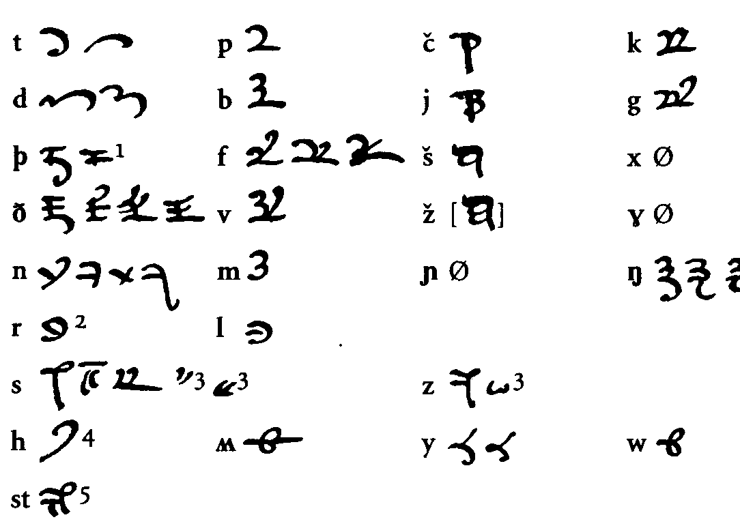
Vowels and diphthongs:
 | (Úrin)
 | (to, woodland, wood, stature, through, would, Túrin)
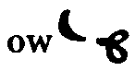 | (so, no, folk, lonely, behold sic)
 | (shadowed)
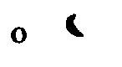 | (forest, before, doors)
 | (halls, lost)
 | (softened, all, nor, court)
a | (heart)
a: | (paths, dark, steadfast, granted, rather)
æ  | (that, having, lands, banks, shadowed, cavernous, Mavwin, heart)
 | (stature)
e | (when, Beleg, led, many, send, said)
ey 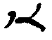 | (may, they, became, ranger, great, lady, away, nay)⁶
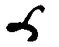 | (name)
i | (coming, in, utterly, until, many, lonely, forest, Thingol's, etc.)
iy 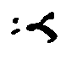 | (be, he, devious, stream, sweetly)⁷
aw | (how, now, thou)
ay 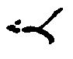 | (by, desire, my, child, mine)
 | (by)⁸
 | (like)
oy[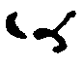]
ə | (coming, utterly, until, at, of, sustenance, discovered, a, girth, etc.)
A preceding vowel is placed to the left of the consonant, a following vowel to the right. In two words (sustenance, present) a vowel diacritic has been misplaced. Vowels are very often omitted.
Carriers:
 short carrier (to, a, through)
long carrier, apparently used only with a (paths, dark, steadfast, granted, rather)
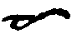 changes o into o:
Punctuation:
full stop (used only once in this text)
Notes on usage:
1. Erroneously used in "thou".
2. Erroneously used in "all".
3. Only used following a consonant, especially at the end of a word.
4. The vertical stroke that appears in this character at the top of the ninth column is an ink smear.
5. Optional.
6. Erroneously used in "die", with an unusual variant (looking more like ed) used erroneously in one occurrence of "he".
7. Erroneously used in "plight".
8. Here an erroneous e was struck through and replaced by a.
Characters not present in the fragment.
The systematic organization of the Rúmilian alphabet makes it possible to reconstruct further letters on the basis of what is present in the Túrin Prose Fragment. Thus the letter representing the phoneme /ž/ clearly has the form 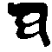, and the diphthong /oy/ is undoubtedly represented by 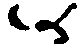. These extrapolations are confirmed by information from other Rúmilian fragments.

However, since the Rúmilian letter-forms are not as systematic as the Fëanorian, the forms of the characters for /ɲ/, /x/ and /ɣ/ cannot be determined with certainty on the basis of this document. Unfortunately, other Rúmilian fragments of similar date are either insufficiently clear or insufficiently complete to provide this information. The documents that I have seen that do contain Rúmilian characters for these sounds, clearly identified as such, represent later Rúmilian modes (circa 1921). However, since /ɲ/ may be represented by /ny/, and since /x/ and /ɣ/ are foreign to the phonology of English, the Túrin Prose Fragment provides adequate information for a Rúmilian mode for the phonemic representation of English.

Acknowledgements
I am very grateful to the Tolkien Estate and the Bodleian Library for their kind permission to reproduce the Túrin Prose Fragment. I would particularly like to thank Christopher Tolkien, Cathleen Blackbum of Morrell, Peel & Gamlen, and Dr. Judith Priestman and the staff of the Department of Western Manuscripts at the Bodleian Library for their assistance at various stages of this project. Many thanks also to Carl F. Hostetter for dealing with the arduous task of fine-tuning the scanned images of the manuscript characters. Finally, I would like to thank the attendees of the Third Annual Colloquium on the Languages of Middle-earth (Los Altos, California, 16-18 January 1993) for their helpful comments on my preliminary analyses of the Bodleian Rúmilian material.
