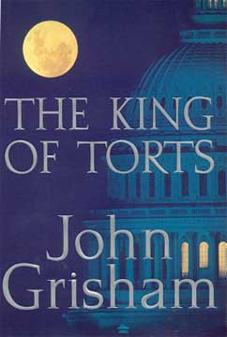 The King of Torts
The Office of the Public Defender is not known as a training ground for bright young litagators. Clay Carter has been there too long, and, like most of his colleagues, dreams of a better job in a real firm. When he reluctantly takes the case of a young man charged with a random street killing, he assumes it is just another of the many senseless murders that hit D.C. every week.
As he digs into the background of his client, Clay stumbles on a conspiracy to horrible to believe. He suddenly finds himself in the middle of a complex case against one of the largest pharmaceutical companies in the world. He was about to become the newest king of torts…
(Taken from the cover of The King of Torts.)

